Personal Finance Project - Skiing Holiday
By: Sophie O’Riordan 4D

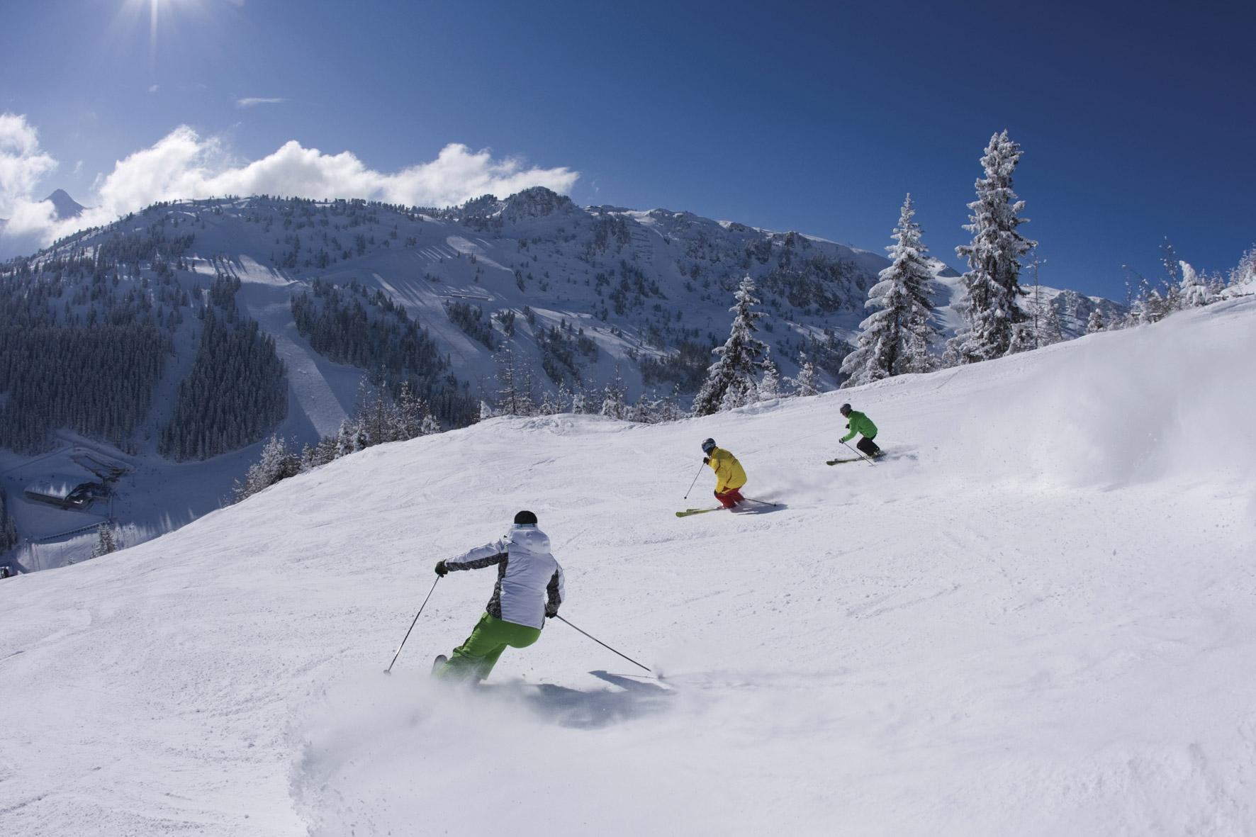
Mayrhofen ~ Austria!

For my Personal Finance project, I have chosen to go skiing in Mayrhofen, Austria for one week! It took a lot of time, effort and inspiration to do this project, but nonetheless I greatly enjoyed the experience of doing this project.
I am a big fan of travelling, but I was never fully aware of the amount of planning (and money!) that needs to go into a trip. It was a fun and worthwhile experience, researching many flights, hotels, restaurants and comparing them. I always feel the need to get the best deal I can, I don’t only look at the price but also at the quality. Read on to learn about my skiing holiday in Mayrhofen!
The aim and outline of the project

For our Personal Finance module, our aim is to learn and understand the concept of Personal Finance. When we will be adults, we will need to pay for everything on a daily basis, and it is very important that we keep a record of all the money that comes in and goes out, to keep things in balance. It is important we know what method of payment is most practical in different situations. Do I use credit card, or debit card? Questions like that will arise in the future, and we can only make an educated decision if we know the pros and cons of each method. Without further adieu let me introduce you to my Personal Finance Project!

I will go, along with one other friend skiing for one week (7 days). We can choose to ski anywhere in the world! Between us both there is a budget of €3000, and this must include flights, checked-in baggage, accommodations, transfers, food, a ski pass and rental of equipment.
Can we book a holiday that fits the bill?

Step one: Deciding where to fly to

As we all know, there are countless places in the world where one can spend a week of skiing down snowy slopes and drinking frothy hot chocolate in cosy cafes! How do I decide where to go? Well firstly, I thought it most logical to go to somewhere in Europe, as I am flying from Dublin airport. The reasons for this is that it is obviously a lot cheaper to fly to a European country than to Canada, or China etc. This immediately narrowed down my choices. Next, I wanted to go somewhere with the same currency as Ireland, being the Euro, so it would be less complicated as there would be no need to exchange currencies. This narrowed down my choices down a little more, ruling out countries in Europe such as Switzerland and Denmark. After reading an article about the best budget skiing places in Europe, I was convinced that I would either fly to Italy or Austria! Eventually after a lot of researching and comparing, I have decided to spend my week of skiing in Mayrhofen, Austria!

A little about Mayrhofen

A few years ago, I went to Mayrhofen with my family and some friends to go skiing! I fell in love with the quaint town of Mayrhofen and its silvery ski slopes, and delicious Austrian food! I thought this was the ideal place to ‘theoretically’ go skiing with my friend, for this project!

Mayrhofen is located within the heart of the Zillertal Valley. It is a Mecca for snow sports enthusiasts as well as providing a great base for those interested in summer pursuits such as mountain biking, hiking and paragliding. The town is home to just under 4000 full time residents and is supported by a high-quality infrastructure. The town centre offers a wide range of different shops from sports to fashion to jewellery and gifts. The nearest major city is Innsbruck which is about 60km away. The town also hosts a number of high profile annual events including Snowbombing and the Altitude comedy festival.

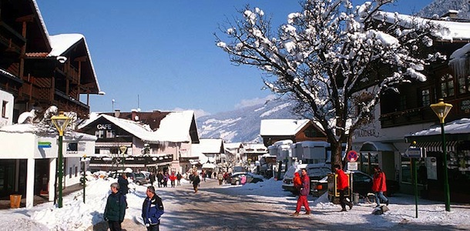
The town of Mayrhofen

Step two: Travel Insurance

Before booking my flights I bought travel insurance for my friend and me. Travel Insurance is insurance that is intended to cover medical expenses, trip cancellation, lost luggage, flight accident and other losses incurred while traveling. I went on to the AIG website and bought Travel Insurance for two adults between the age of 18-35, for a single trip. I got a quote for the travel insurance. A quote is an estimation of what a cost or price is likely to be. I decided to purchase the Budget Single Trip which costs €51.74. I will pay from this using my debit card so I will avoid paying unnecessary fees and so I will save time as most debit card payments register immediately, so there are fewer delays than with credit cards and their pending "float periods," which usually last at least 24 hours.
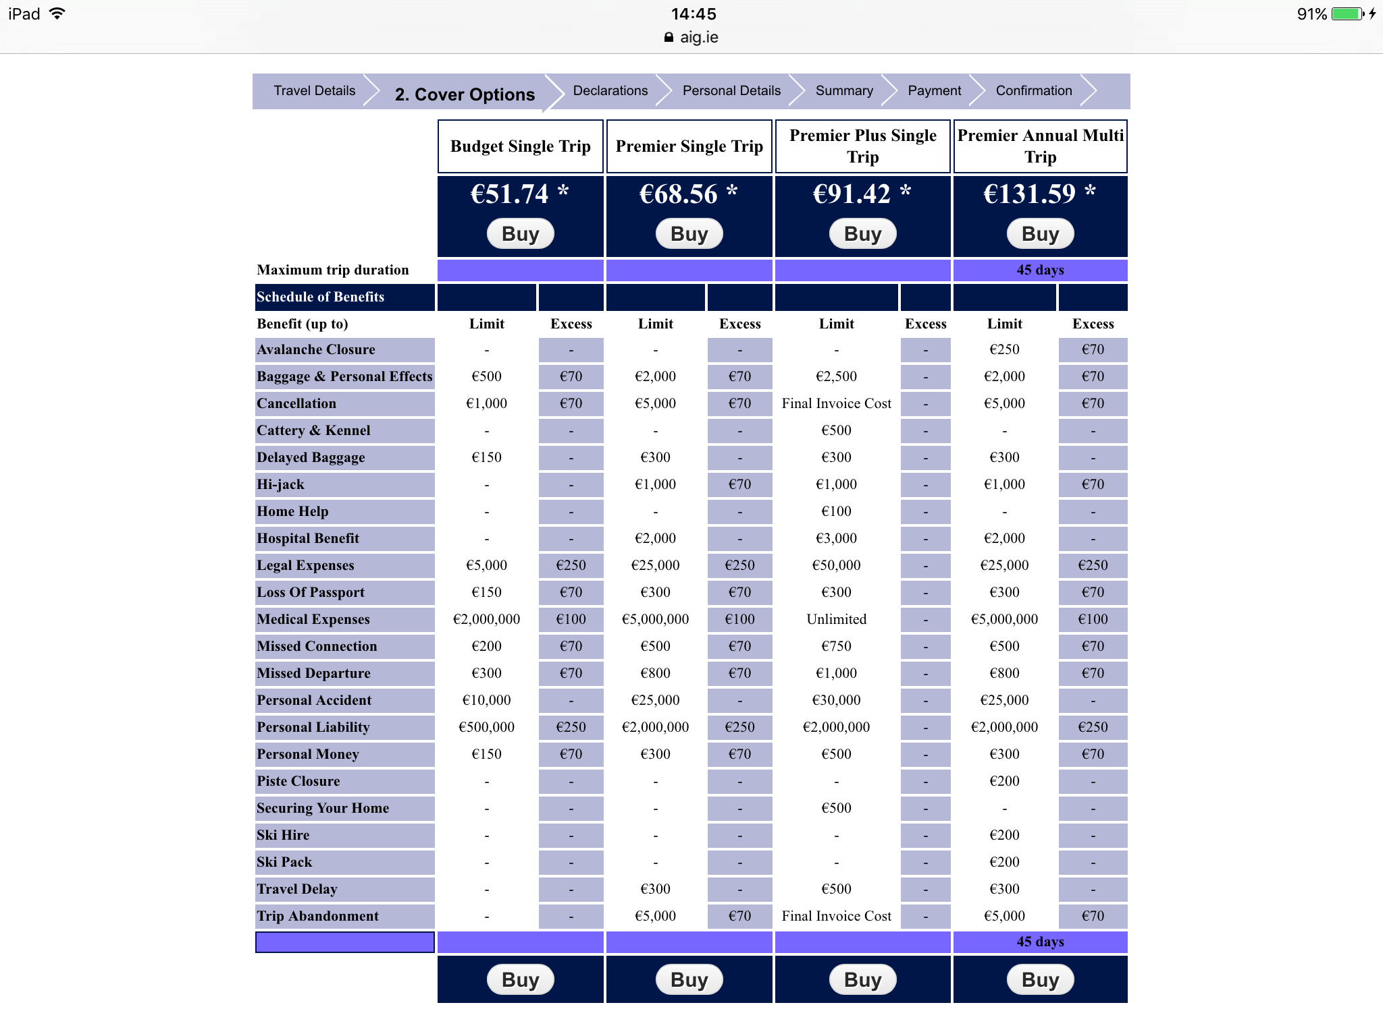
Step three: Booking the Flights

Although Innsbruck airport is the nearest to Mayrhofen, neither Ryanair nor Aer Lingus flies to Innsbruck. I decided to not fly with another airline that I am not familiar with, as this would make our trip a little more stressful than necessary! Also, the flights to Innsbruck were not regular nor cheap. So, I found out that the next nearest airport to the town of Mayrhofen is Munich Airport. I remember when I went to Mayrhofen with my family we also flew to Munich! As Ryanair doesn’t fly to Munich, I booked a return flight to Munich from Dublin Airport with Aerlingus.

The flights cost €257.96 in total, the flights to Munich costing €60.99 each and the flights back to Dublin costing €67.99 each. I did not pay for specific seats, as it is not necessary for my friend and me to be seated next to each other during the flight! I checked in two 15kg bags, which together costed €60. In total the flights added up to €317.92, which I thought was good value!

I will pay for the flights with my credit card, as €317.92 is a large sum of money to take out of my bank account in one go, I prefer to pay this sum over a period of time. Although there will be some of interest charged on the money I spend using my credit card, as ultimately I am borrowing money from the bank (which I must repay within a number of days) it is more practical than using cash or my debit card.
Below is proof of prices:

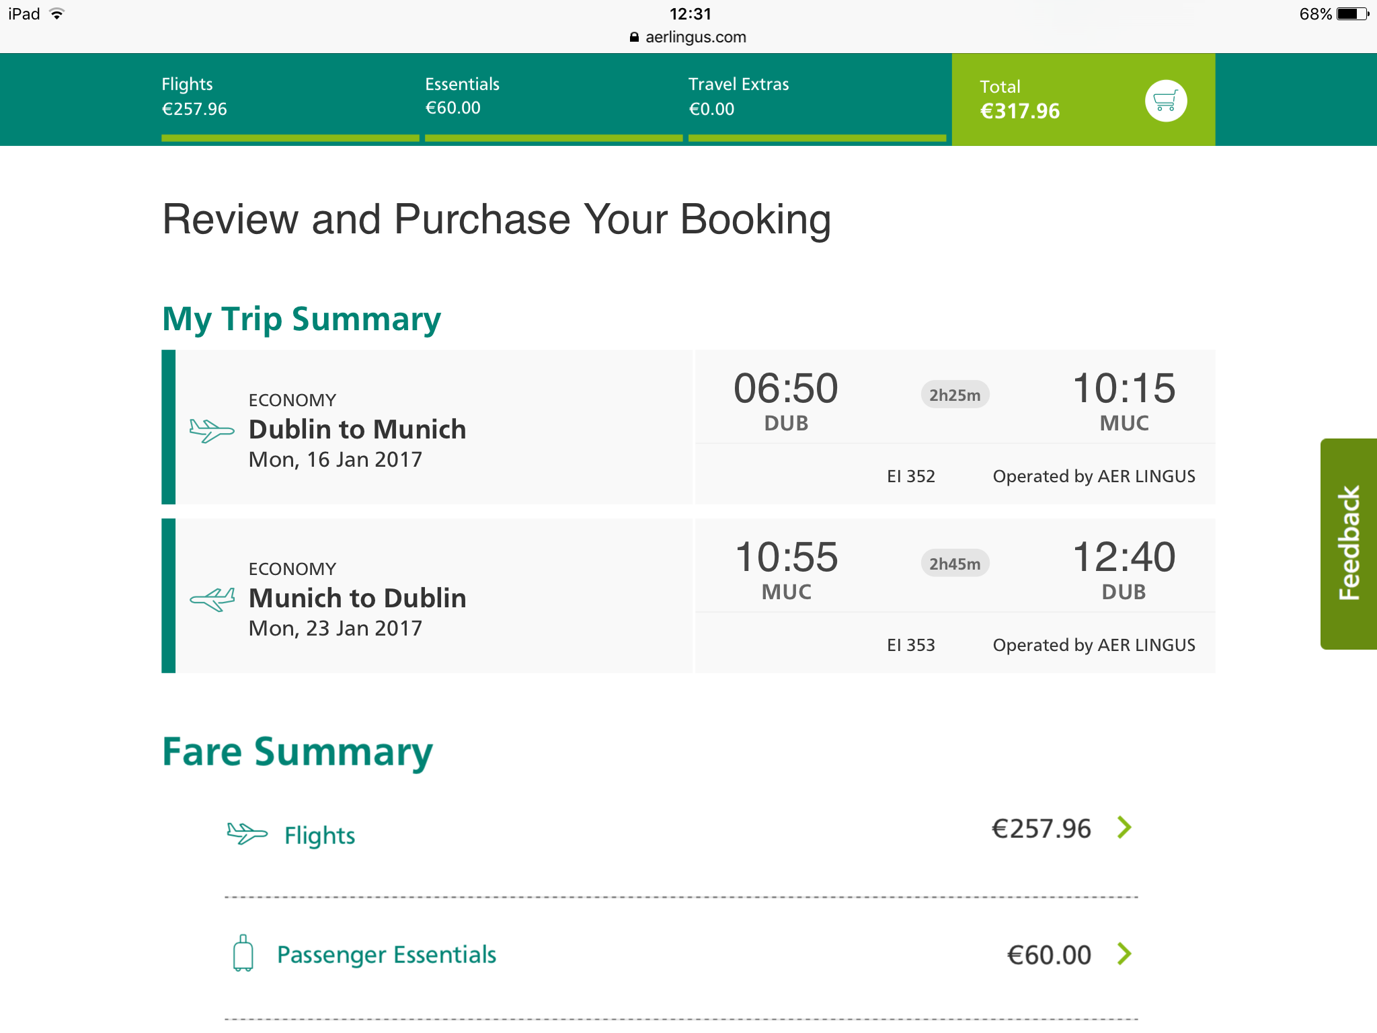
Step four: Transport from Greystones to Dublin Airport

In order to get to Dublin Airport from Greystones we took the Dublin Airport Aircoach. It would pick us up at Greystones Dart Station at 4.04AM on the 16th of January 2017. We would take the Aircoach from Dublin Airport back to Greystones at 13.30AM on the 23rd of January. Altogether this costed €40. I will pay for this using my debit card, as I will have to pay interest if I use my credit card. Also, I can afford to take €40 from my current account.

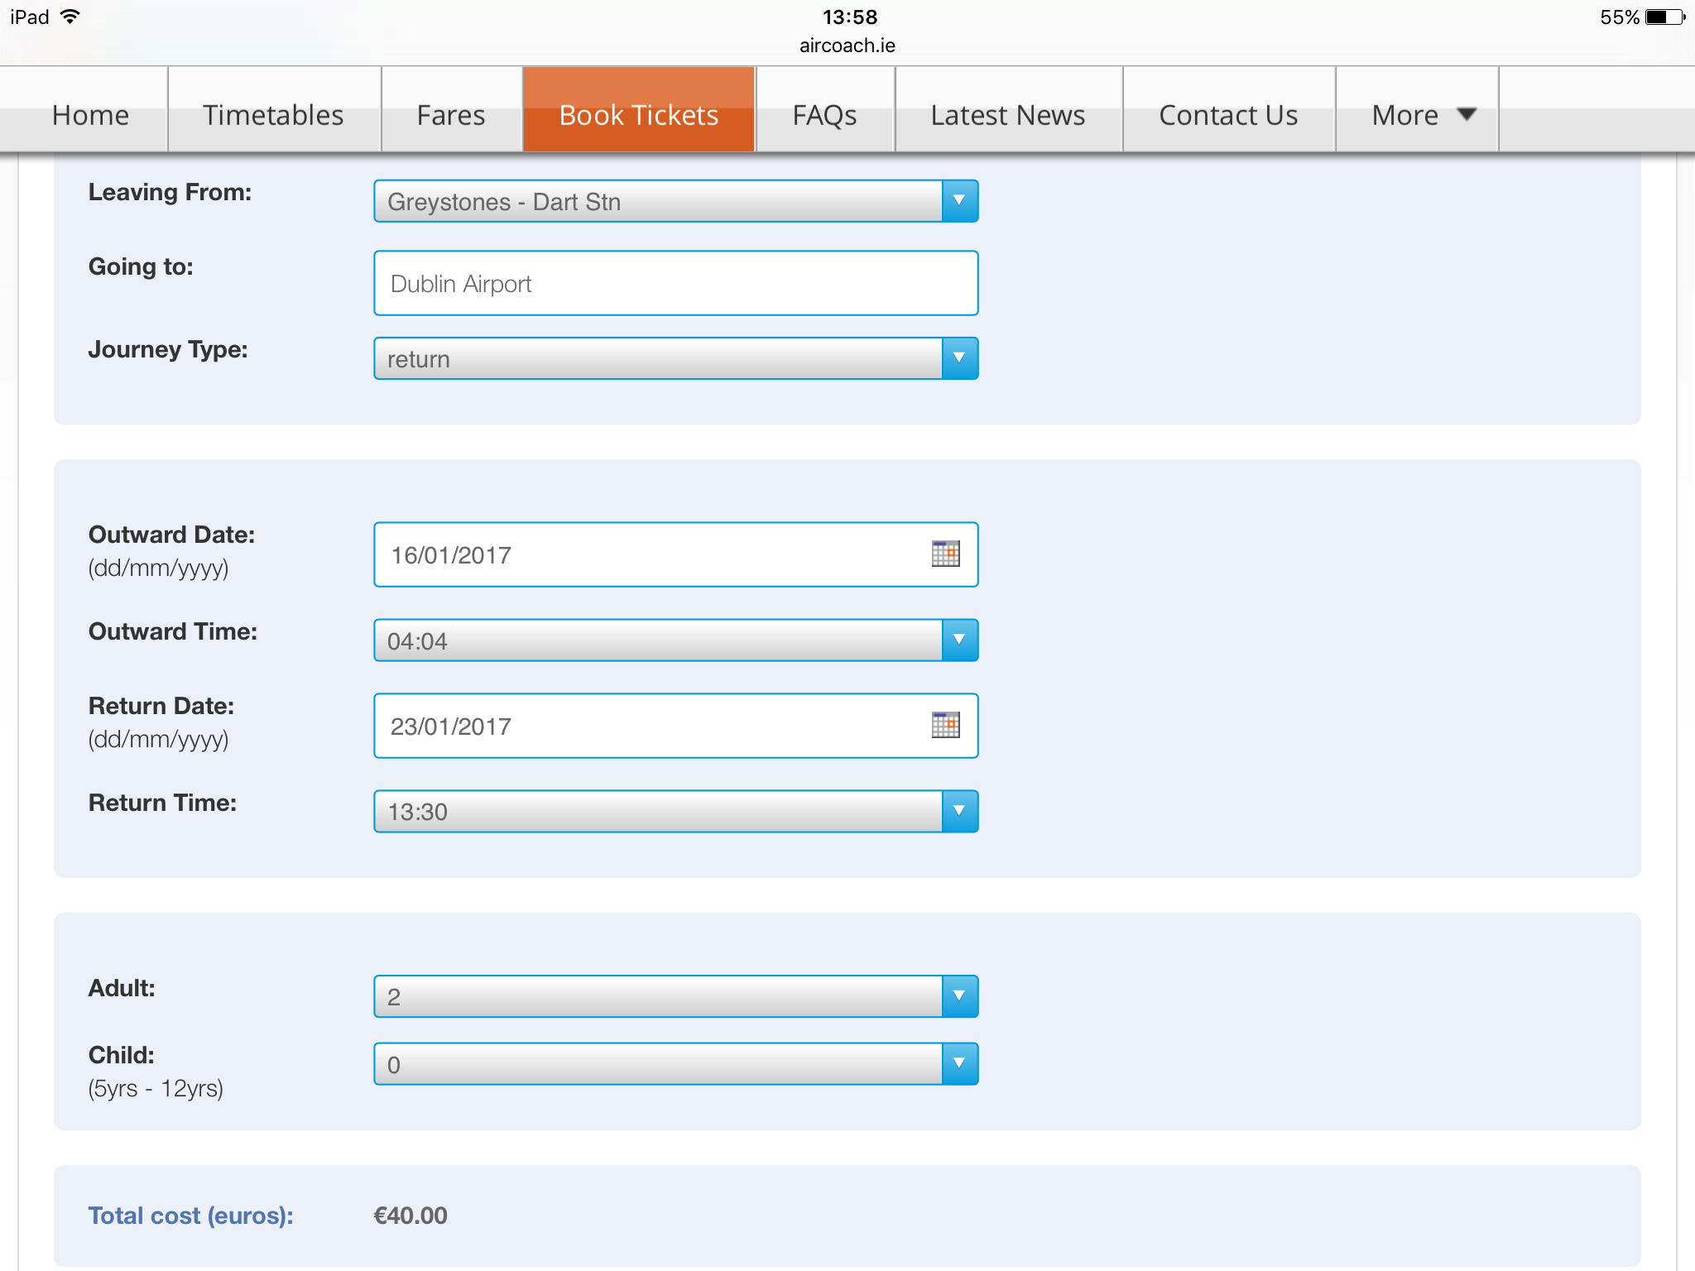

Step five: Transport from Munich Airport to Mayrhofen

I shall take a shuttle from Munich airport directly to Mayrhofen. It would also have been possible for me to take the train, however this route seemed a lot more complicated, as it involved many train-transfers. Also, the cost did not differ that much. So, I decided I would pay a little more for a direct transfer to Mayrhofen, in a shuttle where I am guaranteed a seat! I will take the shuttle from Munich Airport on the 16th of January at 10.15AM for €46,80 per person. This will total to €187.20 for a return trip for two people. I will pay for this using my debit card, since by using my credit card I would be ‘in debt’ until I repay the amount I have ‘borrowed’. I prefer to minimise this debt as much as possible!

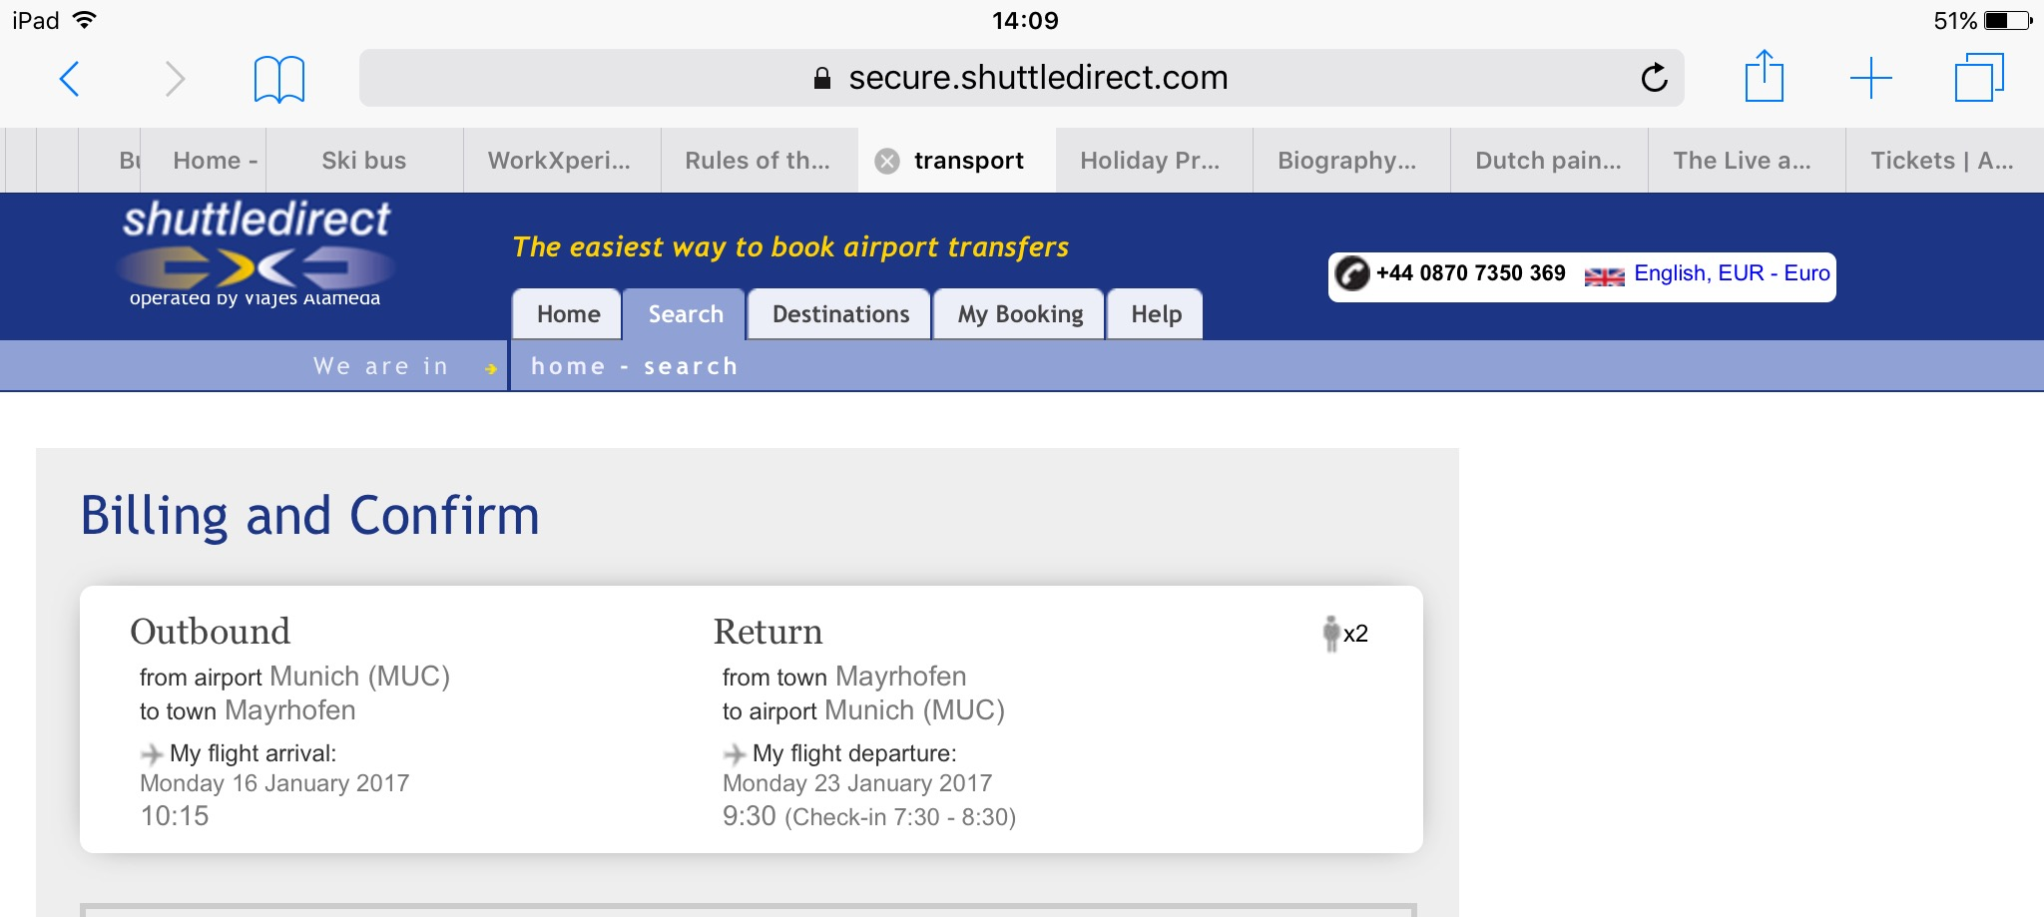
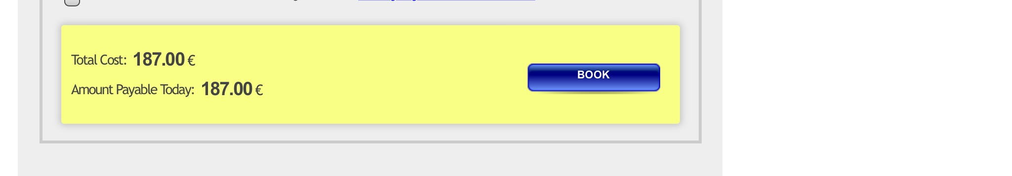

The Shuttle that will bring me from Munich to Mayrhofen!
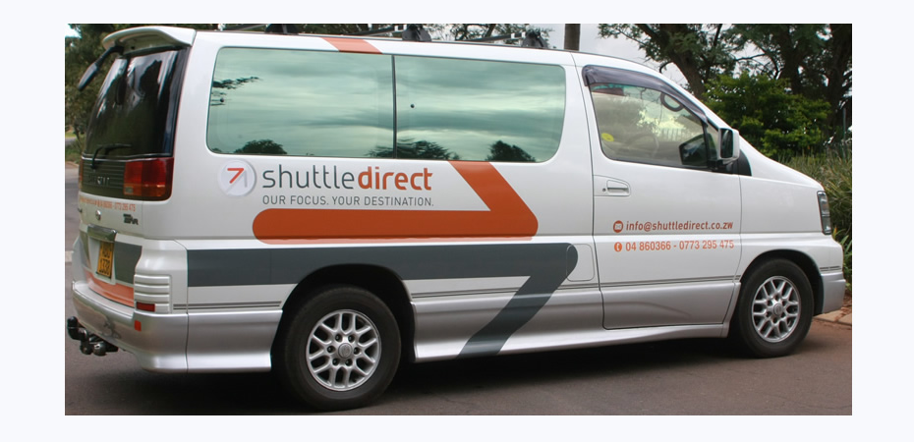

Step six: Accommodation

Finding a nice place to stay, with affordable prices and which is near a town and the ski slopes, was quite a challenge! I did a lot of research on ‘Booking.com’ and compared various hotels and guest houses. In the end, Hotel Rose was the best available option!

Hotel Rose
This traditional 4-star hotel is only a 5-minute walk away from the centre of Mayrhofen, and a 10-minute walk from the cable cars. A ski bus stop is right outside (the ski bus is free).
The spacious rooms at Hotel Rose have a flat-screen cable TV, a safe, and a bathroom. The Rose Hotel's spa area includes a Finnish and a steam sauna, a Kneipp basin, and a hot tub. There is also a gym and a table tennis room.
In the morning a rich breakfast buffet is served. In the evening the restaurant offers various themed evenings, such as a farmers’ buffet, an Italian buffet, or an elegant gala dinner. The garden has a big sunbathing lawn and a covered garden terrace with live music in summer.
This description of Hotel Rose persuaded me almost immediatly that this was the place! The factor that appealed to me the most about this place was that ‘a ski bus stop is right outside’. As I am not renting a car, it is vital I can get to the ski slopes easily.

I booked a double room, for 2 guests for 7 nights at Hotel Rose on the website, Booking.com. I had to book it quickly as there was only one more double bedroom available when I checked! Thankfully I got the last double room. The price added up to €1190, which is a respectable price considering its prime location, the hotel is 4-star, free wifi and breakfast is included. This means we are paying €170 per night, which is below the Mayrhofen average of €176.25 per night for a 4-star hotel! I will pay for the accommodation using my credit card.

Hotel Rose!
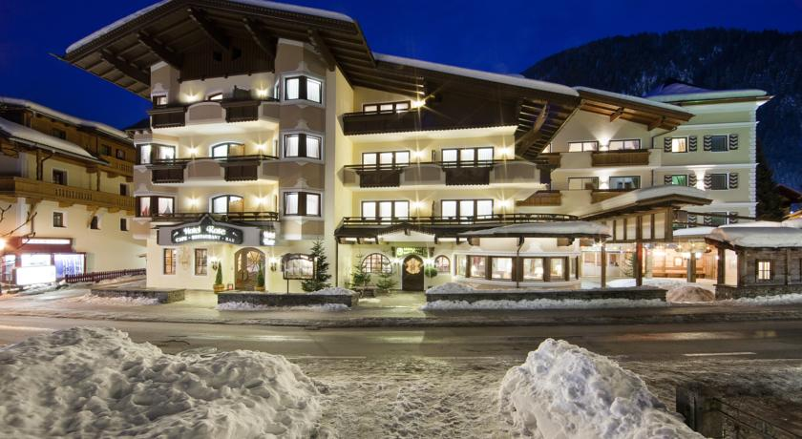
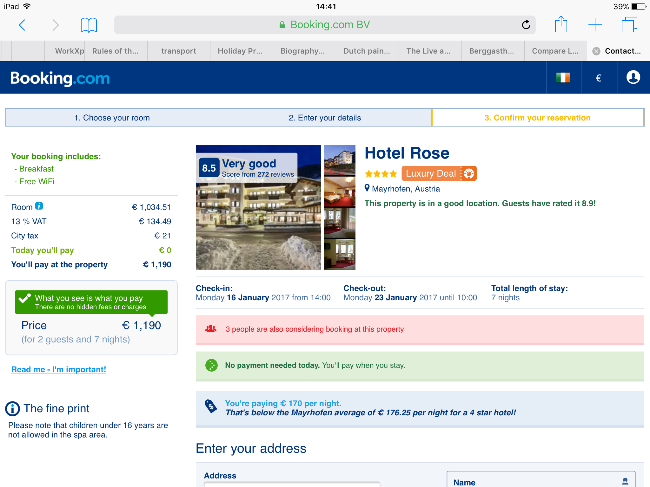

Step seven: Getting the Ski Equipment!

You can’t go skiing without all the ski equipment! I looked up the nearest place that sells and rents ski equipment near Hotel Rose and found the ‘Skischule Mayrhofen’ which is only a 5 minute walk from the hotel.
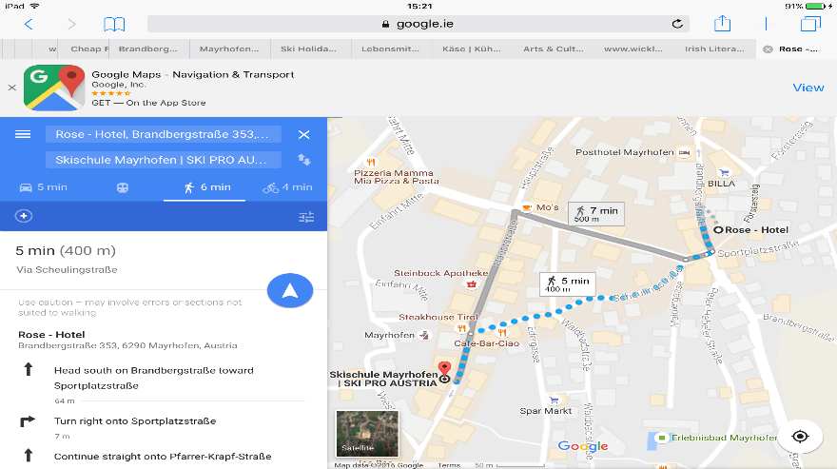

I explored their website and found out that if you pay for the ski equipment online, you get a 10% discount, so of course that is exactly what I did! I had to decide whether I wanted a Gold, Silver or Bronze ski equipment. I decided the description of a Silver skier best suited to my level of skiing: “comfortable ski models for beginners and advanced skiers”. The adults Silver Ski Set includes: skis, ski boots and sticks and costs €119. I will rent the ski equipment for 7 days, as one day is free if I choose 7 days, as opposed to 6 days! I must also rent a helmet, for extra safety. This will cost an additional €24. Together the ski equipment will cost €143 per person and €286 for the both of us. To pay for the ski equipment I will use my debit card.

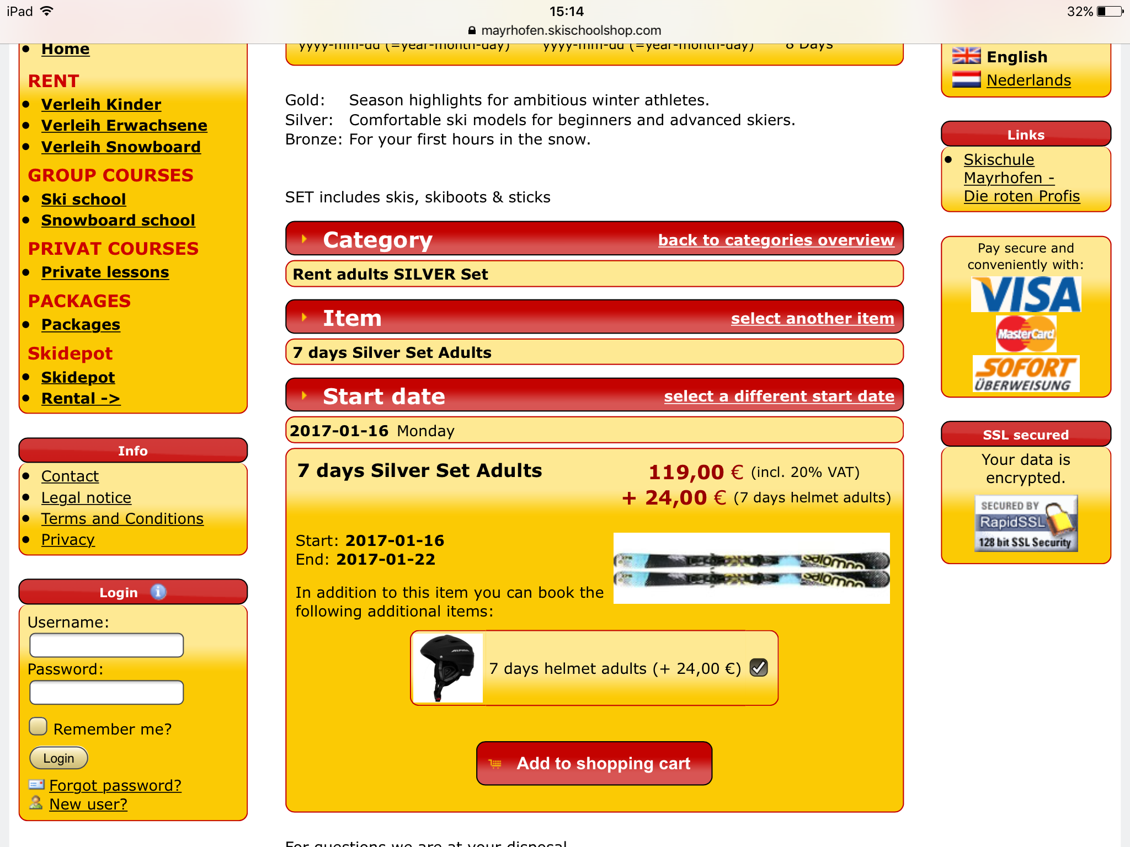

Step eight: Skipass

As the the hotel I have booked does not include a skipass in their deal, I had to research the tariff for 7 days of skiing for 2 adults on the website http://www.mayrhofen.at/en/winter-holiday-family/ski-pass-prices/. I wasn’t aware that skipasses were so expensive and thought I could find a way to avoid buying one but still go skiing in Mayrhofen! Unfortunately this was not possible so I had to give in and buy a skipass, valid for 7 days. The price for 2 adults skiing for 7 days is €549 (€274.50 per person). I will pay for this online using my debit card, as it is a large sum of money to leave my current account all at once. I can not use cash to pay for the skipass, as it is not possible to pay using cash online.

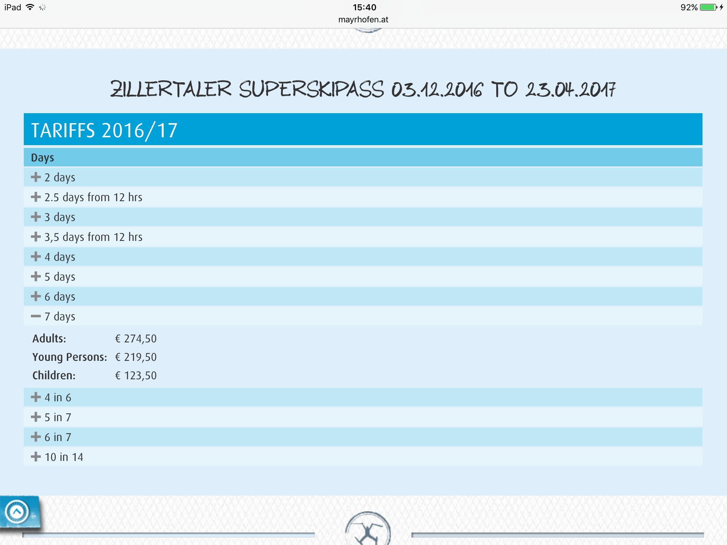

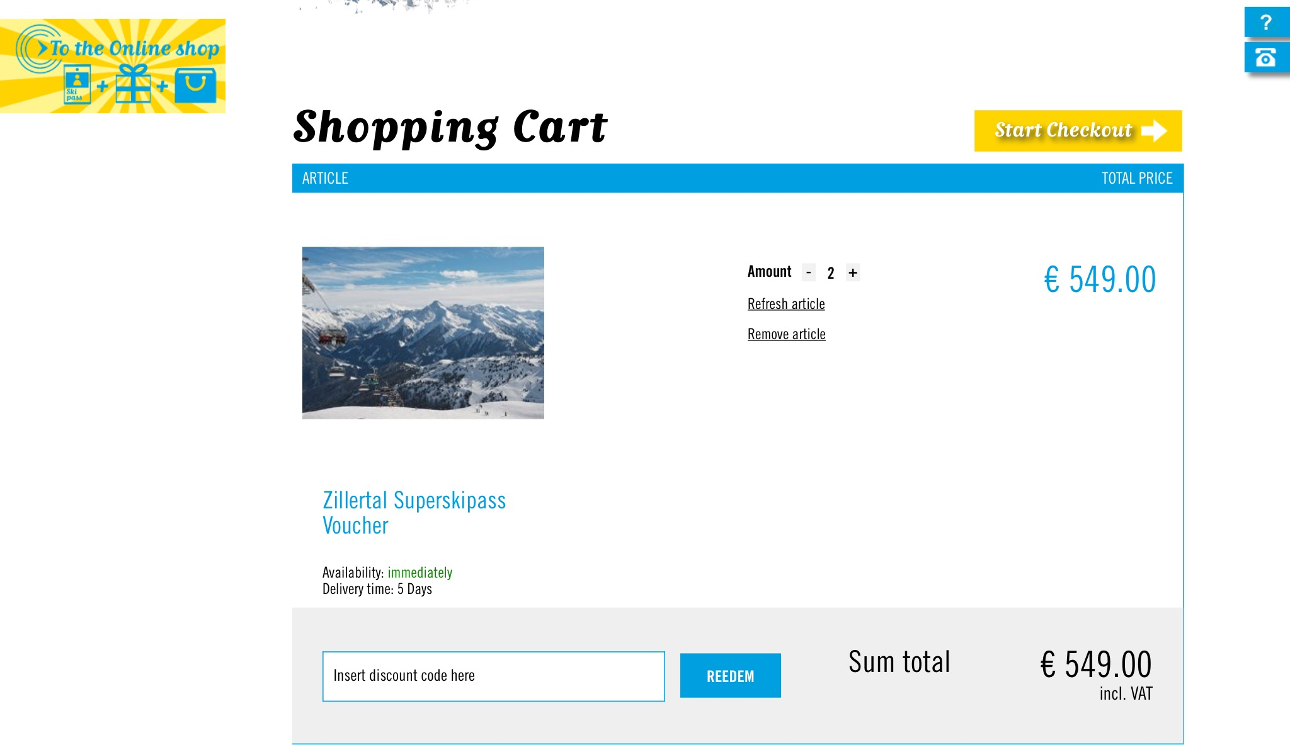

To figure out how much money I have left for lunch, dinner, snacks and souveniers I added up all the money I have spent already and took the total away from 3000.

Total so far:

Travel Insurance ~ €51.74

Flights ~ €317.96

Aircoach ~ €40

Airport Shuttle ~ €187.20

Accommodation ~ €1190

Ski Equipment ~ €286

Ski pass ~ €549

Total: €2621.90
3000 - 2621.90 = €378.10

This means I have €378.10 left to pay for lunch and dinner. Will it be enough?

Step nine: Lunch

Since Hotel Rose is providing me with a nutritious and filling breakfast in the morning, I will not be needing a very big lunch everyday. I discovered that there is a Spar Markt just a 6 minute walk from Hotel Rose.

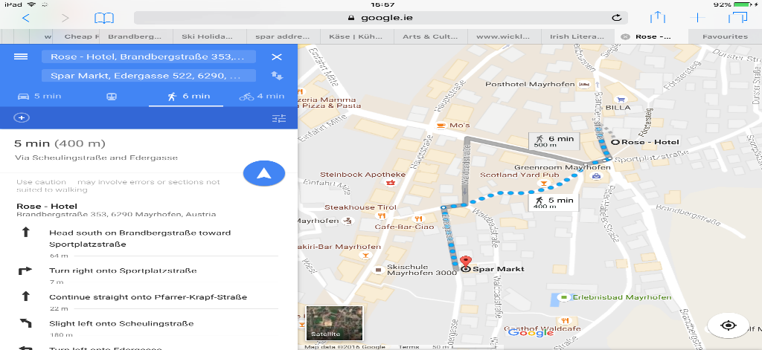

I decided I would buy 2 loaves of bread, two packets of ham, some cheese, apples and water at Spar Market to prepare my own sandwiches for lunch. There is a refrigerator in my hotel room, therefore I will be able to keep this food fresh for the week. I looked up the products Spar Markt sell on their website and found out that the bread costs €2.19, the ham costs €2.19 and the cheese also cost €2.19. Half a kilo of apples cost €1.74 and the water costs €1.29
In total I will have to pay €13.98. I will pay from this using cash at the till. This is the easiest method of payment when the amount is quite small.

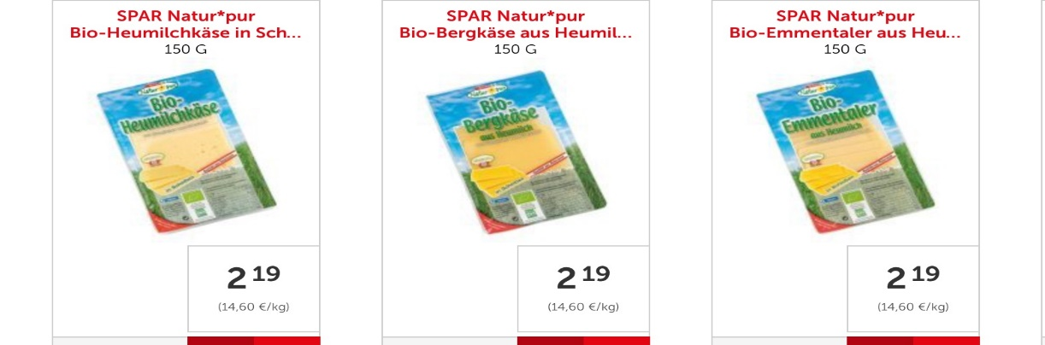
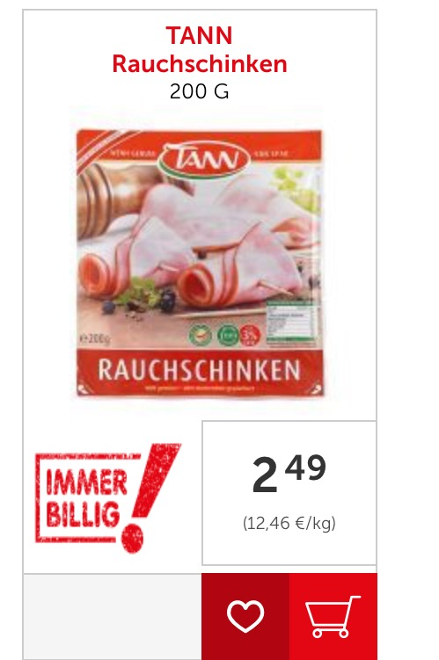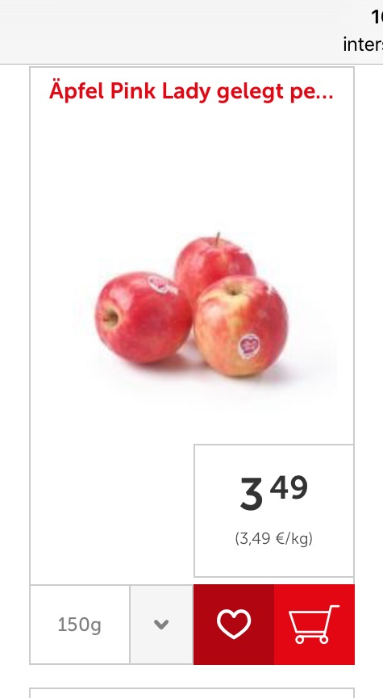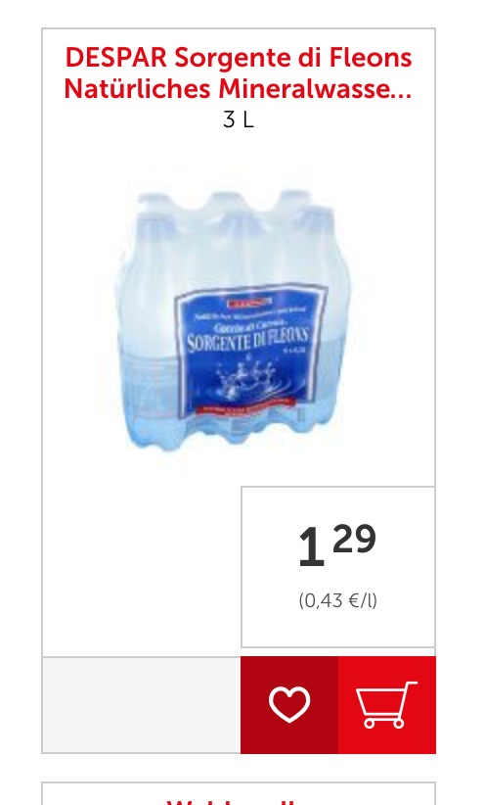

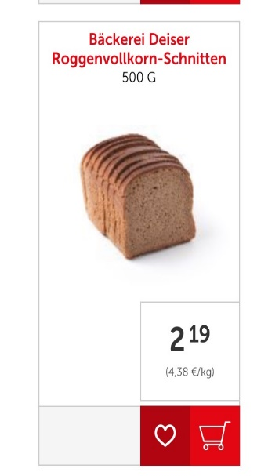

This will be enough for approximately 5 days of lunch, therefore for the last two days I will have lunch at Restaurant Edelweiss. This restaurant has delicious, simple, cheap dishes and is a 1 minute walk from my hotel. Lunch is an average of €7.30 per person. For two people for two days this will cost me €29.20. To pay for this I will use cash. Together my lunch for the week will cost €43.18.

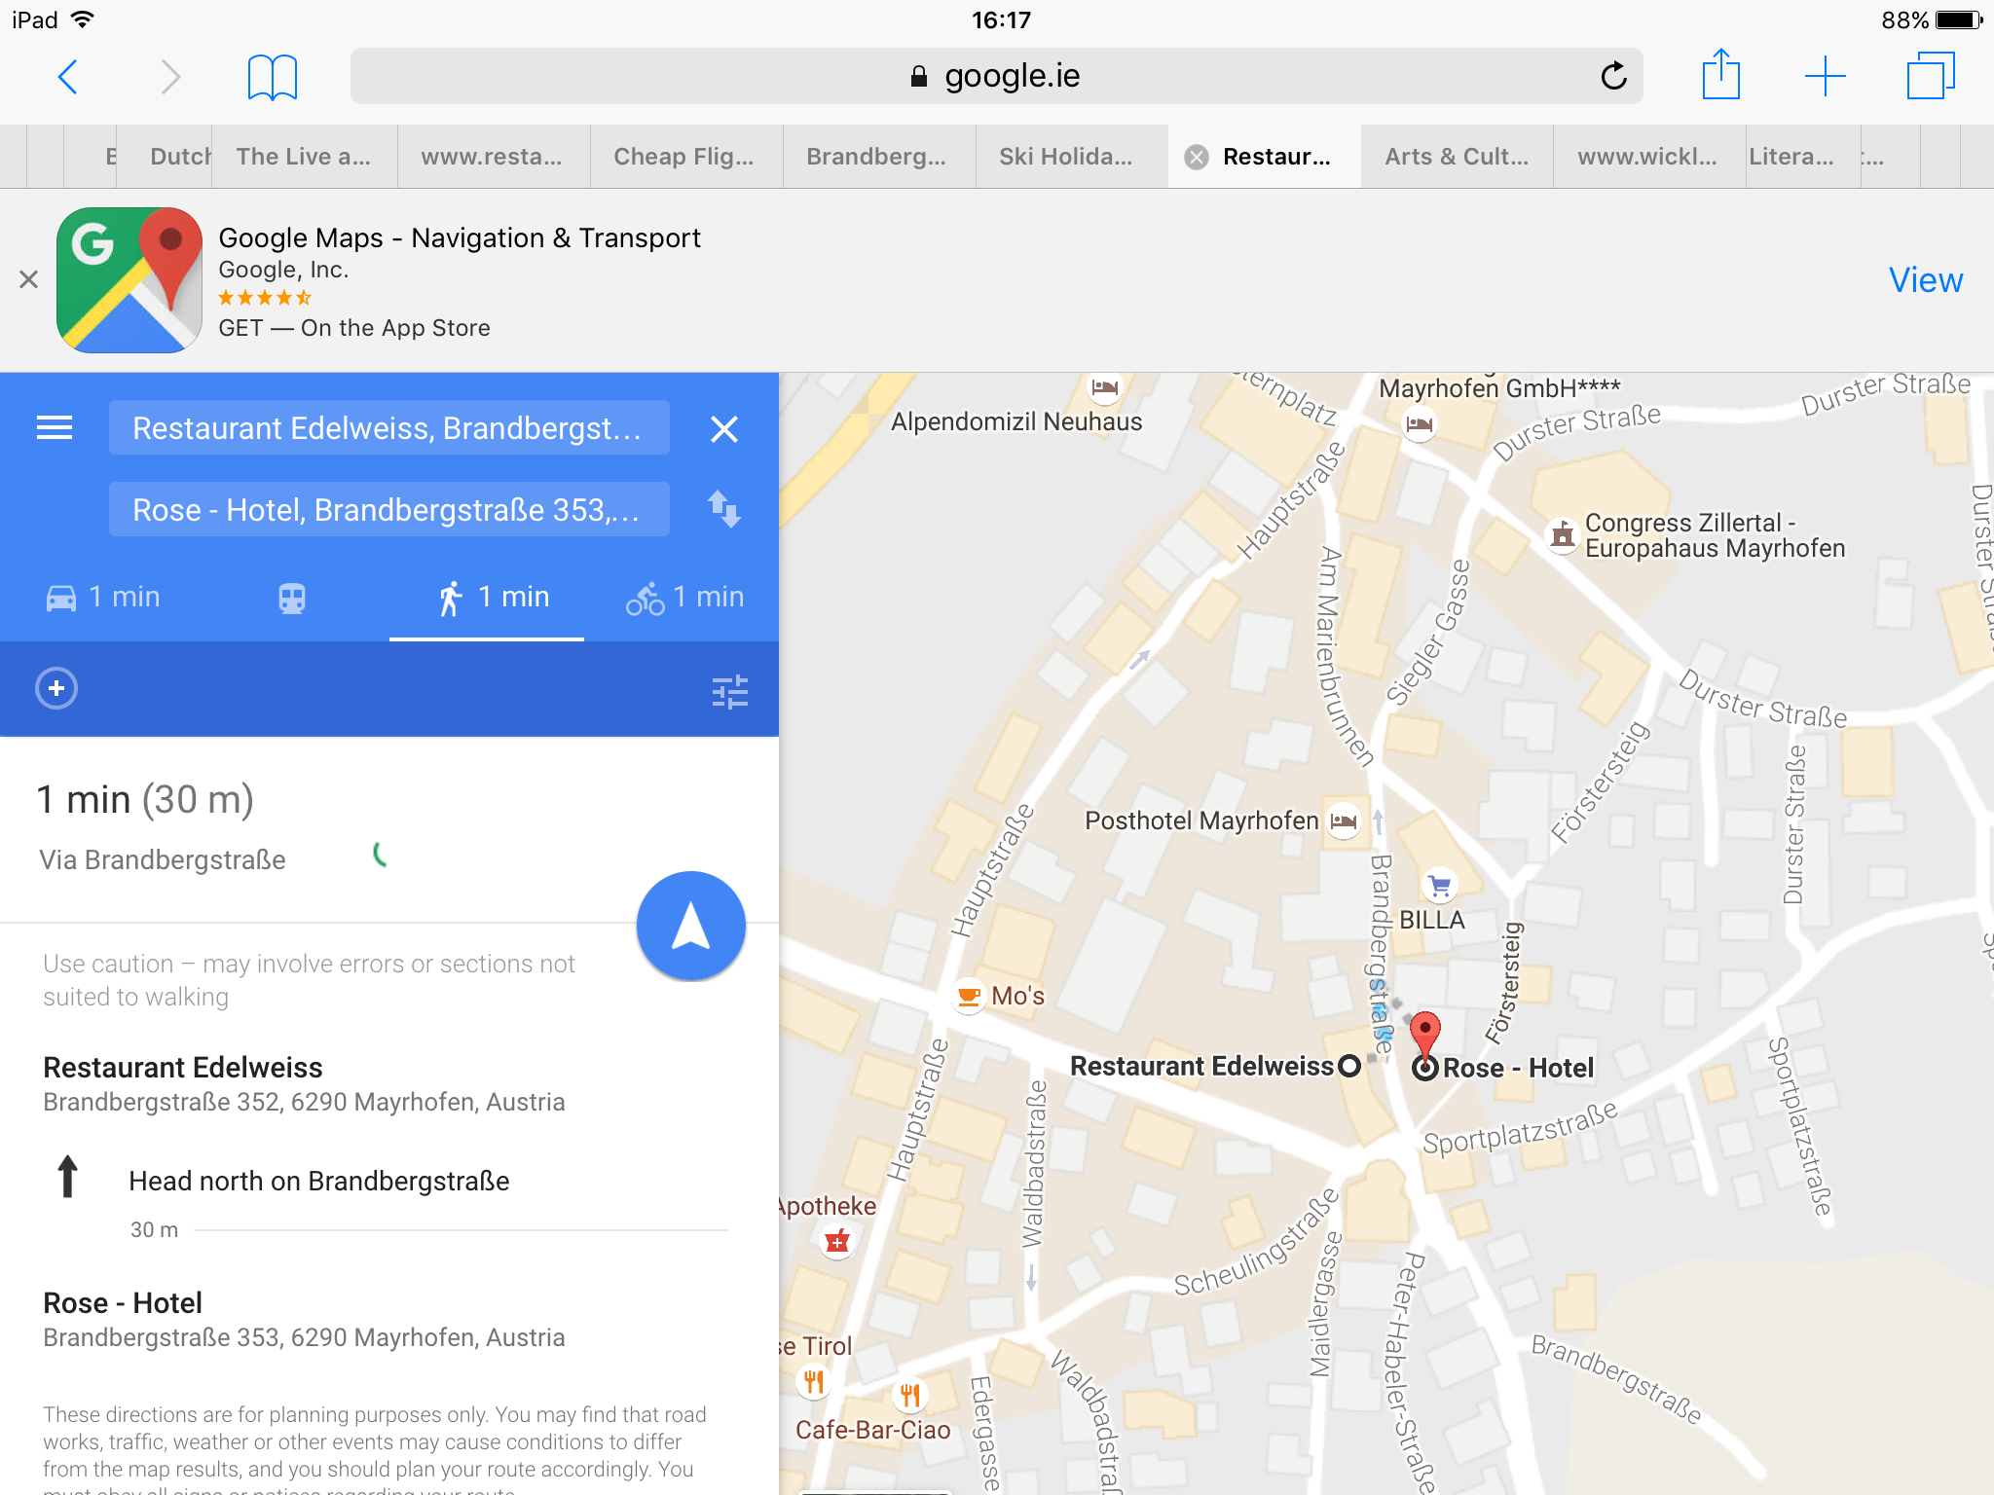

Restaurant Edelweiss!

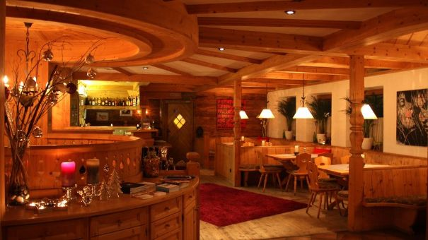
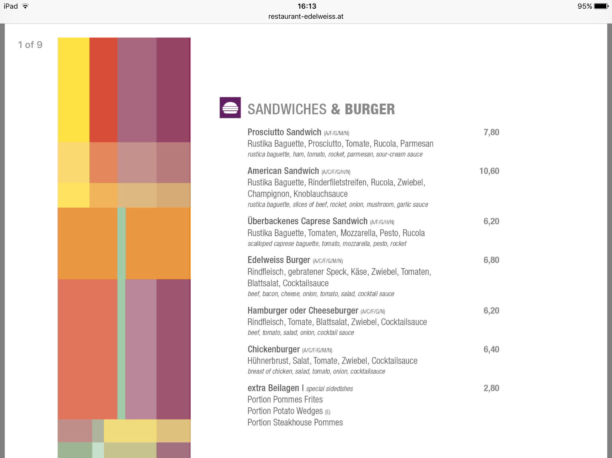

Dinner
After a long day of skiing I will definitely want to have dinner in a cosy place with delicious(and preferably not too expensive) food! I have chosen to eat every evening at Restaurant Edelweiss. I chose this restaurant because it is extremely near to the hotel, so I won’t have to walk a long distance just for a meal. Also, the I think the price of the meals are fair. In addition Restaurant Edelweiss serve some traditional Austrian dishes, and it seems nice to experience some of the Austrian culture by tasting some of their traditional meals! Dinner is an average of €10.55 per person. Therefore 7 dinners for two people amounts to €147.77. I will pay for my dinner using my debit card.

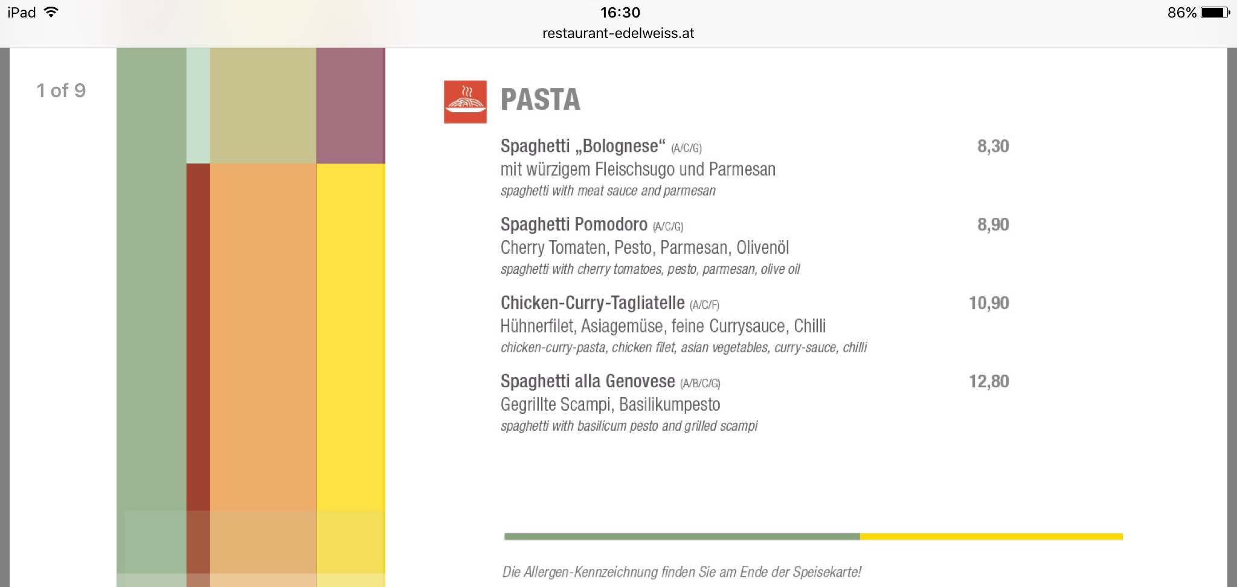

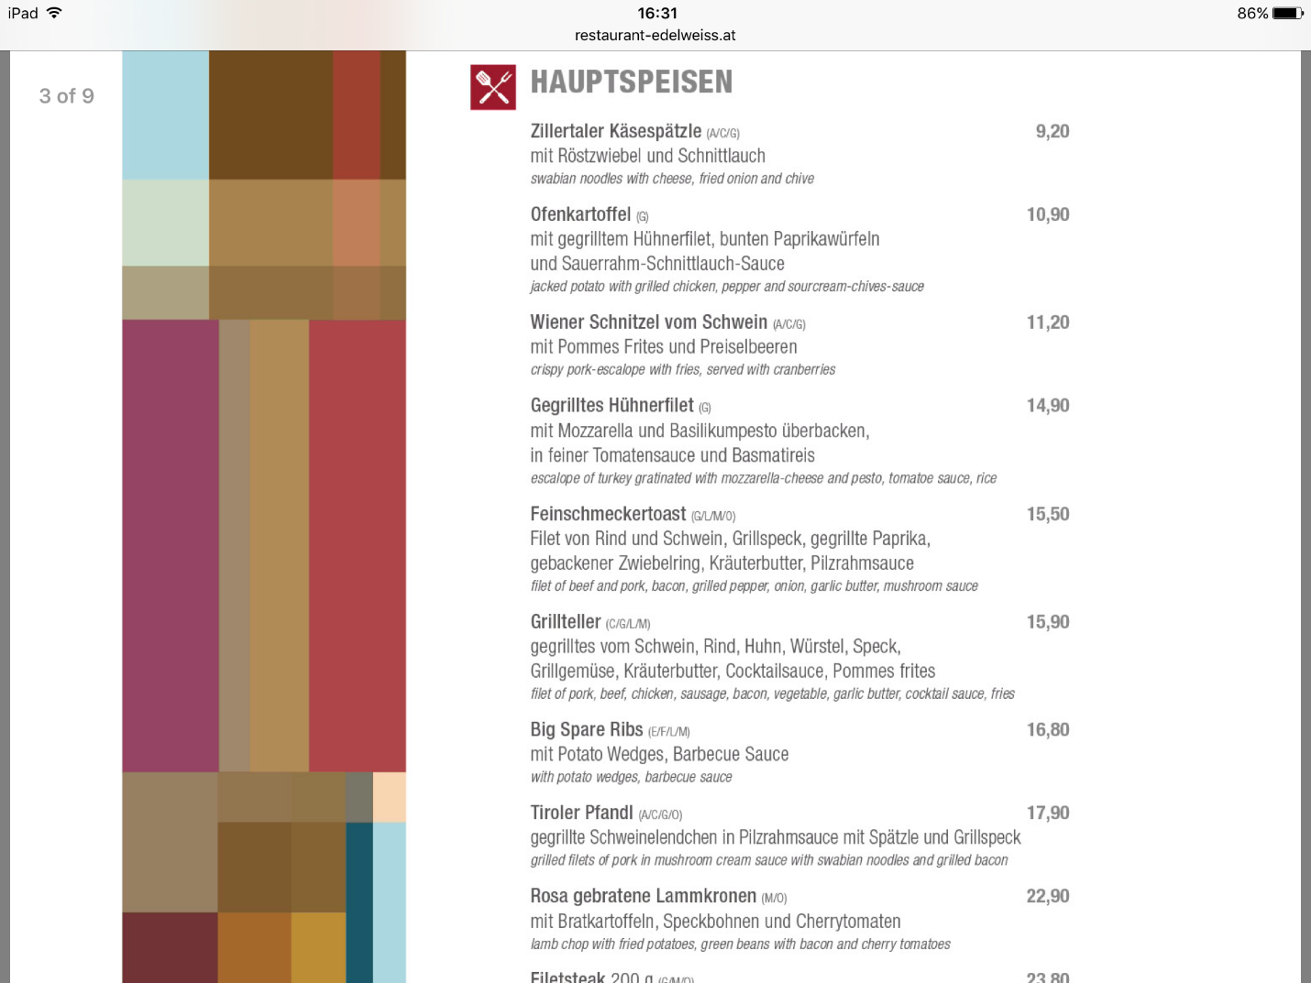
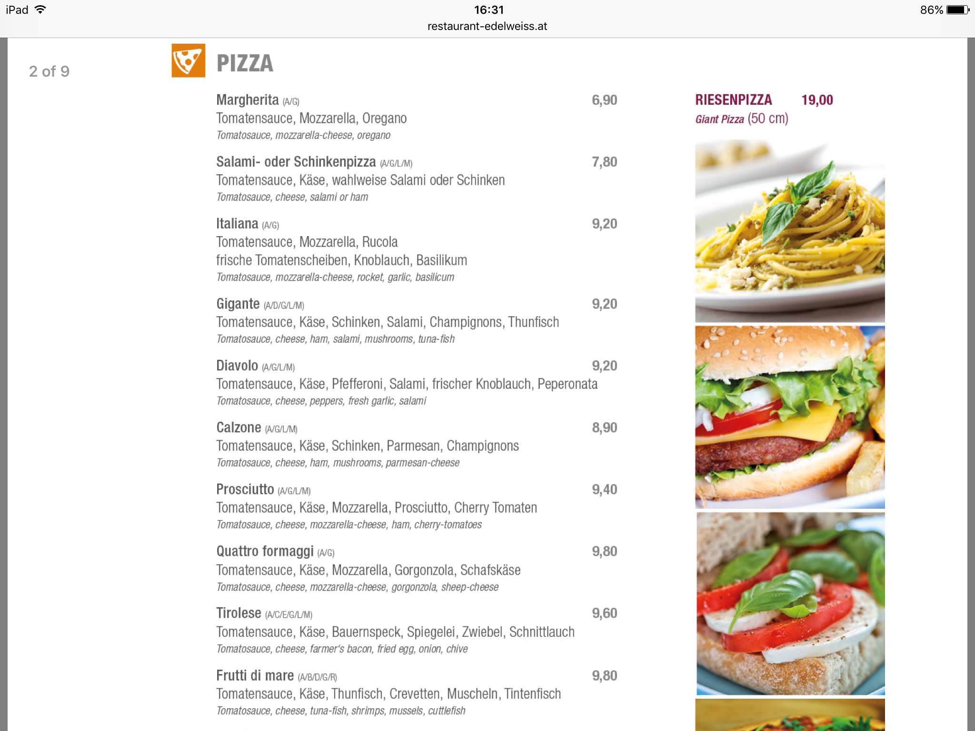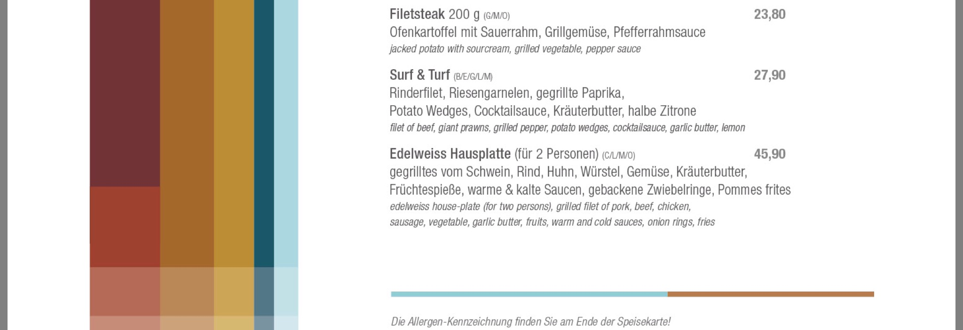

The methods of payment

- Credit Card: allows you to borrow money from your bank to make your purchases, whether you’re buying a burger or a flight ticket to Munich. As long as you pay back the money you borrowed within the “grace period” of 25-30 days, you don’t have to pay extra. If you don’t pay it back in that time period, you’ll have to pay interest — a percentage of the money you owe the bank — on top of what you borrowed.
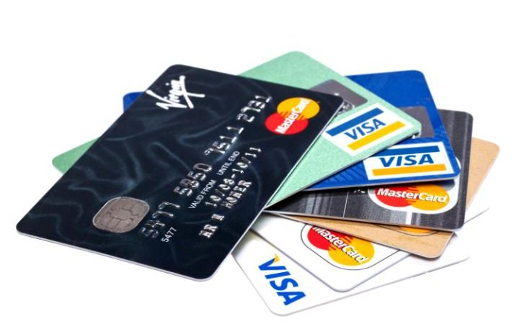
- Debit Card: uses money from a linked account for purchases. The money goes straight from the buyer’s account to the seller’s account at the point of purchase. It’s a safe and convenient alternative to using cash or cheques, and it works for in-person and online purchases. You can also use this card at automated teller machines, or ATMs, when you need to get cash, deposit checks, transfer between accounts or see bank account balances.
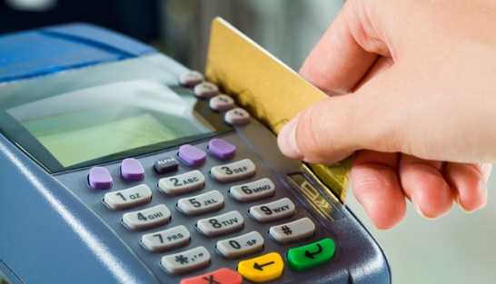
Summary of my Skiing Trip

Expenditure | Cost | Method of payment
Travel Insurance | €51.74 | Debit card
Flights | €317.92 | Credit card
Aircoach | €40 | Debit card
Airport Shuttle | €187 | Debit card
Hotel | €1190 | Credit card
Ski Equipment | €286 | Debit card
Skipass | €549 | Debit card
Lunch | €43.18 | Cash
Dinner | €147.77 | Debit card
Extras(souvenirs etc.) | €187.39 | -
TOTAL | €3000

