STUDENT
ENTERPRISE
PROGRAMME

The Business Report
Business Name: Sophie’s Little Candle Shop
Business Description: Home-made scented candles in jars and pots with sand and pebbles in the jar, and with decoration and seasonal themes
School Name: St Gerard’s School
County: Wicklow
School Address: Thornhill Rd, Oldconnaught, Bray, Co. Wicklow
Category (please tick) Junior Intermediate Senior
Student Name: Sophie O’Riordan
Commencement of Trading Declaration:
I hereby confirm that the above named student enterprise did not begin trading before September of the current academic year.
Mobile Number 085 277 6006
Teacher’s Name

Contents

Executive Summary

Product: The products I have designed, created, and sold as my Mini Company are beautiful and original scented candles in decorated jars with seasonal themes. The special element of these candles is that there is a layer of pebbles and sand carefully placed in the jars, and the scented candle lies comfortably above the sand. I choose this idea since candles are lovely presents for friends and family of all ages. In addition, I believe people like to have a bit of nature in their homes and the sand accompanying the candle in the jar, give a unique and natural feel to the product.

Design: The design for my product is quite simple, but very effective. I gathered jars of various shapes and sizes to create a varied and interesting selection of products for my customers. I believe amongst the selection of candles, there is at least one design that appeals to everyone. A quarter of the candles I sold were handmade by myself. I bought a quality candle-making set, and used many different scents while creating the candles. I also used various types of sand such as course sand, fine sand, pebbles…etc. No two candles are the same, each product is original with a unique design. I purchased different types and colours of ribbons and materials to decorate my product. Furthermore, I designed my logo and business cards from scratch using a website called ‘GraphicSprings’ which provides you with the necessary tools to design a logo.

Packaging: The customer can get their candles packaged at their request for free, and they may choose the colour of the tissue paper and ribbon. The packaging for my product consisted of colourful tissue paper being artistically wrapped around the purchased candle, and tied together at the top with a ribbon and snow-flake shaped peg. I then placed the wrapped-up candle into a paper bag. I bought the tissue paper, ribbon, and pegs at an art store.

Skills: Throughout the course of my project I learned many valuable skills such as project management, bookkeeping, marketing, and promotion skills, making candles and market research. I improved some skills such as accounting, craft skills, presentation skills and IT skills. One of the most important skills that I used very often during my Mini Company project was being creative. To design the candles, business cards, logo, posters as well as make ad decorate the candles I had to brainstorm and be very creative.

Promotion: I employed many different mediums to promote and advertise my product. I posted pictures and information about my Mini Company on my blog ( http://sophieoriordantyblog.weebly.com/ ), I also posted pictures on my social media accounts to make people aware of my Mini Company and hopefully spark interest and attract potential customers, I attached my logo to every one of my products so people could distinguish my product from others, I handed out business cards to people who passed my stall at various markets. When a person bought a candle, I placed a business card in the bag so they could remember me and my mini company and tell their friends about it. I created posters, including key information and pictures, to promote my product around the markets where I sold my product and around my school.

Risk: There isn’t much risk involved in my mini company as I did not require to invest a very large amount of money into the company to allow it to function. I did need to gather a respectable sum of money to start my mini company. I risk I took was having a silent partner who invested into my company. After I sold my candles I had to make a profit in order to pay the silent partner. Another risk I took was putting my personal email on my business cards. I now know I should have created a business email, which would be dedicated solely to my mini company. Since I gave out the business cards to random people at the markets, an individual could have potentially attempted at hacking into my email. Thankfully this did not happen, but I should be more careful in the future!

Difficulties: It is normal for companies to face a number of difficulties while creating, promoting, selling their product, financing their company or organising their company. Since I run this mini company on my own I was faced with the difficulty of managing the entire project on my own and having all the necessary skills to run a company. I also had a little difficulty finding time to make the candles, as I lead a busy social, sports and academic life. Therefore, I eventually decided to make a quarter of the candles from scratch and purchase the rest of the candles I required, to save time. I difficulty I faced was that I was keen on selling my product at Killruddery farmers market, as my product is made using natural products, it is original and a local business. Unfortunately, Killruddery had no more available spaces, so were unable to accept my offer. I solved this issue by securing a space at Greystones Holy Rosary Church Market, at Blackrock Market and at St Gerard’s Christmas Bazaar.

Profit: My Mini company has been very successful over the last three months, with a profit of €177.79. I sold a total of 65 candles over the course of October to December. I gave €90 of my profit to various charities including the Peter McVerry Trust. With the remaining profit, I repaid my silent partner and bought new materials to make more products and to promote my Mini Company.

Business Structure

I have decided to create and run ‘Sophie’s Little Candle Shop’ on my own. Although it is easier to work in a group to distribute the work load, to generate more ideas and to have a broader selection of skills available to the company I made the decision of creating a mini company on my own as I believe it would work more efficiently. I made the right decision as I notice with other Mini Companies, that are made up of large groups, that the work efficiency is lower, as they must first consult the other members more making a decision, they must rely on other people to do their jobs correctly and on-time, and they must all agree on something before they can go through with the ides or suggestion. I have the necessary skills and resources to create my own Mini Company so taking the above points in mind, I formed ‘Sophie’s Little Candle Shop’ on my own.

Working on my own has been a fantastic experience, and I have learned many new and valuable skills in the meantime. I have employed a part-time marketing manager who helps me sell and promote my product at markets. In addition, when I sold my candles at Blackrock Market, two volunteers helped me sell my products and they helped my set up the stall and present my product to in an eye-catching ad attractive way.

The Key Personnel in ‘Sophie’s Little Candle Shop’

Sophie O’Riordan:

Chief Executive Officer (CEO) - My primary function is to be the driving force behind the company; to make things happen, put together the resources to support the company and take the product to the market place.

Operations manager – I am the leader of the project and have the overall responsibility for the financial success of the business. I will set in motion the vision, strategic plan, and goals for the business. I must keep an overview of the project and ensure the company is performing to its full potential.

Financial Manager: A financial manager is a person who takes care of all the important financial functions of an organization. I should maintain a far sightedness in order to ensure that the funds are utilized in the most efficient manner. My actions directly affect the profitability, growth, and goodwill of the firm. I must raise the funds to finance the company, I have to keep a record of all the financial transactions that take place in the company, I must spend the available money wisely and effectively and I must create accounts for the company, to keep an eye on where the money has gone and where it has come from.

Design and Product Development: I am in charge of continuously updating and improving the product, based on customer reviews, experiments and surveys. I am responsible for designing and creating a quality product that matches the product description, and creating a product that function properly.

Administration: Part of my job is to email markets and school around Ireland to ask for permission to sell my product. I must research markets and school that could potentially accept my offer to sell at their premises. Once I have discovered a method to contact them, I must write polite and clear emails outlining exactly who I am, what my product is and finally for permission to sell my product, or I must phone people to discuss selling my product. I must make sure I am constantly chcking my email, social media amd phone to ensure I do not miss any opportunities to sell my candles.

Emma Beashel:

Part-time Marketing Manager: Emma Beashel is also in Transition Year and has the necessary skills to promote and sell products. She has studied Business studies for Junior Cert so she understands the marketing mix and is familiar with the most effective methods of advertising. She also has good communication skills. Although Emma is not in my mini company, she has volunteered to help me with the promoting and selling of my product. Her role is to help with the set-up of the stall at markets, to present the product in the most striking an eye-catching way, to sell the product to customers, to convince people to buy the product and to help with the packaging of the product.

Claire Schuijt and Ella McGill:

Volunteers: Claire Schuijt, from St Columba’s and Ella McGill from Mount Temple Secondary school, both kindly volunteered to help me with selling my product at Blackrock Market. They helped make posters to hang up around Blackrock Market, they carried the candles, equipments and other materials I required to set up my stall at the market, they advised me on how to present my candles and they distributed business cards to passing people. With their help I managed to sell many candles at Blackrock market and promote my product.

The Product

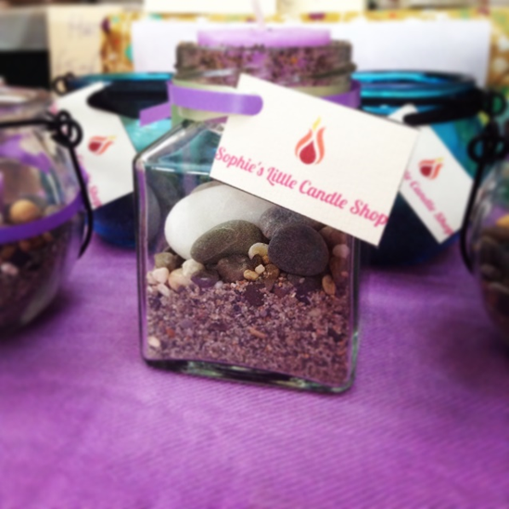

Product description and Innovation
‘Sophie’s Little Candle Shop’ is specialized in selling hand-made and unique candles in jars. The key element of this product is that, unlike any other candle you can purchase in a shop, it has a layer of natural sand and pebbles carefully scattered at the bottom of the jar. It is not artificial sand, but real and natural Irish sand. It is a local product from Greystones, which uses the sea as its core.

The candles come in a variety of colours and scents to ensure every customer finds a candle that is just right for them! When I was selling my candles in the months of October and November I focused on scents such as lavender, elderflower, and vanilla. Once I sold my products in December, I embraced the Christmas theme by producing candles with scents such as cinnamon, mullberry and cranberry.

My product also looks as good as it smells. As seen in the pictures above, each candle is fitted with my mini company logo. A colourful ribbon, I made sure the ribbon matched the colour of the candle, is attached around the jar. During the Christmas season, the ribbon would have Christmas wishes and greeting artistically written across it, or have seasonal patterns decorate the ribbon.
With a few of my candles I glued colourful tissue paper around the jar, so that when the candle is lighted the colour of the tissue paper is beautifully reflected on a surface.

The Idea

After lots of brainstorming, collaborating and researching I finally decided what I would do for my mini company. I first wrote down on a piece of paper all the things, services and products that I personally would like to purchase. By doing this I got a lot of inspiration as I was motivated to create a company that I would enjoy developing. Something else that gave me some inspiration was a big school ‘festival’ called Foot Fest. At my old school in Belgium we would have an annual big market and celebrations. Each section (meaning nationality of people) would have their own stands, selling products from their countries and also providing services. Thinking about all the products and services each section sold opened my eyes to all the possibilities there are for my Mini Company!

I finally settled on selling candles as I adore candles and believe many people would buy this product, especially around Christmas time. Also, they would be feasible to produce. One day as I was walking along the beach I had a sort of epiphany and saw countless possibilities to use the sand for my product!

Individual and Unique Product
The aspects of this product that make it stand out are:
- Hand-made candles
- Different shapes and sizes of jars
- Sand and pebbles
- Ribbon with special patterns and colours
- Logo
- Business cards
- Presentation
- Natural, Local products

The fact that a number of the candles are home-made with natural products and scents boost the originality of this product.
The jars come in interesting shapes and sizes. Some jars have narrow tops ad have candles carefully balancing on the top, others have a wide bases and have candles surrounded by sand and large pebbles at the bottom. As I mentioned before, no two candles are the same. Sophie’s Little Candle Shop has the unlimited ability to surprise the customers with the designs, colours and shapes of the product.
The use of the local sand and pebbles in small qualities celebrate the beauty of Ireland in things as small a sand grain with its individual shape and colour and wonderful scent of fresh air and sea water.
The types ribbon used in my mini company are rare and special as I purchased them from a small quaint shop in the Netherlands. I was impressed by the detail of the patterns and vibrance of the colour of these ribbons that I bought some while visiting my family in The Netherlands.
I personally designed the logo and business cards on the website ‘GraphicSprings’. It is beyond vital for a company, however small, to distinguish themelves from competitors by creating their own logo. That is exactly what I did. Each candle has the logo attached to it, which make them look very professional and sets them apart from other cndle companies.
The presentation of my product plays a big part in the origibaloty of my mini company. I used colourful tablecloths to catch people’s attention. In the months of October and Nivember I preferred to use purple and blue tablecloths, and in December I utilised green and red tablecloths. I hung fairy lights across the front of the table to create a warm, cosy and friendly feel to my produt. In addition I placed fresh ivy along the table and put posters around my stall to broadcast to the world who I am and what my product is!
Most importantly, this a natural and local product that celebrates nature and the beauty of Ireland. It is environmentally friendly and promotes the arts and crafts.

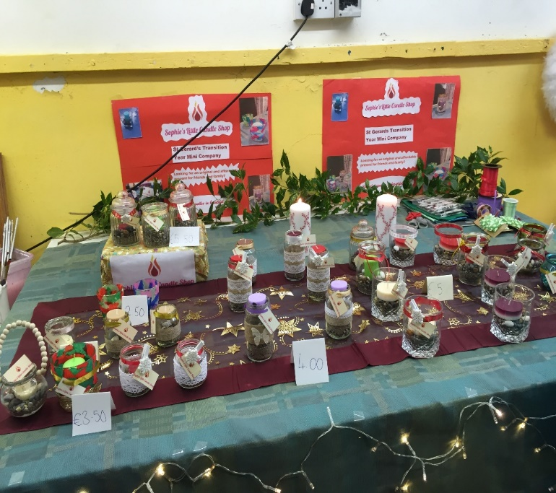
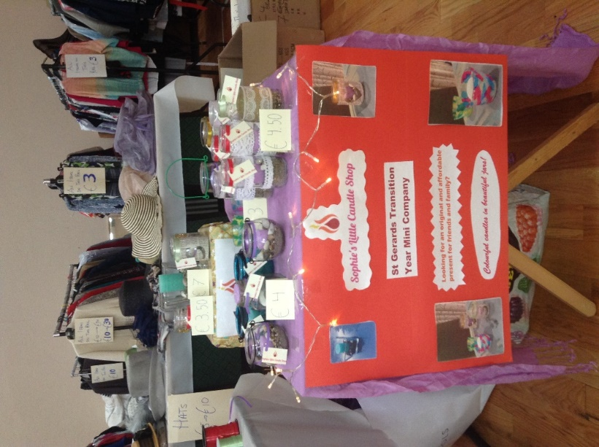

Difficulties

I faced a few difficulties while producing my candles. The most prominent one was trying to master a design of a candlein a jar than I had invented myself!
One of the designs I wanted to employ for my product was quite difficult to master and required lots of experimenting before it actually worked, and it was suitable to selling. I received a large quantity of narrow jars with narrow tops. I could not simply place a candle on top of a layer of sand at the bottom of the jar, as I had been doing with all the other jars, since people would not be able to reach the candle through the top to light it. You can’t sell candles that people can’t light. So, I thought, since the top is so narrow I could balance a candle in it. However, this proved harder than expected as the candle was too fragile at the top, and the slightest movement would cause it to fall to the bottom of the jar. Eventually \i found a solution; I put a layer of PVA glu around the inner rim of the top. Then I sprinkled fine sand over the glue. After letting it dry for a couple a minutes I placed a tealight, without the metal cup surrounding it as it seems easier for the wax to firmly attach itself to the glue and sand, than the metal. I left the metal at the very bottom of the tealight, so that it wouldn’t leak on to the jar. After days of trying I finally found a solution and would make over 30 of these candles, and they would be my best-selling design.

SWOT Analysis

Strengths
Weaknesses

- Time consuming to produce
- Seasonal (more winter than summer time)

- It is local and natural
- A lovely gift for all ages
- Budget friendly

Threats
Opportunities

- Sell nationally as a product from Wicklow
- Contracts for big events (weddings, party, funeral)
- Competitors may copy concept or develop variations
- Difficult to sell in large quanities (hand-made)
- Difficult to transport

Marketing/Promotion

Market Research
I mainly undertook Primary Market Research, by creating an online questionnaire for people to answer. I used the website Survey Monkey, because this website automatically puts the results into charts and percentages. The results proved very interesting and useful in the planning, manufacture and promotion of my product. I learned that people didn’t necessarily want an organic, or natural products, but people did like the idea of having personalized products. I discovered that most people would buy relatives and friends presents at either Christmas or Birthdays, so I decided to create candles that suit these events.
The online questionnaire was completed by 25 people from the ages of 11 to 78.
Below are the results from my online survey: market research survey of fifty people results below

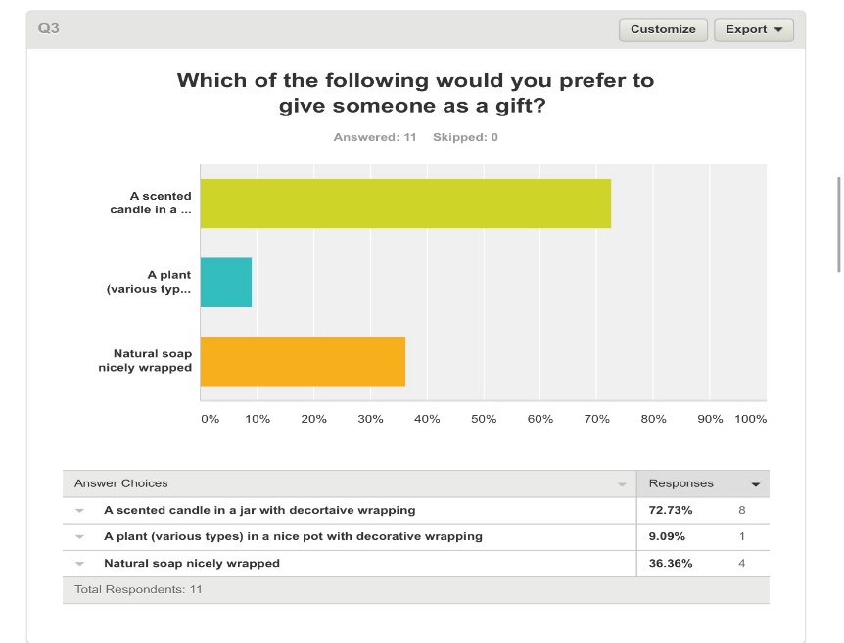
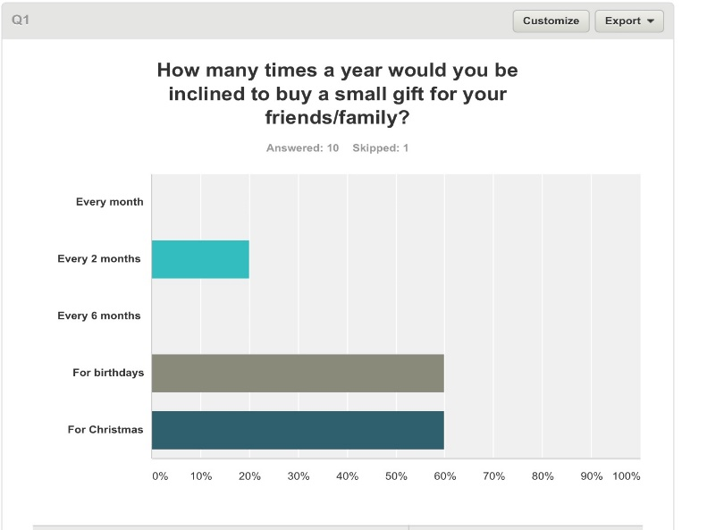

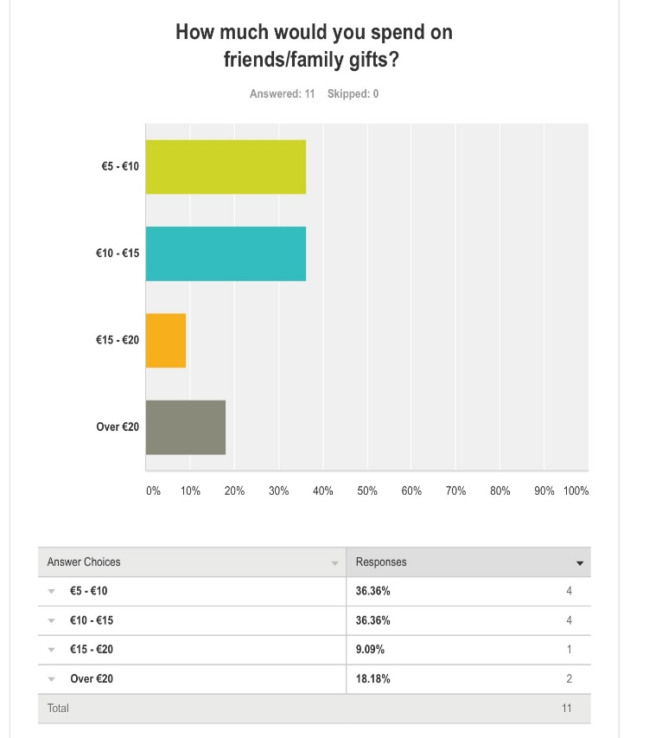
Market Research Results

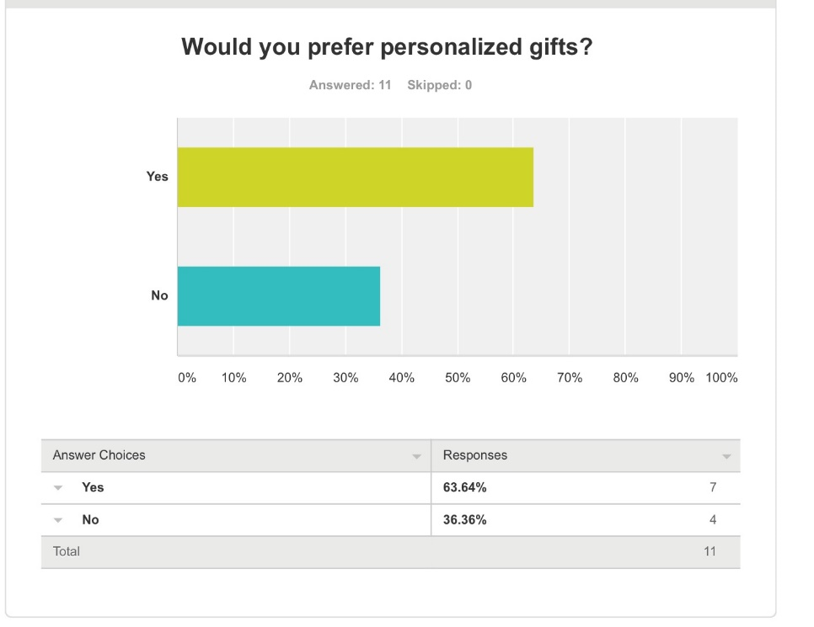
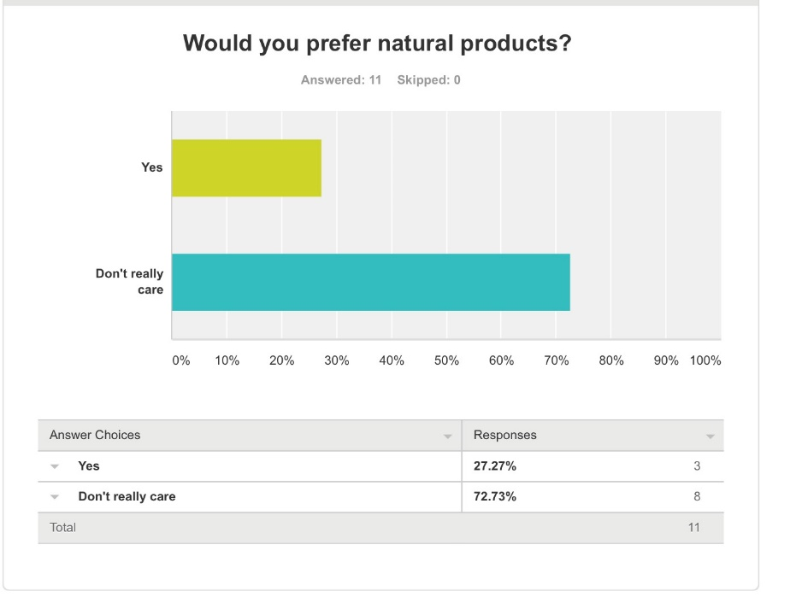
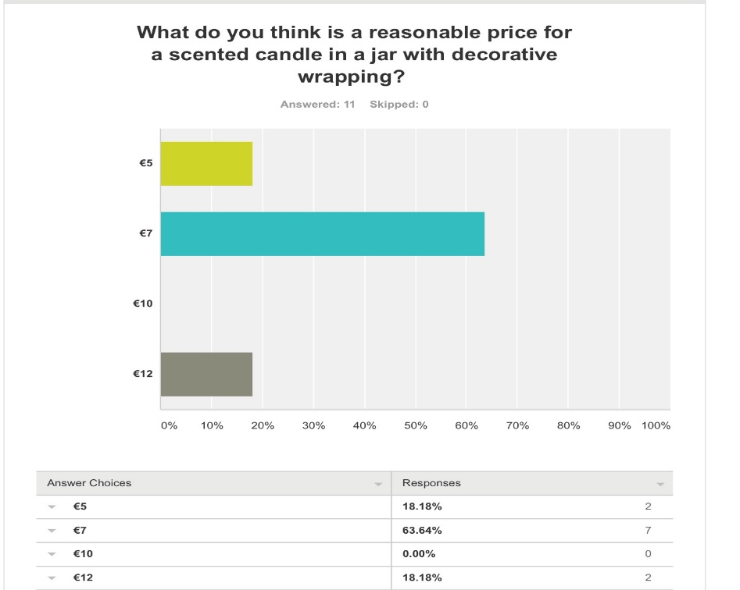

Marketing Mix

Product: Sophie’s Little Candle Shop provides customers with beautiful and original candles. The candles are aimed at people who like to decorate their hones and make the cosy, who prefer natural and local products over artificial products from foreign countries, who need to buy a gift or present for a birthday, Christmas, wedding…etc. My product has a large target market. It may appeal more to females than males but I observed the customers while selling my product, and approximately 40% of them were male. They have a simple but effective design, and are safe for use, but advised to keep out of reach from very young children when they are lit.

Price: The cost price for each candle is low, meaning it is easy for my mini company to make a profit. Though the candles look more expensive than they ae because of the level of effort and time that goes into making each one. I calculated that I make an 90% profit margin on each candle, which is very good! I have an advantage because my candles cost less than my competitors and I sell a scented candle in a jar with sand and pebbles as opposed to simply a scented candle. At Blackrock Market a person was selling scented candles for €8 to €12 a piece. I sold my candles at €3 to €6 a piece, and although the other candles were bigger I made more sales since I presented mine effectively and decorated the jars with ribbon. Once I realized at Greystones Holy Rosary Church Fair, that customers were willing to pay more than €5 for a candle, I decided to increase th prices when I sold my product at Blackrock Market, and it was a success because this tactical move increased my sales revenue.

Place: I decided to sell my product at local markets and school, as I believe the type of people who attend these markets would be my target market. I sold my candles at Greystones Holy Rosary Church as many people were curious to see my product after mass, and were interested in the fact that is was produced locally in Greystones. I made many sales at Blackrock Market, I sent the manager of Blackrock market a polite email with a synopsis of my Mini company and with pictures. I received a reply hours later, accepting me to set up a stall there. I sold my candles on Sunday, as many people would be out with their families and would be keen to purchase quaint and unique products. I gave out many business cards to passing people, with my email address. If people needed candles for a wedding, funeral, party or just for a gift they could sent me an order by email, and they could request the design of the candles and quanitity. I would then produce the candles before the deadline, and the customer could pick up they order at the market I would be located at that day. I also sold at the annual Christmas bazaar at my school St Gerard’s. My Business teacher sent an email to all the staff in St Gerard’s about my Mini Company, so on the night of the Bazaar everybody knew about my product, and therefore I sold out!
Promotion: To promote my product, I have used various methods. I made posters outlining my product, the cost and the place and time where they can be purchased. On my blog (http://sophieoriordantyblog.weebly.com/) , I have posted an announcement that people can order candles beforehand and then collect their purchase at the Christmas Bazaar at our school, on the 14th of December. I have created simple business cards that I put in customers’ bags once they have purchased my product, and give to people passing by my table. Below is a copy of my business card:
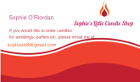

I have also used social media to promote my business. I have posted a picture of my mini company products on Instagram, therefore many people I know will be aware and maybe interested in my products! I received 95 likes on Instagram and due to this I have received orders from a few mothers of people in my school, who are interested in buying my candles to give to colleagues as Christmas presents. On all my products, I have put a label with my logo, so other people might recognise my company and consider buying one themselves too. I have made a poster presenting my product and myself, as I believe people prefer the information presented to them, rather than asking questions.

Packaging: My product does not necessarily require packaging, as the product itself is decorated and some jars have a handle, so therefore they are practical to carry. I took a lot of care and time deciding which colours to use for each candle, I made sure the ribbon ad the candle were the same colour and that the type sand and pebbels suited the theme of each candle. In December I added pegs with snowflakes to the product, to nhance the winter season It is vital that you present your poduct properly to the public, as in a busy market you need to be able to catch, and hold, people’ attention long nough for them to purchase the product. I provided a free service of packaging the produvt at the customer’s request. I made sure to keep a free space on my table to wrap the candle carefully in tissue paper and tie it at the top with a ribbon and peg. The children enjoyed the luxury of picking out the colour of the tissue paper and the ribbon for their candle. This element attracted families, as once they see one family purchase a candle they consider purchasing one themselves. I also provide free bags with my logo to the customer to carry their candle.

Finance

To start up my candle company, my silent partner invested €50 in September, so I could purchase the necessary goods and equipment to create my products. As you can see below in the table which clearly outlines my costs, that my cost =s for producing a candle are generally quite low. Therefore, I did not require to invest a large sum of money into my company in order for it to operate successfully. My silent partner further invested €15 in October and €10 in November. I also used the profits that I made from selling my product to finance my company.
I have managed to successfully run a company, with a large profit made on sales.

Pricing Strategy and Cost of Goods
I produced a range of different candles, which all cost different amounts to make. In addition, some candles took more time, effort, and patience to make therefore they cost more. I added all my costs together to discover the total cost of producing a candle. Then I decided on a reasonable price for my product, putting myself in the shoes of the consumer and speculating how much I would pay for a candle. Furthermore, I asked a number of other people to honestly tell me how much they would pay for a candle, and to give me the reasons why. Eventually I started to increase my prices, thankfully instead of decreasing prices, as sales were going so well. Below is a breakdown of the costs of producing a candle, and the price per unit.

Cost Candle type 1:

Costs | €
Jar | 1
Candle | 0.60
Packaging | 0.10
Business Card | 0.20
Logo | 0.10
Peg | 0.09
Total | €2.09

Cost Candle type 2:

Costs | €
Jar | 0.60
Candle | 0.10
Packaging | 0.10
Business Card | 0.20
Logo | 0.10
Peg | 0.09
Total | €1.19

As explained above, it costs approximately €1 to €2.50 to create and package a candle. I wanted to make sure that I would sell a lot of candles in the first month of sales, therefore I cautisiouly priced my candles at a low price to attract customers. Firstly, a candle cost between €2 and €4.50. As the orders and sales increased, I decided to increase the prices as I saw an opportunity to make an even larger profit. A candle then cost between €3 and €6.
I also made some deals with customers who wanted to buy large quanities of my product. One lady was hosting a party at her house, and bought all the remaining candles I had, about 15 candles to decorate her house. The candles all had different prices, so she said she could pay €35 for the lot. I quickly calculated in my mind if I was making a loss with this offer, and if it was worth it. I decided to agree to the deal, an neatly wrapped all the candles for the lady. This happen another couple of times, and each time I almost sold out after the deal!

Cash-Flow Forecast

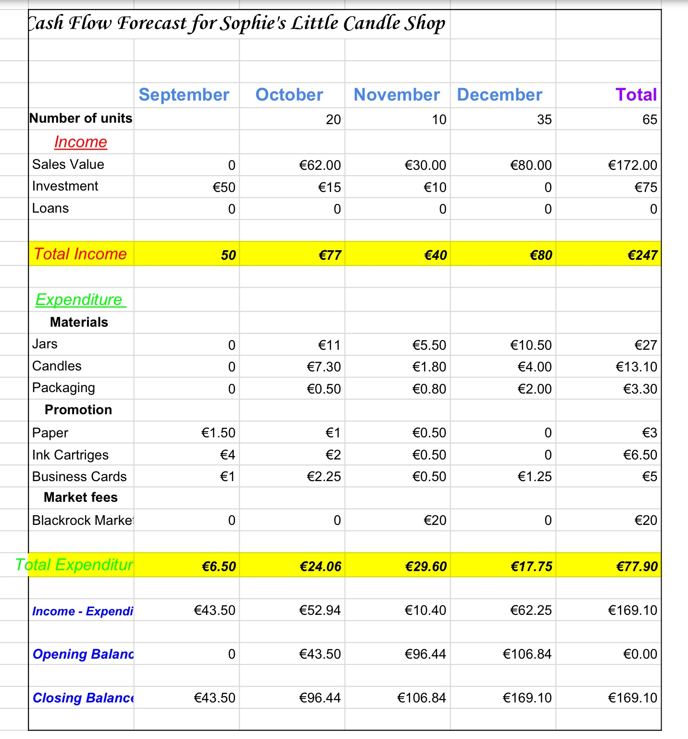

Income and Expenditure Account

Details | € | €
Income
Sales | 180.10
Investment | 75
Total Income | 255.10
Expenditure
Jars | 26.31
Candles | 13.30
Packaging | 3.20
Paper | 3
Ink Cartriges | 6.50
Business Cards | 5
Blackrock Market Fee | 20
Total Expenditure | 77.31
Income - Expenditure |  | 177.79
Net Profit |  | 177.79

My Net Profit is €8.69 larger than I had forecasted, since I managed to increase the prices of my products and because I reduced my costs a little. Creating a cash-flow forecast for my mini company was beyond useful, as it provided me with a goal I wanted to reach for each month. It also ensured I did not purchase materials and equipment beyond my forecasted amount.

Sales

- I sold 22 candles in October, which is 34.375% of my total sales.
- I sold 6 candles in November, which is 9.375% of my total sales.
- I sold 36 candles in December, which is 56.25% of my total sales.

Profit Margin

Formula = Profit divided by sales, times 100.
Profit = Sales – Cost

Profit Candle 1: €5.50 – €2.09 = €3.41
Profit Margin: €3.41 divided by €5.50 times 100 = 62%

Profit Candle 2: €4.50 - €1.19 = €3.31
Profit Margin: €3.31 divided by €4.50 times 100 = 74%

The average profit margin for a candle is 68%.

My Product
I have decided to sell scented candles in jars and pots, with decoration and seasonal themes. I choose this idea since I think candles are lovely presents for friends and family of all ages, and this product was the most popular in my online survey – details below. As I enjoy making crafts, I could use this skill to decorate the candles and present them to a sufficiently high standard. I have created many different sizes of candles in various jars and pots. I hope my company is original and catch’s people’s attention. I am selling my product at a series of different venues, from local markets to school markets.
My products will cost between €2.50 and €6; since almost every candle is unique it would not be fair to charge the same price for all of them. I have bought some of the jars and received some of them too. I have hand-made a dozen candles and bought the rest. The scents I am selling are vanilla, lavender, cinnamon, mulberry and cranberry. In addition, I use ribbon, paper, ink, tissue paper and sand/stones in the manufacture of my product. When I sell my products, the customer gets their candle wrapped in their choice of coloured tissue paper and gets a free paper bag to place their candle in.

Blackrock Market

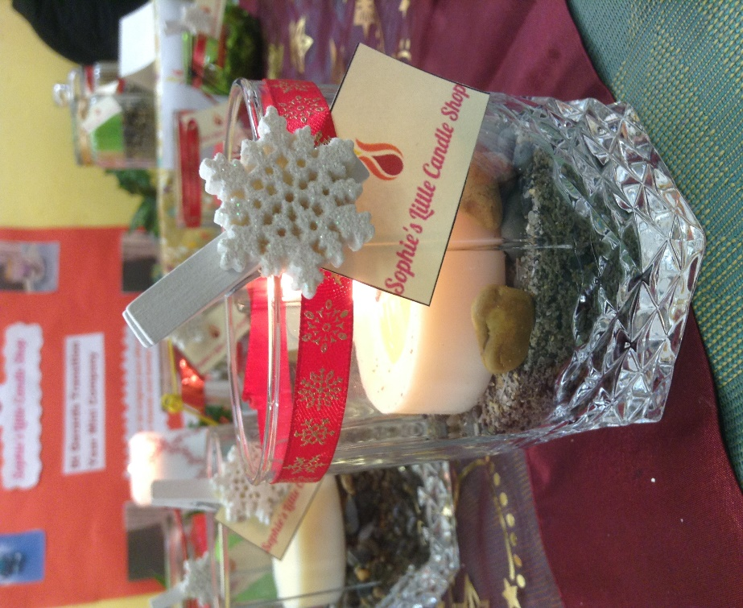
Greystones Holy Rosary Church Fair

Advertising
My target market are people of all ages who need to purchase presents for friends and family. Therefore, I sold my product at family events such as Greystones annual fair and Blackrock Market.
I received permission to place a few posters around the school about my mini company a few days before the Christmas Bazaar. I would like to do this to raise awareness so people will be more inclined to come to my table at the Bazaar.

Finance
To finance my mini company, I invested my own money. In addition, my mother invested €40 into my mini company. My source of income comes from the candles I sell. The costs of making the candles are generally quite low, and I only need to sell a few in order to make a profit. It cost €24.88 to produce 40 candles. My main costs are: the jars (the ones I bought), the candles which range from €0.25 to €0.70 per candles and the packaging which includes tissue paper, ribbon, paper, ink etc.
I have based the price of my products on the costs. The price of my candles ranges from €2.50 to €6.

Progress so far

I have already sold my product in the Greystones Holy Rosary Church at their annual charity Fair on Sunday 16th October. I sold out, and all together I made a profit of €42.50, this was more than I could've ever expected for my first time! I gave €30 to the charity this sale was for and kept the €12.50 to buy more materials for the next match of candles I will make. It was a great experience and helped me improve my product. I noticed that a lot of my customers particularly liked one type of candle I had made. Therefore, I made sure to create extra of this popular type of candle. Also, I received useful customer comments such as:
- They would like more Christmas themed candles
- My poster was very informative and eye-catching
- They are reasonable prices

On Sunday the 20th of November, I sold my product at Blackrock Market. Firstly, I emailed the Blackrock Market office in October, enquiring if it would be possible for me to sell my product there. I included a few pictures of my products, and explained that it was a Transition Year mini company. Immediately I received a positive response, and was given permission to sell there.

I made 40 candles all together, and spent some time planning the design of my table, as presentation is key. As I am running this mini company on my own, I thought it would be nice to have some friends help me sell my product! A friend from Killester and a friend that goes to St Columba’s came to help me out!

It was a very enjoyable and eye-opening experience. To rent a table at Blackrock Market I had to pay a reduced price of €20 (originally €30), as I am a student. In the end, I did not sell that many candles, I sold 12, as many people seemed to browse and look around as opposed to buying. I concluded that people didn’t go to Blackrock market to purposely buy gifts, but rather to look around. I had many people stop and look and comment on my candles, which was very nice!

My candles seem more suited to a craft fair or Christmas market, as that is where people are willing to buy original and hand-made gifts.
I look forward to selling my product at the school Christmas bazaar on the 14th of December.

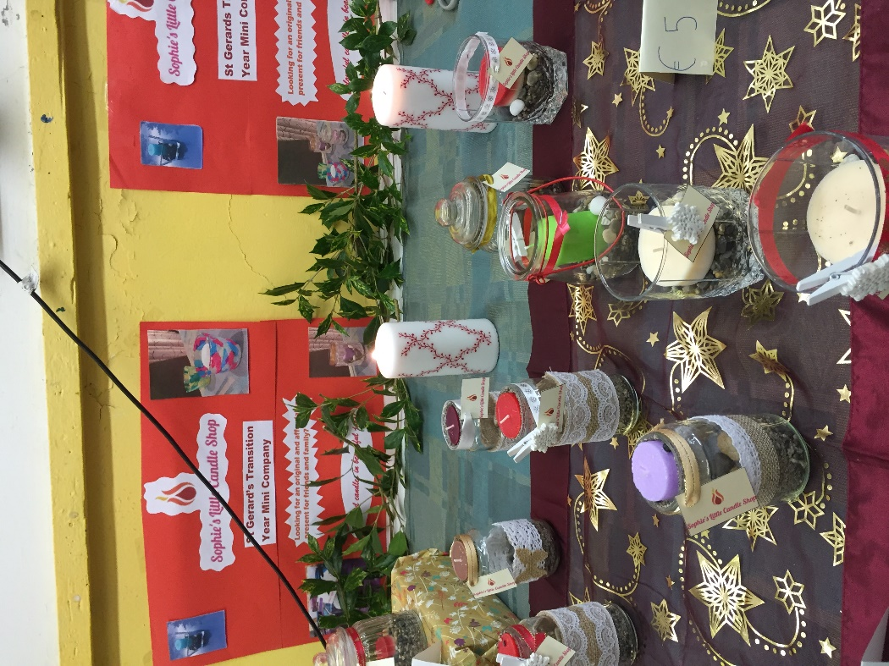
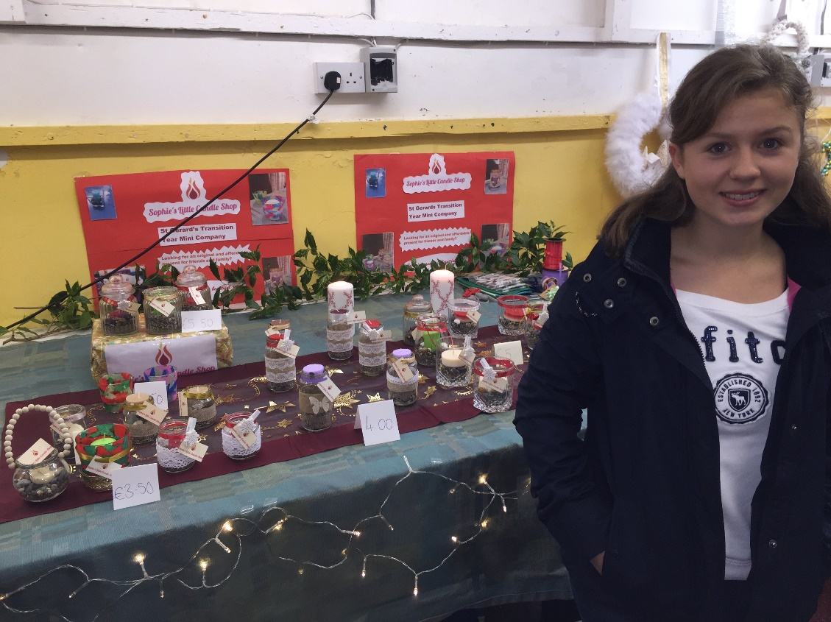
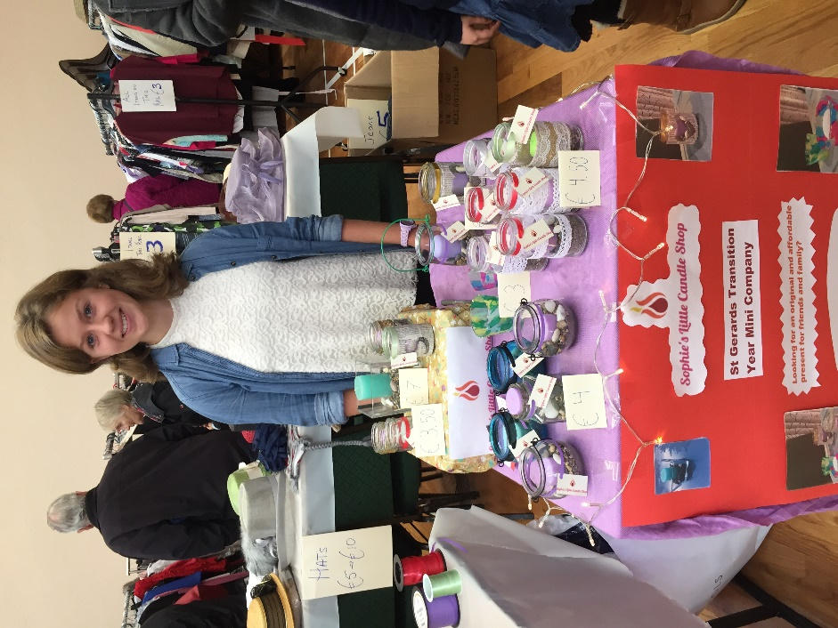

Mini Company Report

Sophie’s Little Candle Shop

By Sophie O’Riordan 4D

Business name: Sophie’s Little Candle Shop
Business Idea: Colourful, scented candles in jars filled with sand and stones. The jars are decorated with ribbon and other materials.
Logo:

Target Market: People buying presents for friends and family (Christmas presents).
Price: Ranging from €2.50 to €6.
Advertising: Posters, Business cards, Social media, logo on products.

