Mini Company Report

Sophie’s Little Candle Shop

By Sophie O’Riordan 4D

Business name: Sophie’s Little Candle Shop
Business Idea: Colourful, scented candles in jars filled with sand and stones. The jars are decorated with ribbon and other materials.
Logo:

Target Market: People buying presents for friends and family (Christmas presents).
Price: Ranging from €2.50 to €6.
Advertising: Posters, Business cards, Social media, logo on products.

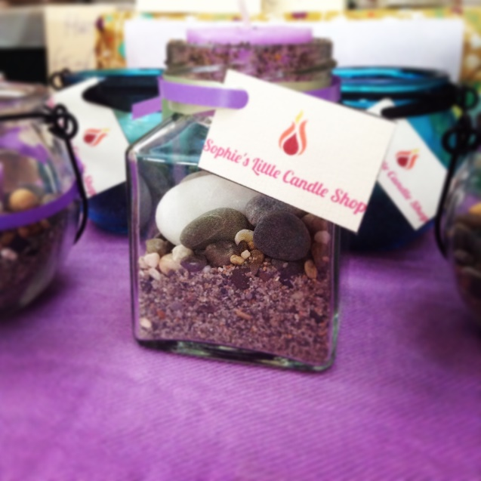

My Product
I have decided to sell scented candles in jars and pots, with decoration and seasonal themes. I choose this idea since I think candles are lovely presents for friends and family of all ages, and this product was the most popular in my online survey – details below. As I enjoy making crafts, I could use this skill to decorate the candles and present them to a sufficiently high standard. I have created many different sizes of candles in various jars and pots. I hope my company is original and catch’s people’s attention. I am selling my product at a series of different venues, from local markets to school markets.
My products will cost between €2.50 and €6; since almost every candle is unique it would not be fair to charge the same price for all of them. I have bought some of the jars and received some of them too. I have hand-made a dozen candles and bought the rest. The scents I am selling are vanilla, lavender, cinnamon, mulberry and cranberry. In addition, I use ribbon, paper, ink, tissue paper and sand/stones in the manufacture of my product. When I sell my products, the customer gets their candle wrapped in their choice of coloured tissue paper and gets a free paper bag to place their candle in.

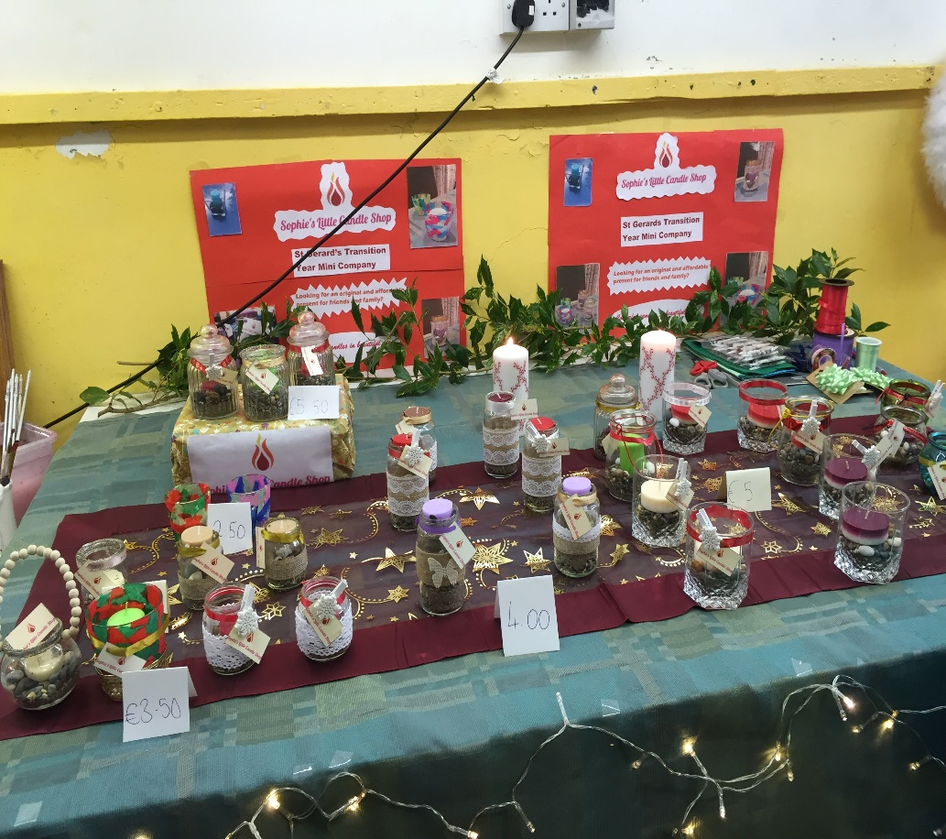
Blackrock Market

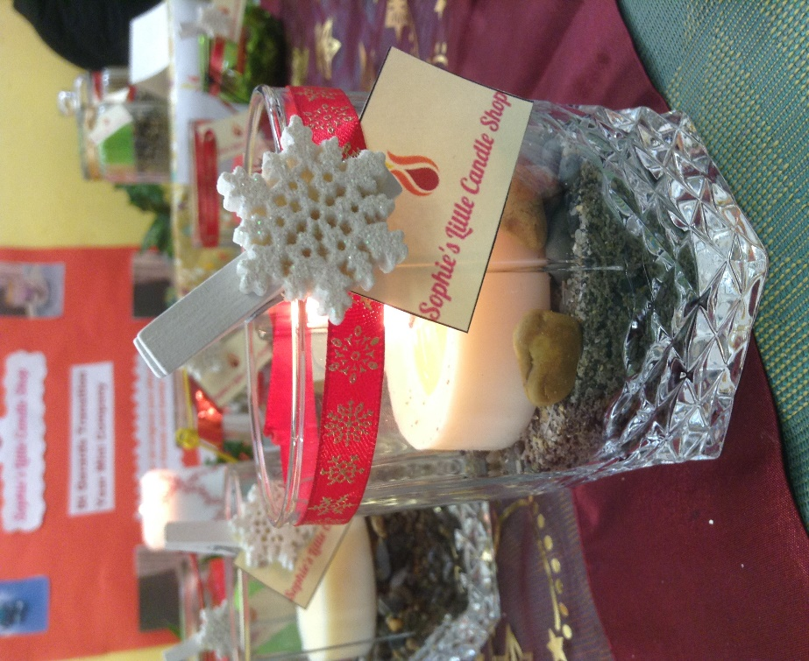
Greystones Holy Rosary Church Fair

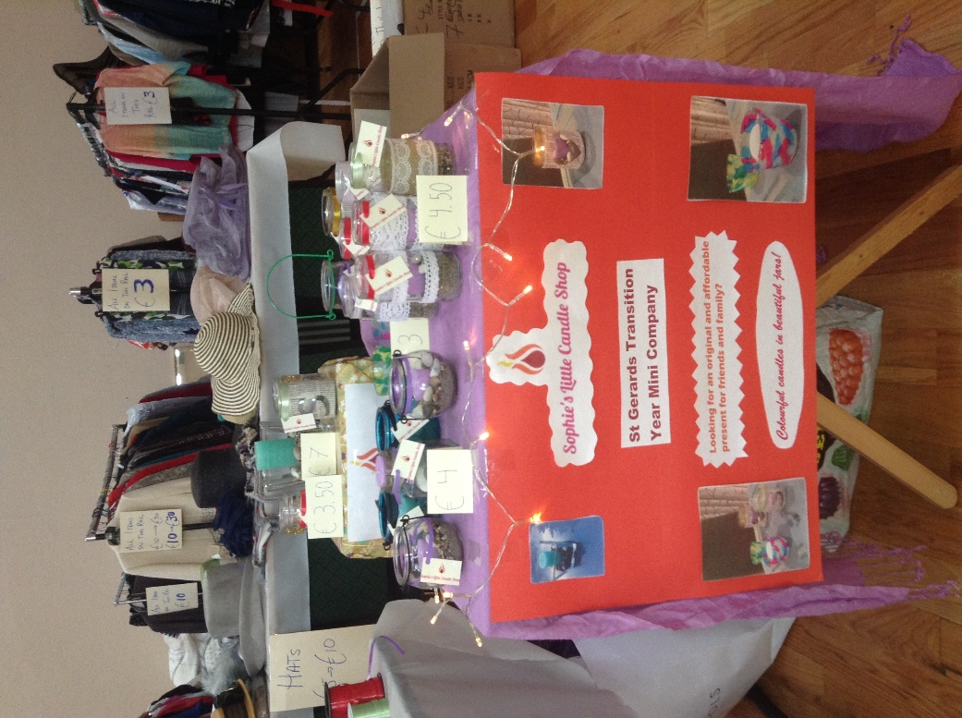

Market Research
I mainly undertook Primary Market Research, by creating an online questionnaire for people to answer. I used the website Survey Monkey, because this website automatically puts the results into charts and percentages. The results proved very interesting and useful in the planning, manufacture and promotion of my product. I learned that people didn’t necessarily want an organic, or natural products, but people did like the idea of having personalized products. I discovered that most people would buy relatives and friends presents at either Christmas or Birthdays, so I decided to create candles that suit these events. Below are the results from my online survey:

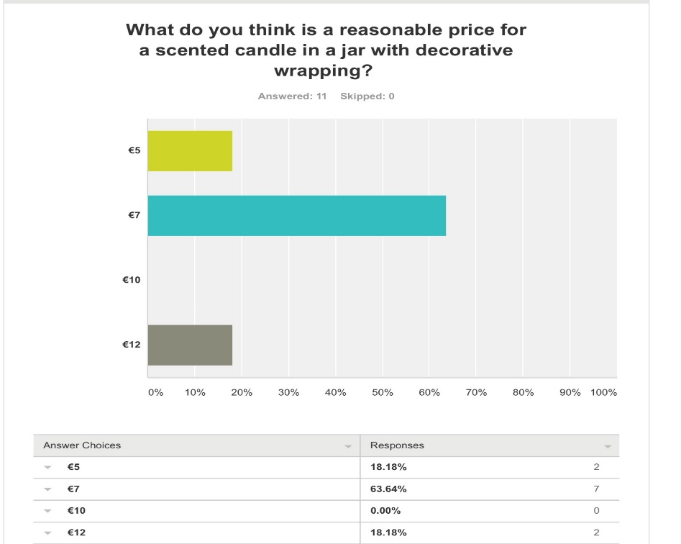
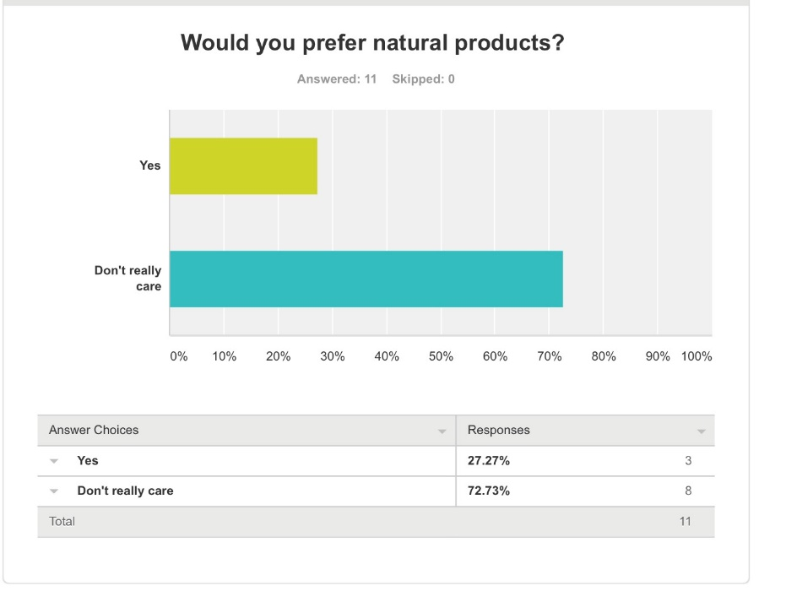
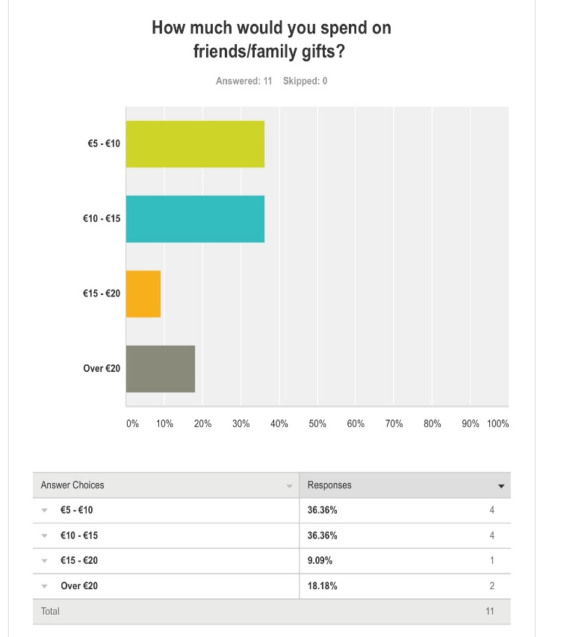
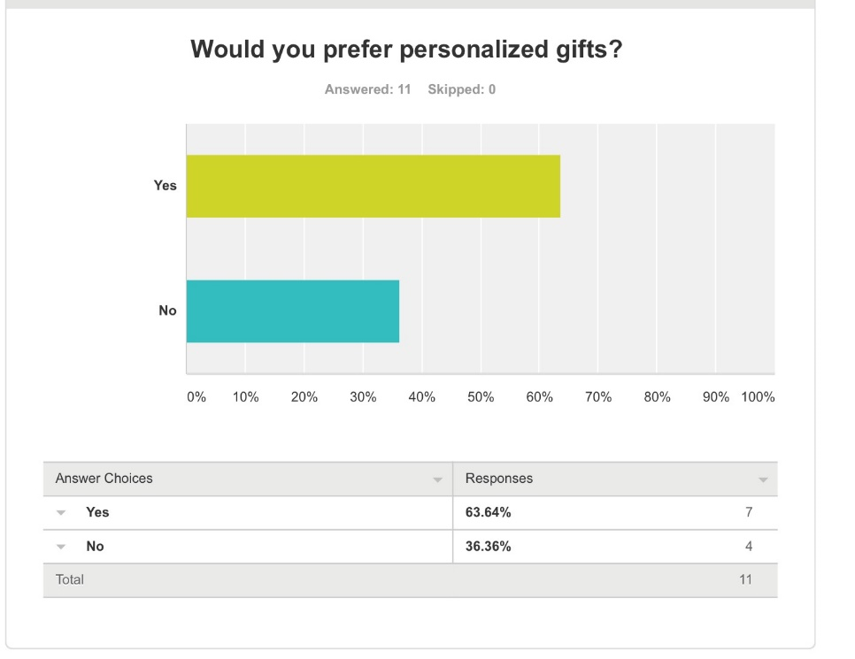
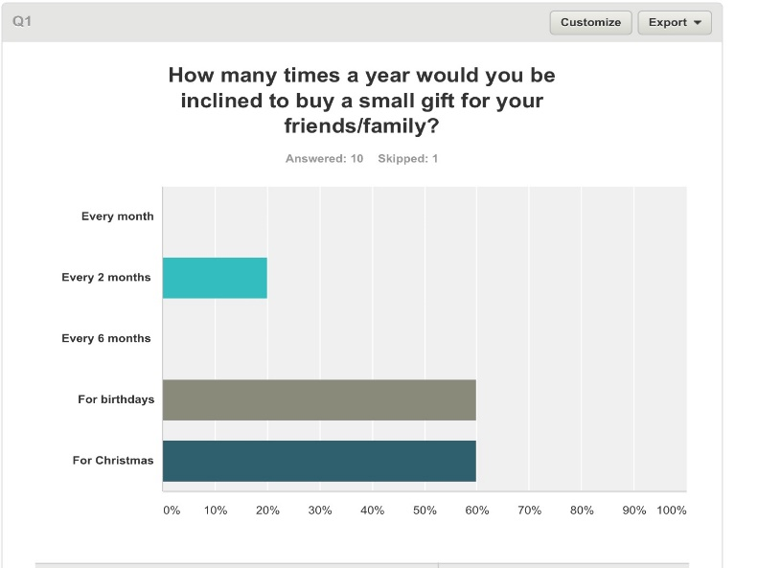
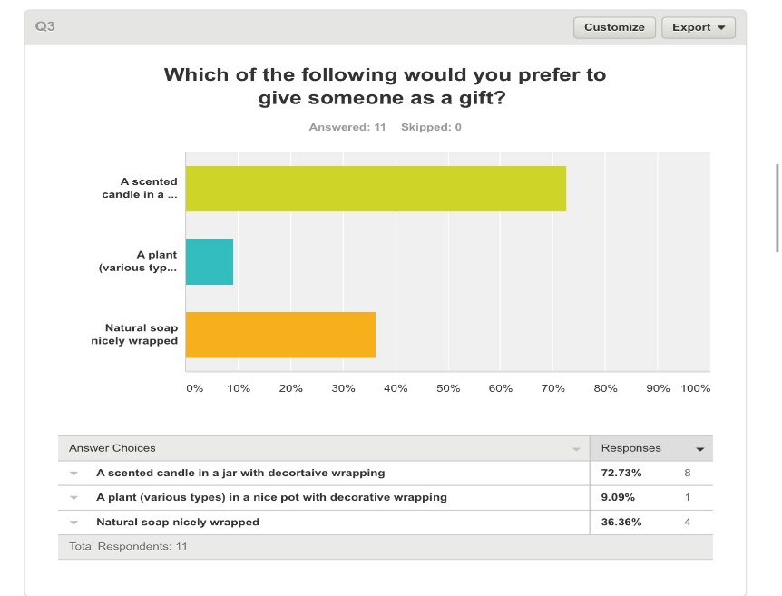
Advertising
My target market are people of all ages who need to purchase presents for friends and family. Therefore, I sold my product at family events such as Greystones annual fair and Blackrock Market. To promote my product, I have used various methods. I made posters outlining my product, the cost and the place and time where they can be purchased. On my blog, I have posted an announcement that people can order candles beforehand and then collect their purchase at the Christmas Bazaar at our school, on the 14th of December. I have created simple business cards that I put in customers’ bags once they have purchased my product, and give to people passing by my table. Below is a copy of my business card:
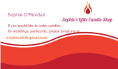

I have also used social media to promote my business. I have posted a picture of my mini company products on Instagram, therefore many people I know will be aware and maybe interested in my products! I have already received orders from a few mothers of my friends, who are interested in buying my candles to give to colleagues as Christmas presents. On all my products, I have put a label with my logo, so other people might recognise my company and consider buying one themselves too. I have made a poster presenting my product and myself, as I believe people prefer the information presented to them, rather than asking questions.
I received permission to place a few posters around the school about my mini company a few days before the Christmas Bazaar. I would like to do this to raise awareness so people will be more inclined to come to my table at the Bazaar.

Finance
To finance my mini company, I invested my own money. In addition, my mother invested €40 into my mini company. My source of income comes from the candles I sell. The costs of making the candles are generally quite low, and I only need to sell a few in order to make a profit. It cost €24.88 to produce 40 candles. My main costs are: the jars (the ones I bought), the candles which range from €0.25 to €0.70 per candles and the packaging which includes tissue paper, ribbon, paper, ink etc.
I have based the price of my products on the costs. The price of my candles ranges from €2.50 to €6.

Progress so far

I have already sold my product in the Greystones Holy Rosary Church at their annual charity Fair on Sunday 16th October. I sold out, and all together I made a profit of €42.50, this was more than I could've ever expected for my first time! I gave €30 to the charity this sale was for and kept the €12.50 to buy more materials for the next match of candles I will make. It was a great experience and helped me improve my product. I noticed that a lot of my customers particularly liked one type of candle I had made. Therefore, I made sure to create extra of this popular type of candle. Also, I received useful customer comments such as:
- They would like more Christmas themed candles
- My poster was very informative and eye-catching
- They are reasonable prices

On Sunday the 20th of November, I sold my product at Blackrock Market. Firstly, I emailed the Blackrock Market office in October, enquiring if it would be possible for me to sell my product there. I included a few pictures of my products, and explained that it was a Transition Year mini company. Immediately I received a positive response, and was given permission to sell there.

I made 40 candles all together, and spent some time planning the design of my table, as presentation is key. As I am running this mini company on my own, I thought it would be nice to have some friends help me sell my product! A friend from Killester and a friend that goes to St Columbas came to help me out!

It was a very enjoyable and eye-opening experience. To rent a table at Blackrock Market I had to pay a reduced price of €20 (originally €30), as I am a student. In the end, I did not sell that many candles, I sold 12, as many people seemed to browse and look around as opposed to buying. I concluded that people didn’t go to Blackrock market to purposely buy gifts, but rather to look around. I had many people stop and look and comment on my candles, which was very nice!

My candles seem more suited to a craft fair or Christmas market, as that is where people are willing to buy original and hand-made gifts.
I look forward to selling my product at the school Christmas bazaar on the 14th of December.

