Media Studies

Movie: Fantastic Beasts and Where to Find Them

Director: David Yates

Release Date: November 8th 2016

Main Characters: Newt Scamander (Eddie Redmayne)
Porpentina Goldstein (Katherine Waterston)
Percival Graves (Colin Farrell)
Credence (Ezra Miller)
Jacob Kowalski (Dan Fogler)

Genre: Fantasy/ Action
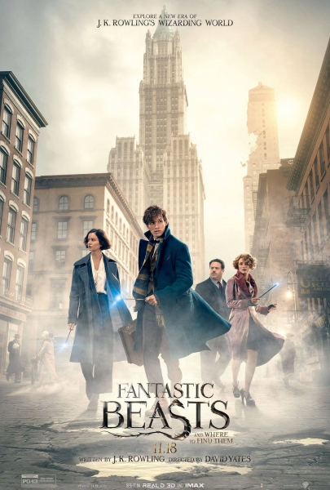

Contents

Cover page……page 1

Contents……….page 2

What is Mise-en-Scene?…...page 3

Characters……..page 4-9

Setting………….page 10-12

Editing………….page 13-15

Sound and Music…..page 15-18

Conclusion………page 19

What is Mise-en-Scène?

The term ‘mise-en-scène’ is borrowed from a French theatrical expression, meaning “put into the scene”. It is the arrangement of everything that appears in the framing – actors, lighting, setting, props and costume. Mise-en-scène also refers to how the film’s world is made real to the audiences. Mise-en-scène is valued for helping set the tone, emotion and meaning of the shot. It is also used to refer to the many single scenes that are within the film to represent the film. The term is broad, and it is also used among professional and experienced screenwriters.
Mise-en-scene is one of the most important elements of the filmmaking industry, as it what was brings the movies we watch, to life. Directors aim to master the skill of making fictional stories and non-fictional stories realistic to the audience, they can achieve this using elements of mise-en-scene such as adjusting the lighting, or the camera angle, choosing the right costumes for the era portrayed the movie and adding sound effects in the background to enhance the experience of watching the movie.

In my opinion, mise-en-scene is clearly utilised in the movie ‘Fantastic Beasts and Where to Find Them’. Mise-en-scene is so well executed that I almost believed the fictional world of wizards and witches in the movie, exists! I will be explaining the different aspects of mise-en-scene in the movie mentioned above, these include:
- Characters
- Setting
- Editing
- Sound and Music

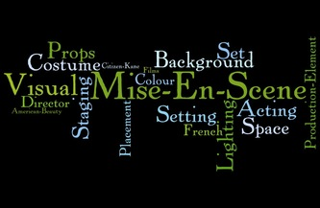

Characters

An actor or actress’s performance can make or break a movie regardless of how engaging the story is or how well the editing was done… It is the actor’s duty to bring his or her character to life within the framework of the story, and his emotional input dictates how strongly the audience feels about the film. Acting depends upon actions, facial expressions and gestures, language, and voice.

I have chosen to do my Media Studies Project on the movie ‘Fantastic Beasts and Where to Find Them’ which is written by J.K Rowling. It is set in the year 1926 New York, in the Harry Potter universe. The dark wizard Gellert Grindelwald is terrorizing the magical community. Witches and wizards from all over the world are on high alert as he prepares to launch his next attack. It is a thrilling movie with many unique characters that bring the wizarding world to life through their actions, expressions, costumes, and language.

Below is a click to the move trailer:
https://www.youtube.com/watch?v=sGNnv_g9h4k

Actions

Moviegoers and readers identify with stories through the characters. The most powerful way to reach an audience is through the characters' emotions and actions. For only when we connect with the characters on an emotional level, does the interaction become deep and meaningful, and the film’s world become real. Here is an example of a scene in ‘Fantastic Beast and Where to Find Them’ where the actions of the characters bring the wizarding world to life.

Magical Repairs
The scene starts with a large cluster of people gathering around the small apartment, belonging to Jacob Kowalski, collapsed in a big heap. Although there is a large crowd, we can clearly see Newt and Porpentina in the middle of the crowd because of their reaction to what they have just witnessed. The rest of the crowd looked slightly surprised but mostly curious, however everything about Newt’s face and actions at this moment scream out worry and alarm. Newt knows exactly what has caused this massive damage. If the world discovers what has caused the damage, the wizarding world could risk exposure. All this is portrayed in Newt’s actions and gestures throughout the scene without him uttering a single word. The air is grey and dusty due to the recent falling of bricks on the ground, it gives the scene an almost mysterious and dark feel.
Without hesitation Newt races up the remaining parts of the apartment and frantically searches for something. We still don’t know what caused the damaged or why Newt is so worried. Evidently just as curious and confused as us, Porpentina follows Newt and attempts to track down the source of the damage. However, by the time she reaches Newt in the remaining room of the apartment, Newt has magically repaired the building to its original state with his wand.

It is truly incredible when the bricks on the ground all fly and twirl in the sky and join to form Jacob’s small apartment. The magic looks so realistic, and the look of concentration and motivation on Newt’s face as he repairs the building makes us really believe he is doing magic. His actions bring the wizarding world of magic to life. When Porpentina finds Newt, he is seated awkwardly on a chair in the repaired room. The humble furniture and size of Jacob Kowalski’s apartment already tells us a lot about the character of Jacob.

We discover that a magical creature, who escaped from Newt’s briefcase, caused the damage. Porpentina’s face, when she notices the magical creature, swiftly changes from emotion to emotion. We see anger as she shouts at Newt for bringing dangerous creatures into America (Newt is from England) then alarm as the creature launches itself at the gobsmacked Jacob who is sitting very frightened in the corner. We barely notice him until now. Then worry, as Jacob is injured by the creature, and fear as she realizes a Muggle (non-magical person) has just witnessed magic, and could spread the secret of the wizarding world. The visual and sound impacts, the comedic timing, and the exhibitions from the three principle drives all join to make a little yet significant scene that keeps on giving the film its remarkable voice.

Newt repairing the collapsed building.
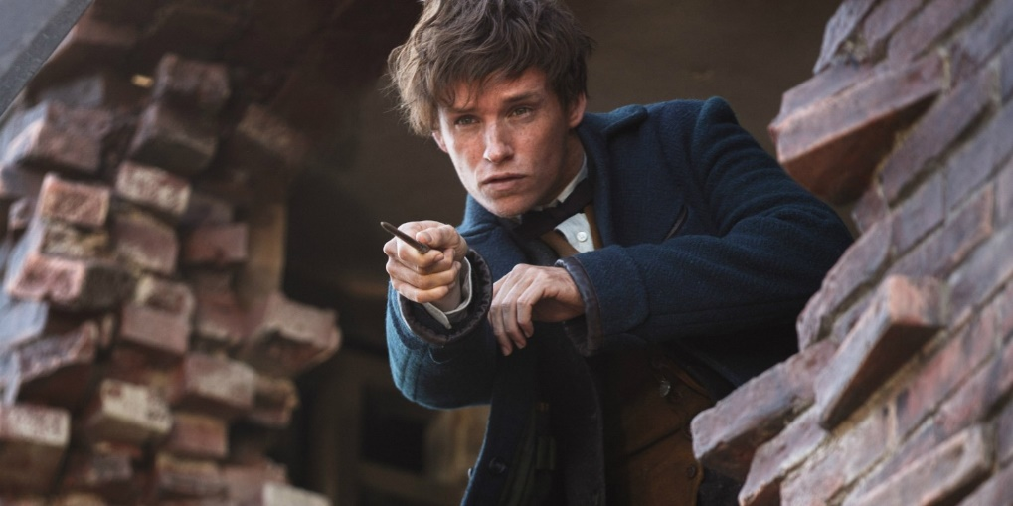

Facial Expressions

Jacob Witnesses Magic for the first time
The characters are all gathered in Porpentina’s apartment, that she shares with her sister, Queenie. Newt attempts to discreetly leave the room, as he needs to find all his magical creatures that have escaped from his briefcase. His facial expression is mingled with nervousness and hope. His eyes are squinted, and his mouth in a tense line, as he slowly and quietly shuffles towards the door; it is obvious he is hoping no one will notice his departure. However, the others see him heading for the door, and very casually ask what he would like for dinner. You can see the guilt shower upon him, as he is caught trying to leave without saying goodbye, or giving a valid reason. His head drops a little and his hand squeezes the door handle in frustration. This is a clear but short moment where the facial expressions of a character make the movie very realistic, as we can relate to moments like these.

Meanwhile Jacob is sitting at the table in total and complete shock and awe at what he is experiencing. Jacob has never seen or heard of the wizarding community, and is quite clearly a little overwhelmed by it all. Queenie can read people’s minds and we get the impression that she is very lonely since, from the moment the two men enter the room, she can’t stop smiling (and flirting). Queenie reads Jacob’s mind, and finds out his likes strudel. So, she suddenly prepares a strudel in the air using her wand, we can see that it is not as easy as it may look as she is biting her lip in deep concentration. Jacob, on the other hand, can’t believe what is happening in front of his eyes, and he barely blinks throughout the whole scene. His mouth is wide open in awe and he is virtually speechless. The room is mainly lit by candle light and the soft light reflected on Queenie’s face gives an illusion of radiance and light coming from her. Once Jacob smells the strudel his facial expression tells us he is extremely content, slightly confused and most prominently suddenly in love with Queenie.
This scene has very little dialogue in it, but the story is instead told through facial expressions and gestures which is almost more effective and realistic.

Link to the scene in the movie: https://www.youtube.com/watch?v=wVEmwJ-l0Ko

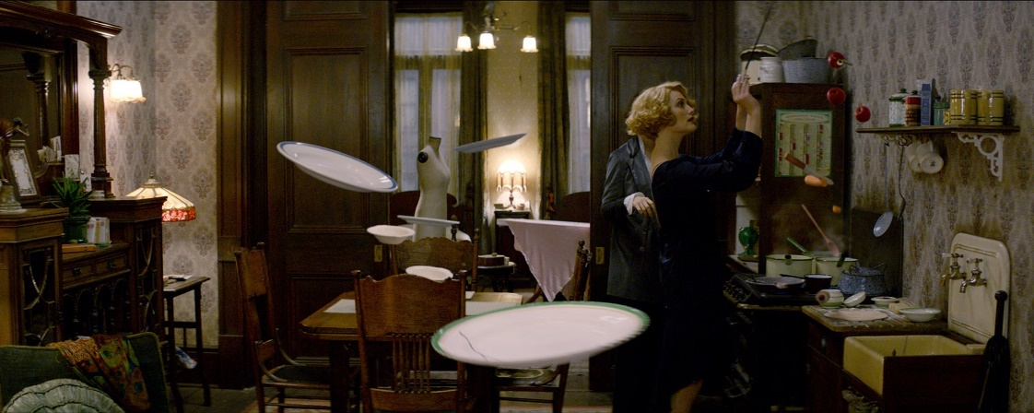
Costumes

Arguably the most easily noticeable aspect of mise-en-scène is costume. Costume can include both makeup or wardrobe choices used to convey a character’s personality or status, and to signify these differences between characters. Costume is an important part of signifying the era in which the film is set and advertising that era’s fashions.

The clothes in the movie ‘Fantastic Beasts and Where to Find Them’ are very typical 1920’s style. Since the movie is set in 1920s America, the clothes must be from this era. The main character, Newt Scamander, often wears an outfit to suggest he is a bit odd and unlike the average man you see walking on the street. Also, he is English, so he is dressed a little different than the American men. Most of the people on set wear dark and gloomy colours such as black, brown, and grey. However, Newt is dressed in a long, blue overcoat, a mustard vest, black trousers (which are a little too short for him, suggesting his awkward nature) and a bow-tie and brown shoes. All the men in this movie wear hats, which is rarely done nowadays. This small detail makes the audience really feel as if they have immersed themselves in 1920s America. The women wear hats, long coats, and long skirts. They also seem to all have short hair.

Newt Scamander
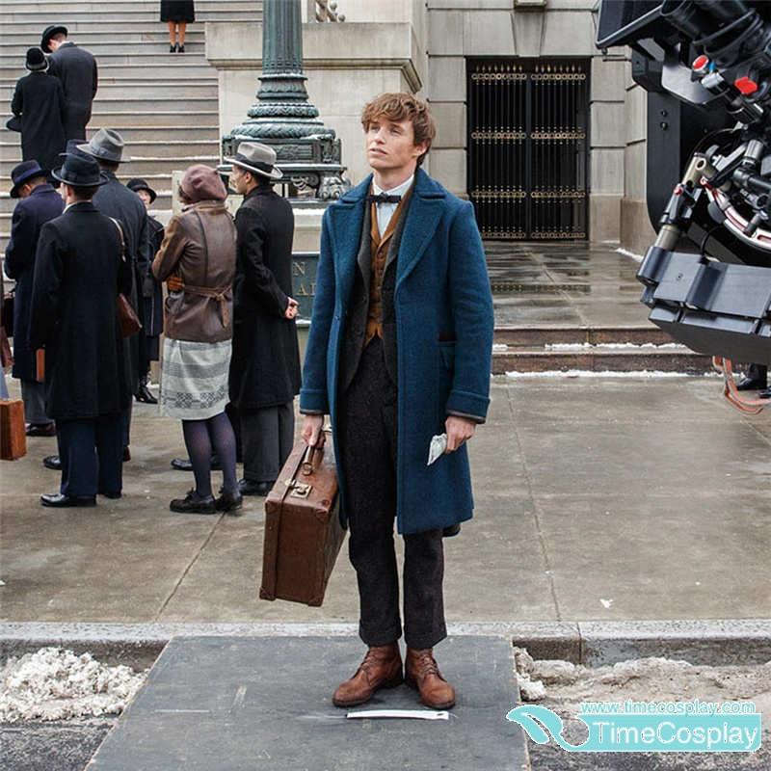

It occurred to me the difference in the costumes worn by the ordinary people on the streets, and the costumes worn by the witches and wizards. By giving each group of people a different style of clothing, it separated the two worlds even more from each other, and emphasised how different they are.

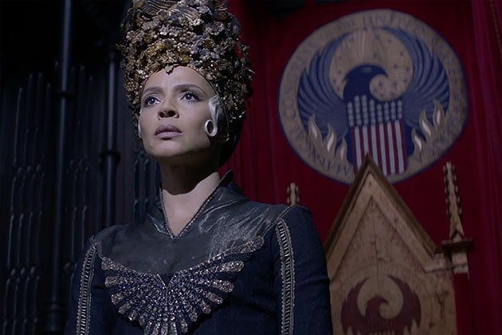

In one scene, the four main characters: Newt, Porpentina, Queenie and Jacob enter a speakeasy, to meet a famous goblin for critical information. In order to enter the speakeasy, they magically transform their clothing into the typical 1920s style dresses and suits. When they enter, it is quite an amazing sight. The audience really feels as though they have just gone 100 years back in history. All the people in the speakeasy are clothed in amazing dresses and suits. The men are all smoking, and the music played is jazzy. Without the incredible outfits, the scene would not be as realistic. The costumes are one of the most important elements of a movie, the variety costumes in ‘Fantastic Beasts and where to Find Them’, create a fascinating movie. Every day we would see lots of different types of people wearing different types of clothes because of professional, status, culture...etc. and this is clearly shown in this movie.

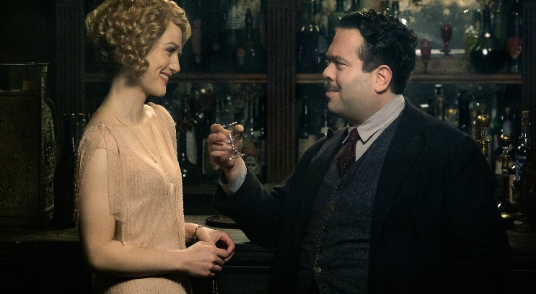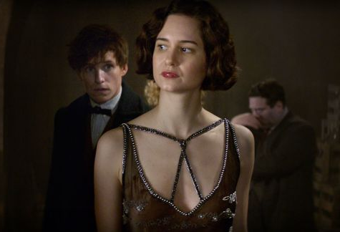

Language

Since the movie is set in New York, America, most of the characters have strong American accents to make it feel like we are really in America. There is a huge contrast between Newt’s posh English accent and Jacob’s worker New Yorker accent which is realistic, and funny at times. The language used is generally quite simple and to-the-point, as it is a fast-paced action filled movie. To show how the characters are feeling in a scene, let it be angry, sad, scared or happy they use different types of language and different tones in their voices which adds to making the movie come alive. The language used is easy to follow and colloquial language is often used. As there is always so much happening, the dialogue is often short and simple.
We learn a lot about the characters and their motives, by the language and words that they use.

When we are brought into the hidden wizarding world in New York, lots of words are spoken that do not exist in the ordinary English dictionary. This makes us feel like the wizarding community is exotic, different and are separated from the rest of the world, as they have their own words.

Setting

The setting of a movie is one of the most important elements, as the setting is where the whole movie takes place. The setting enhances the character’s world and transports us into the world of the movie. What can a setting contribute to the narrative? Well, pretty much everything that a character can, including conveying a tone, emotion, or idea. Setting creates both a sense of place and a mood and it may also reflect a character’s emotional state of mind. It can be entirely fabricated within a studio, but it may also be found and filmed on-location.

Location

Fantastic Beasts and where to find them is set in 1920s New York City. This fact makes the movie even more magical and fascinating, as we are being brought back in time in an imaginary time machine. The 1920s was an exciting and thrilling era, so setting a movie in the most modern and forward-thinking city in the world at the time, is perfect for this movie. 1920s New York was in itself magical, with the high-rise buildings and smog covered streets from all the car exhausts, and the fact that there is an entire wizarding world concealed and hidden within this magical city creates feelings of curiosity and interest. If this movie was set in 2016 Dublin it wouldn’t be half as interesting and mysterious! The movie isn’t actually filmed in New York City, but rather in various locations in England including St George’s Building and Cunard Building in Liverpool. With many special effects and very realistic computer animation, the audience really believes we are in New York and we are without doubt engrossed in the story and feeling of magic.

Customs Area
When Newt Scamander Scamander arrives in New York, we see a magnificent aerial shot of New York, which already gives us a sense of the location. Once the ship is docked in New York, all the passengers from the ship scurry off the ship and enter the customs to be examined and checked before they can enter New York. The ship opens directly into the customs area and crowds we see crowds bustling around and starting in long queues desperate to enter the ‘land of hope and dreams’.
We are in awe as the camera shows us a glimpse of the ‘1920s style re-created customs area’. This customs area truly makes us believe we are in 1920s New York, and really brings the movie to life. We believe in the character’s world. The customs area is not re-created on a computer program but is it a set that was constructed solely for the purpose of this movie, to make it look as real as possible.

Link to scene in the movie: https://www.youtube.com/watch?v=EAhWriND718
Customs area, New York
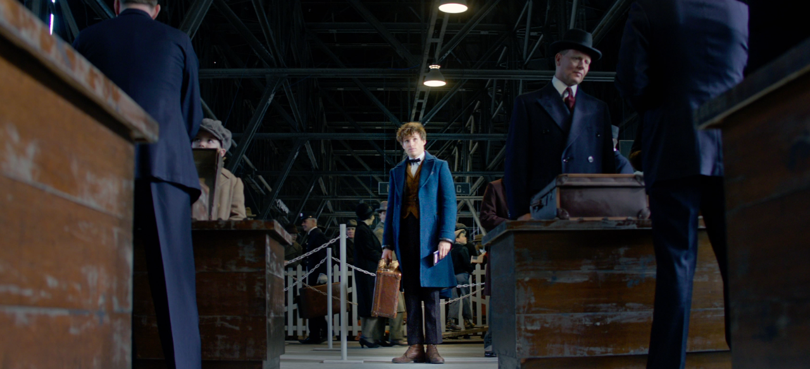

Props

The location is made more authentic by the specific props used which fit fantastically in the era the movie is set in. A property (commonly shortened to prop) is an item used on screen or stage to help enhance a performance. It can make a scene feel more authentic or help actors play their role more adequately.
Cars
Props are most commonly used in conveying the time and place the narrative is set. Props are often the only indicator of what decade, or cultural movement a story is set in. In Fantastic Beasts and Where to Find Them, the city streets of New York are crowded with cars from the 1920s, massive bicycles, and even carriages pulled by horses. These props really make the audience feel as if we have stepped into the 1920s.
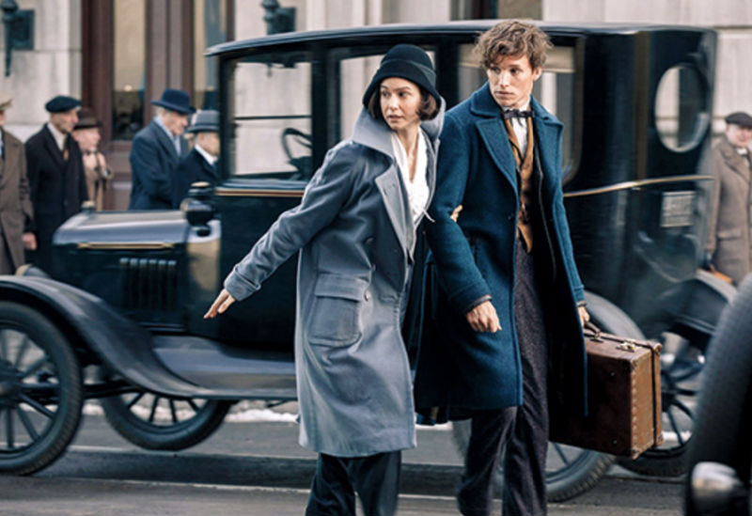

Newt’s Suitcase
Film characters often become instantly recognisable through their props. In this case, Newt Scamander is almost never seen without his treasured suitcase. This prop almost emphasised the awkward nature of Newt, as his briefcase is a bit oversized and very battered and no one walks around with their suitcase.
This is a very important and vital prop in the movie, as in fact, it is a magical suitcase which he bewitched with an Undetectable Extension Charm. Therefore, in the suitcase he hides several beasts he discovered while he travelled. He could hide the contents from Muggles (non-wizard humans) by flipping a switch. This prop helps enhance the fact that we are in a world where wizards and exist, and where inventions such as this magical suitcase are possible.

"You're an interesting man, Mr Scamander. Just like your suitcase, I think there's more to you than meets the eye."
—Percival Graves
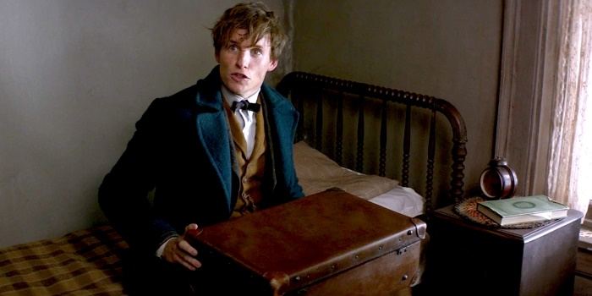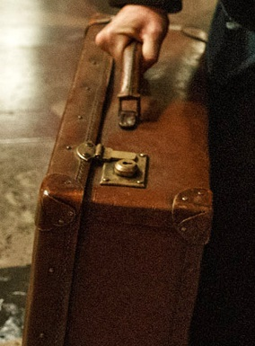
Wands
Wands are what define the wizard and witch community, they are the symbol of magic. Without wands, there would be no magic, without magic there would be no wizarding community, without the wizarding community there would be no Harry Potter or Fantastic Beasts and Where to Find Them… The wands highlight the fact that we are in the magical world of 1920s New York, and they make the character’s world believable.

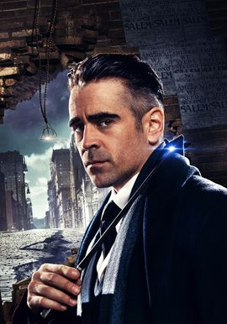
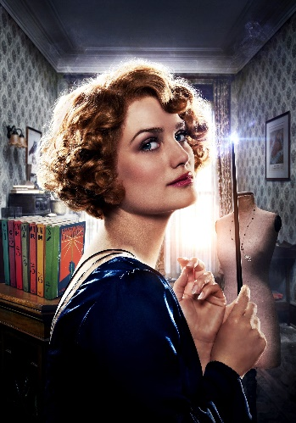
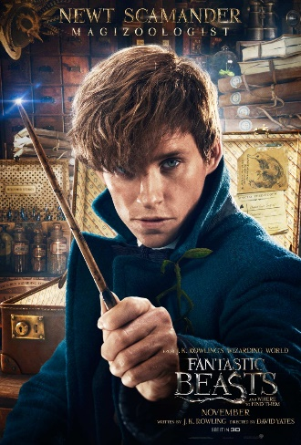

Editing

The exact definition of film editing is the activity of selecting the scenes to be shown and putting them together to create a film. Editing greatly contributes to a film's realistic story. Editing includes cutting frames, shots, special effects, etc. All of these elements help to illustrate a reality on film to the audience. Editing also includes several transitioning styles to create realistic continuity that is normally present in reality. These elements of editing are greatly used in all types of films such as documentaries, dramas, or animated films like those from Pixar Studios.
Montage
In filmmaking, a montage is an editing technique in which shots are juxtaposed (meaning: to place close together or side by side) in an often fast-paced fashion that compresses time and conveys a lot of information in a relatively short period.
People say that continuity editing is about taking shots away, while montage is about adding shots in. There’s some truth in this simple idea—we sometimes call montage additive editing, while continuity editing might be called reductive editing.
Beginning of movie
The movie opens with an establishing shot, giving us a bird’s-eye view of a dark room, showing us briefly where the action is about to start. Starting in silent, dramatic fashion, Fantastic Beasts and Where to Find Them opens with a team of wizards about to face down an unseen enemy... and get defeated rather quickly. While we don't see what it is that destroys them, the fight is over in an instant, as a bright blue light flashes that seemingly kills everyone in the room. That is, except for one man with slicked-back white hair who never turns to face the camera.

Next a series of newspaper headlines -- featuring the famous Harry Potter moving photographs -- splash across the screen, setting the tone for Fantastic Beasts and Where to Find Them 1926 setting. It seems that things are not quite peaceful in the era, not only because of the actions of the dark wizard Gellert Grindelwald, but because there are beast attacks happening and a growing anti-wizard sentiment in the United States. Clearly, it's not a great time to be magically inclined stateside, but evidently that doesn't stop Newt Scamander (Eddie Redmayne) from hopping on a boat and setting sail for New York.

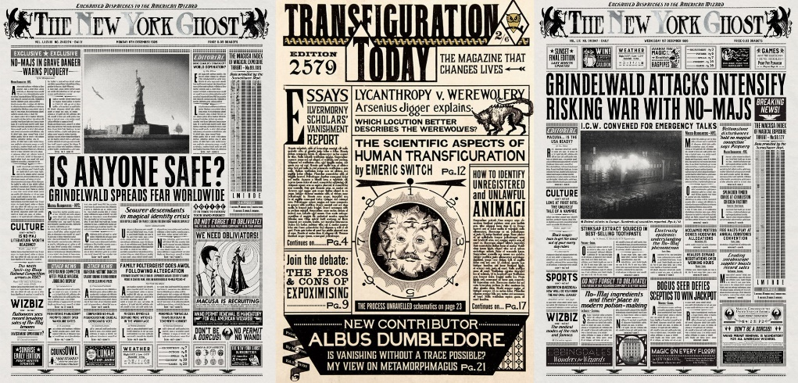

Opening scene (until 1 minute 30 seconds): https://www.youtube.com/watch?v=3O3WtQMQZ84

Visual Effects
Visual effects is the term used to describe any imagery created, altered, or enhanced for a film that cannot be accomplished during live-action shooting. In other words, much of the art of visual effects takes place in post-production, after primary image capture is complete. Visual effects are added to the movie during the editing stage.
Visual effects are an increasingly integral part of the filmmaking process in all genres. Due to the fact that this movie is based on a fictional world where wizards, witches, goblins, and trolls exist visual effects play a key role in the movie, and they help to create a world of fantasy that looks realistic and believable. Without the use of visual effects, ‘Fantastic Beasts and Where to Find Them’ would not be the same, the visual effects make this movie iconic and memorable and intensify the reality of this fictional world.

Inside Newt’s Suitcase
Newt’s suitcase, looks very ordinary from the outside; it’s slightly grubby and made of well-worn tan leather. We know Newt brought this unique case with him to New York in 1926 and that it has a ‘Muggle Worthy’ setting to protect the beasts inside from prying muggle (non-magical people!) eyes. Inside the suitcase, you will find an incredible place where Newt hides all his magical creatures. This suitcase is a doorway to a magically expanded environment, the creatures live in their natural habitats in this enchanted suitcase. Everything in this suitcase is created with visual effects, the animals and the plants, the sky, and the ground all weren’t there while they were filming the movie. The scene was filmed in a big empty space, with signs representing the objects or animals that will be there. It must be awfully difficult for the actors to imagine the creatures roaming about, and imagine walking through forests and deserts while acting! Once the film has been filmed, the scene is edited using various visual effects technologies to create the world of magic that the audience see in the movie. If the editing is not done properly, it will give away that the place depicted does not exist and will leave the audience disappointed. If the editing is done perfectly, with the actors interacting with the magical creatures realistically and so forth, the movie will be a magical journey.

https://www.youtube.com/watch?v=vQ4QAf0Ax08

The set for the scene ‘inside Newt’s suitcase’
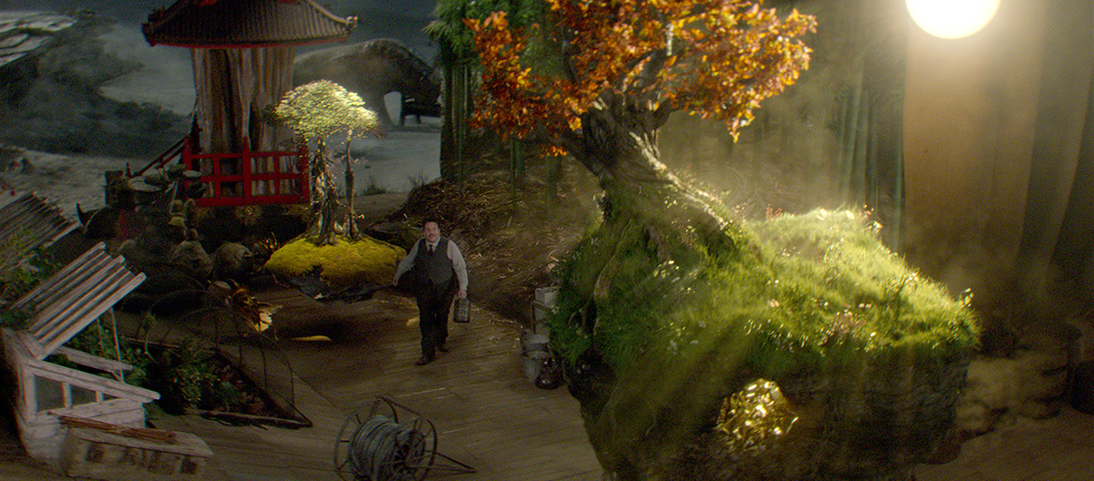

Sound and Music

“Sound” refers to everything we hear in a movie — words, sound effects, and music. Sound is used in movies to heighten a mood, provide us with information about the location of a scene, advance the plot, and tell us about the characters in the story.
Perhaps the most interesting use of sound in a movie is the very absence of it: silence. At key points in a film, directors may use silence in much the same way that they would use a freeze frame. Both tend to arrest the audience’s attention to highlight some action or change in story direction. Silence can be used to build up a scene’s intensity or to foreshadow impending doom.

Non-Diegetic Sound: refers to all those audio elements that come from outside of the fictional world we see on screen, including the musical score and sound effects like the screeches in the shower scene in Psycho.

Diegetic Sound: refers to all those audio elements that come from sources inside the world we see on the screen, including dialogue, doors slamming, footsteps, etc.

Credence and the Wand
Credence is an orphan, and lives with a horrible lady who detests everything about the wizarding world. He has an extremely tense relationship with his foster mother, Mary Lou, who heads the New Salem Philanthropic Society in New York City, a group hell bent on persecuting witches and wizards. Credence is abused daily by his foster mother for showing the slightest sympathy or interest in witches and wizards. One night, when Credence assumes his mother isn’t at home, he searches frantically and noisily under his sister’s bed for a wand. It is completely silent in the house, and all you hear is Credence thumping and thudding loudly on the floor as he moves furniture and shoves objects away to find this wand. The audience are very tense, whispering to Credence to be more quiet!! Then suddenly, through the silence we hear the distinct sounds of high-heels walking up the stairs. The silence is almost unbearable with the long intervals between each ‘click’ of the heel on the stair and the creaks of the wooden floor. Meanwhile Credence hasn’t heard a thing and continues his hectic search for the wand. Then everything is silent, for what seems like ages, as Credence hears the footsteps too. The door bashes open and the intense silence is broken. The silence in this scene was very effective, as it exemplified the small creaks in the wood and the sound of those footsteps. The sound in this scene made the audience become fully engaged in the film’s world, and created a tense and dramatic scene.

https://www.youtube.com/watch?v=2j48-4ATMVA

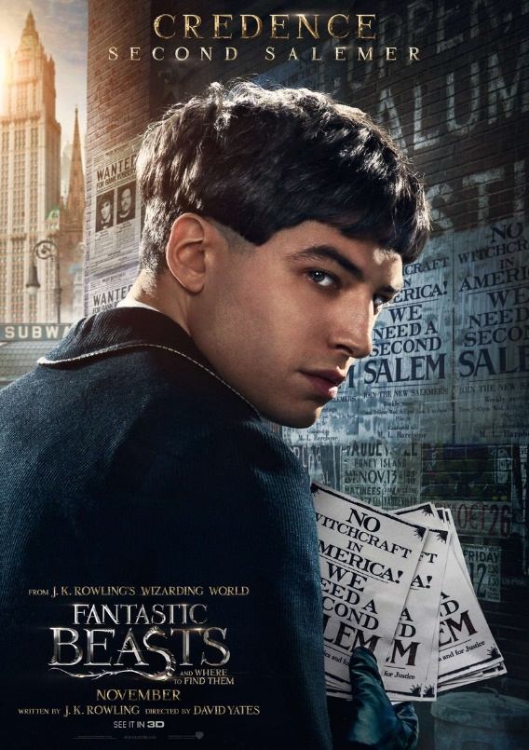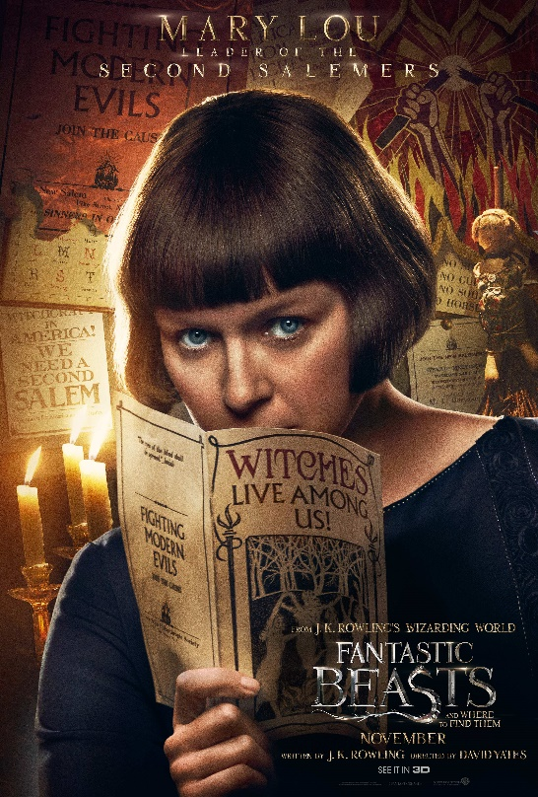

Music
Music adds to the emotional quality of the film. There is some empirical evidence to support this: fast and loud music arouses, slow and soft music calms. Motion and emotion are often entwined. Music, used skilfully, can cover up otherwise weak directing or cinematography.
The most effective scores are those which operate just below the consciousness of the moviegoer. Many in the film industry, including the composers, feel that music offers a kind of sub-text; it serves as thought bubbles on screen. When stories are transferred from the page to the screen, inner thoughts and commentary are lost, a major reason why many people feel a film version of a story is far inferior to the book. This sort of commentary is somewhat replaced by the music.

The soundtrack for Fantastic Beasts and Where to Find Them, is brilliant. It adds to the magical experience of watching the movie, it creates intimacy between the characters, it creates tension and action during fights and does much, much more to make this movie the amazing movie it is.

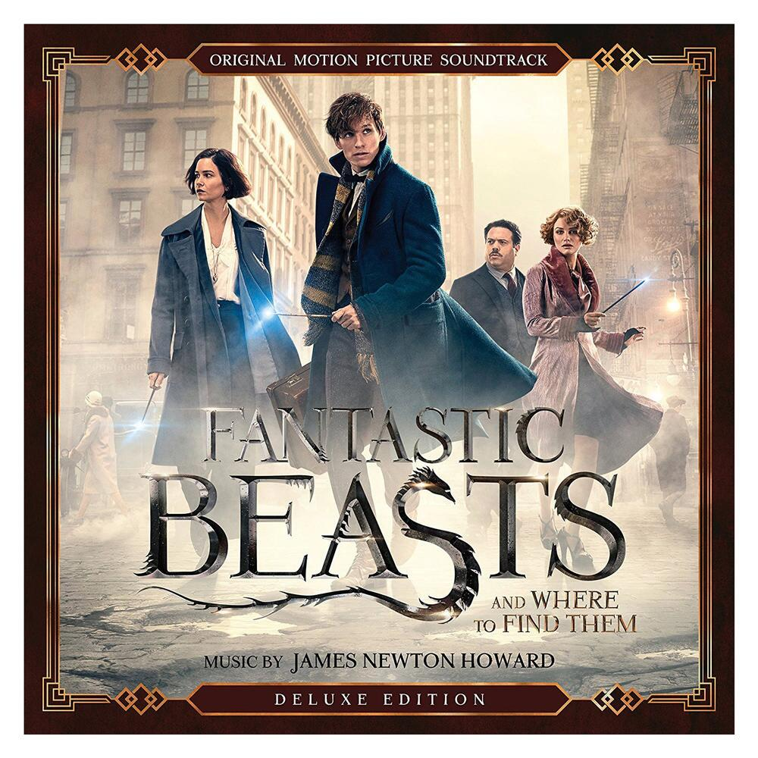

The Obsurus Roof Chase

The music adds to the frightening discovery that a deadly obscurus is roaming the streets of New York. This composition reflects the emotion of the characters in this scene, it has anger, fear and alertness and makes the chase on the rooftop even more thrilling and exciting.

https://m.youtube.com/watch?v=jlyDJnHQM-E

The Obscurus
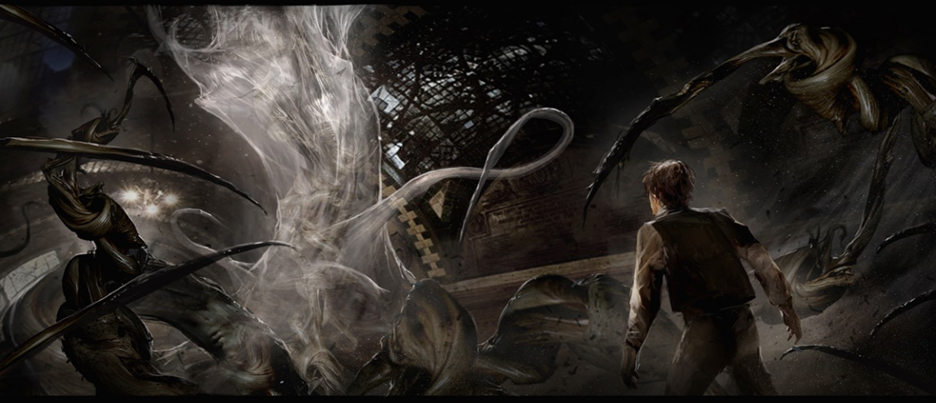
The Blind Pig
So, there’s this scene in Fantastic Beasts and Where to Find Them. Newt Scamander, Jacob Kowalski and Tina and Queenie Goldstein visit a speakeasy for reasons pertaining to their adventure. The venue is called The Blind Pig. It’s dark, seedy, and the perfect sanctuary for witches and wizards looking for a drink. This song is perfect for the scene. It gives the scene a real 1920s feel and enhances the sleazy and laid back mood in the bar.

https://m.youtube.com/watch?v=jdJlFSOQpAo

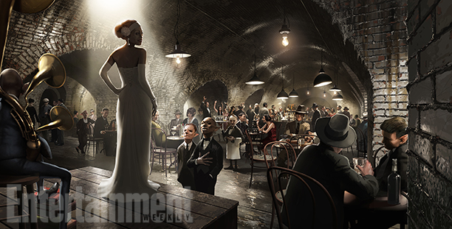

Conclusion

In a nutshell, the brilliant use of mise-en-scene in the movie ‘Fantastic Beasts and Where to Find Them’ made the film’s enchanted and spellbinding world of wizards and witches appear very real to me! The visual effects, allow your eyes to see things we have never seen before and almost made me consider if maybe somewhere in some other universe a creature like this does exist! The characters were memorable, and gave the film a boost of originality. The simple fact that the movie is set in New York, an iconic and incredibly famous city, makes the movie seem all the more realistic as the doesn’t story unfold in a fictional city, but in New York, a place millions of people, including me, have visited! Imagine wizards and witches secretly operating behind the walls and under the grounds of New York city, it is not entirely impossible…

Quotes
Reality is how we interpret it. Imagination and volition play a part in that interpretation. Which means that all reality is to some extent a fiction.
A film is - or should be - more like music than like fiction. It should be a progression of moods and feelings. The theme, what's behind the emotion, the meaning, all that comes later.
What I do like is hiking. And that's what filmmaking is. It's a hike. It's challenging and exhausting, and you don't know what the terrain is going to be or necessarily even which direction you're going in... but it sure is beautiful.

By: Sophie O’Riordan 4D

