Economics - Foreign Exchange Project

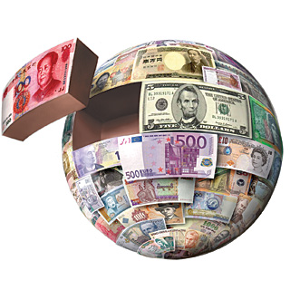

Project outline:
The aim of this Foreign Exchange project is to make the most profit on the currencies we have invested in. On Monday the 7th of November all the students in the Economics class had to choose 3-5 currencies to invest in. We were each given €100,000 and we had to invest a minimum of €10,000 into each economy. On Monday the 21st of November we will check the value of the currencies we have invested in. We all want to make more profit on our investments than the others! Below is a summary of the currencies I have chosen to invest in, and the amount I invested in each.

Forex | Investment (€) | Buying Rate | Holding in Foreign Currency
- Swiss Franc | 20,000 | 1.0792 | 21584
2) Chinese Yuan Renminbi | 20,000 | 7.536 | 150720
3) South-Korean Won | 20,000 | 1281.93 | 25638600
4) Malaysian Ringgit | 20,000 | 4.6826 | 93652
5) Norwegian Kroner | 20,000 | 9.1142 | 182284

In addition we must write 500 words on each economy using the following headings:
- Geopolitical Risk
- What are the main trade areas?
- What areas does the country invest in?
- Tourism

What is Geopolitical Risk?
Political risk is the risk an investment’s returns could suffer as a result of political changes or instability in a country. Instability affecting investment returns could come from a change in government, legislative bodies, other foreign policy makers or military control. Political risk is also known as “geopolitical risk” and becomes more of a factor as the time horizon of an investment gets longer. A time horizon is the length of time over which an investment is made or held before it is liquidated. Some political risks can be insured against through international agencies or other government bodies.

Switzerland

Currency: Swiss Franc

Switzerland continues to be the world’s most competitive economy according to the World Economic Forum’s (WEF) Global Competitiveness Index 2014-2015. The economy of Switzerland is one of the world's most stable economies. Its policy of long-term monetary security and political stability has made Switzerland a safe haven for investors, creating an economy that is increasingly dependent on a steady tide of foreign investment.

Geopolitical Risk
Switzerland is classified as a “Country Risk Tier 1” country, with very low levels of economic, political and financial system risk.

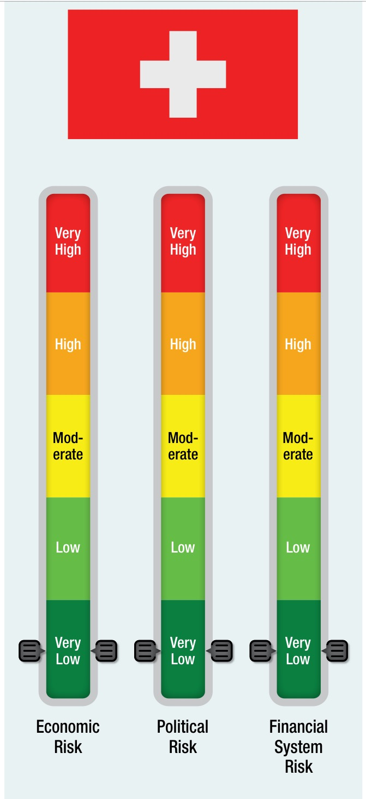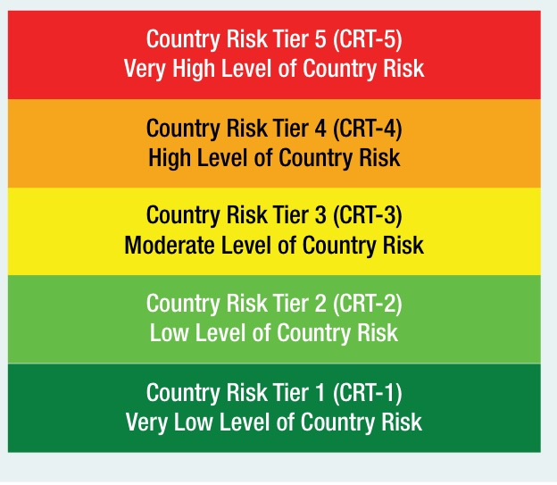
Switzerland has a highly developed financial services sector and manufactures high-technology products, such as pharmaceuticals, electronics, chemicals, watches and precision machinery. Though Switzerland opted out of the EU and the European Economic Area, its economy is highly integrated with the rest of Western Europe and is widely known as a global financial hub. The country also has very low rates of unemployment. Since 2012, Switzerland has had negative rates of inflation, it is forecasted that this trend will continue through 2017. Inflation is defined as the general increase in the price of goods and services over a period of time. While political shifts do occur, Switzerland benefits from a stable and predictable political system. Since 2009 the Swiss financial sector, including insurance, has been regulated by the Financial Market Supervisory Authority. In January 2015 the Swiss removed the cap versus the euro, allowing their currency, the franc, to significantly appreciate. The currency remains overvalued, but it is unlikely that the bank will shift policy in the near-term.

What are the main trade areas?
The economy in Switzerland is divided into three sectors:
"Landwirtschaft" (agriculture)
"Industrie" (industry)
"Dienstleistungen" (services)
Less than 10% of the population is employed in agriculture, also considered the primary sector. This sector is strongly supported by the government.
About 40% of the population is employed in industry, trade and handicraft, also considered the secondary sector. This sector includes the machine and metal industry, watch industry and the textile industry. All of them export much of their products to foreign countries and suffer a lot because of the expensive Swiss Franc. The fact that Switzerland does not belong to the European Union additionally slows down the Swiss exports.
More than 50% of the population is employed in the services sector, also considered the tertiary sector. This sector includes banking, assurances, tourism and so on. Banking is one of the most important businesses in Switzerland.
The main exports areas are: watches, food processing like Nestlé, chemical for industrial and construction use like Sika AG, pharmaceutical like Novartis and Roche and vehicles.
The main imports are: chemicals, machines, vehicles, agricultural and fishery and metals.
Switzerland's largest trading partner is Germany.
According to the World Fact-book numbers, Switzerland is the 20th largest exporter and the 18th largest importer.

What does Switzerland invest in?

Main Investing Countries 2013, in %
Netherlands. 27.6
Luxembourg 21.0
USA 12.7
Austria. 8.7
France. 5.6
Germany. 3.7
UK. 3.1
Offshore financial centres in the Caribbean. 2.2
Main Invested Sectors 2013, in %
Finance and holding 52.1
Trade. 18.4
Chemicals and plastics. 7.0
Electronics, watches, energy and optics 4.6
Banking sector. 4.4

Foreign Investment
Switzerland is generally open to foreign investment and grants foreign investors national treatment. However, the government restricts investment in vacation real estate, utilities, and other sectors considered essential to national security.

Tourism in Switzerland

- The Matterhorn in Zermatt
This pyramid shaped giant is arguably the most photographed mountain in the world and therefore, also Switzerland's most famous Alpine peak and a top place to visit in Switzerland.
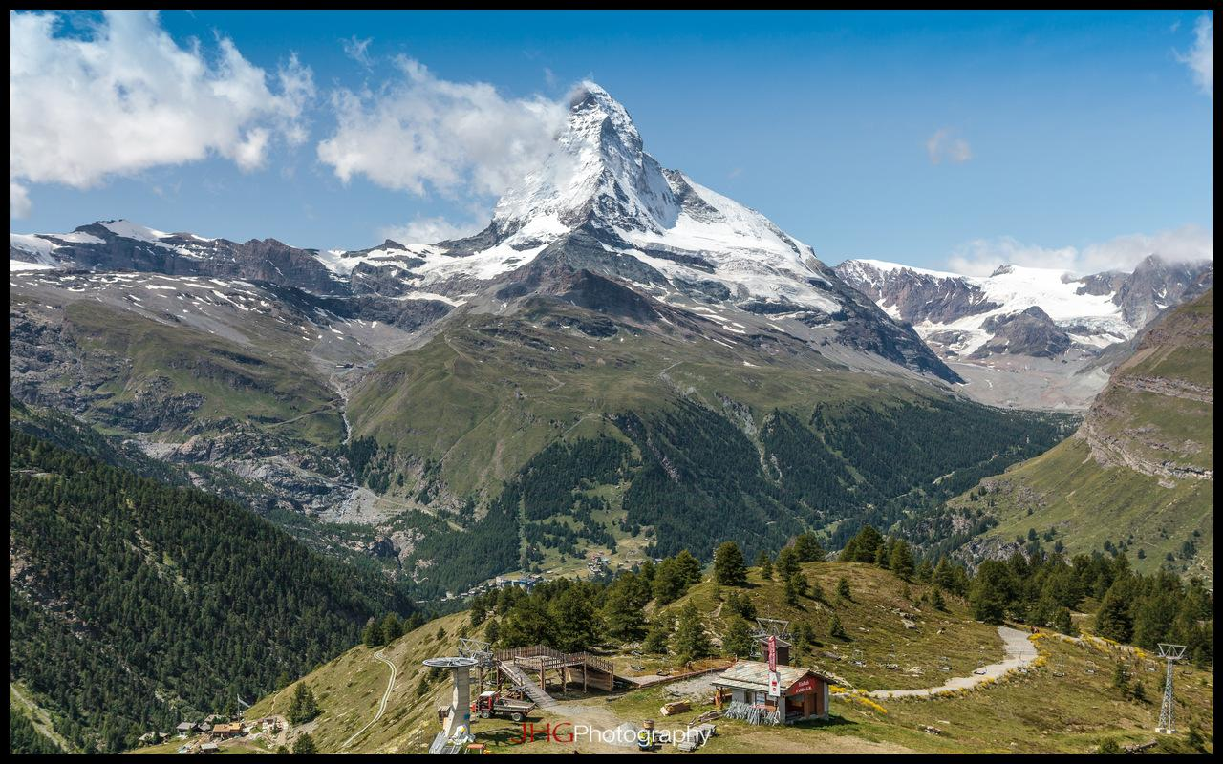

2. Chillon Castle
Located in the heart of the Swiss Riviera on the banks of Lake Geneva is Chillon Castle – the four-century old water fortress. This is one of the most visited historic buildings in Switzerland and certainly a top place to visit in Switzerland.

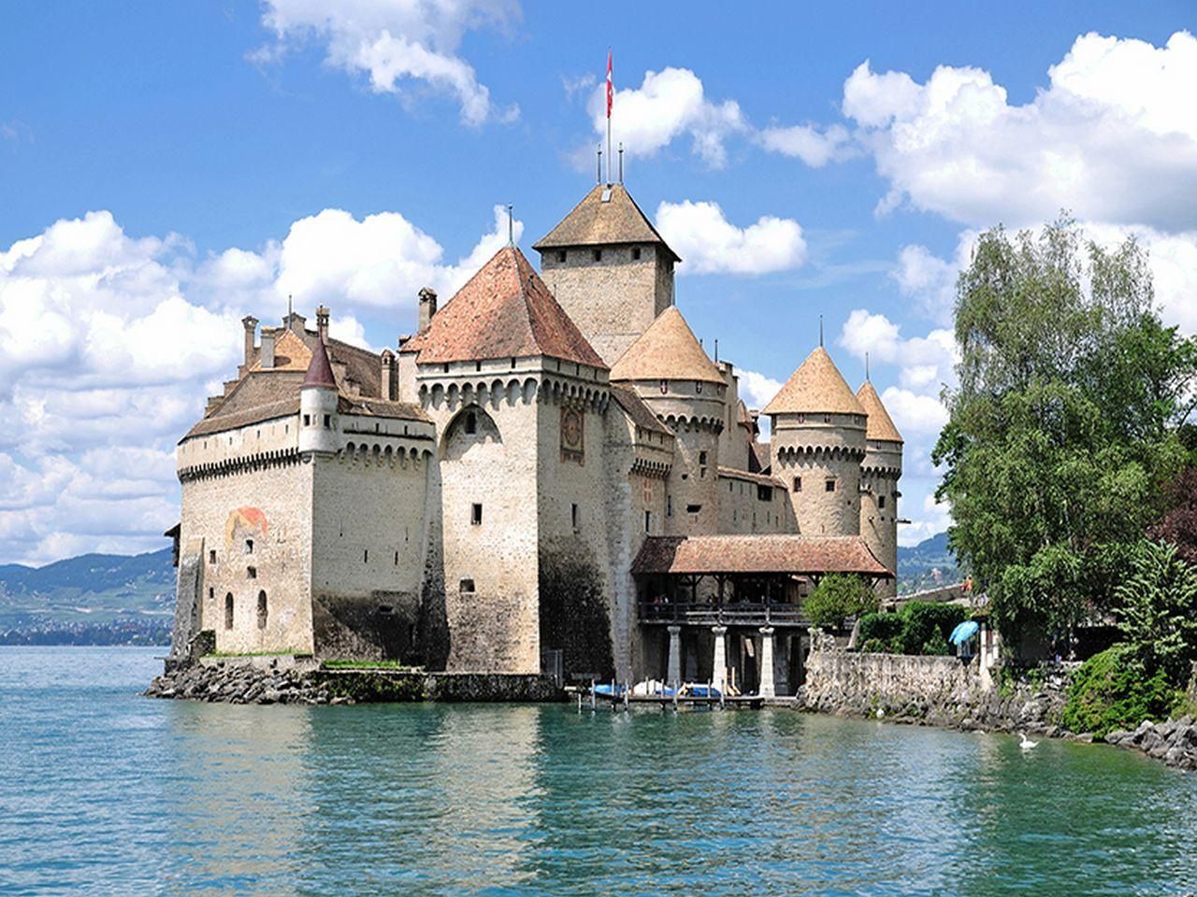

3. Lugano
Travelling to Lugano shows Switzerland in a different light. Bordering Italy in the south, the Italian influence is undeniable. Lugano is flush with museums and a number of heritage sites housed in neoclassical palazzos.

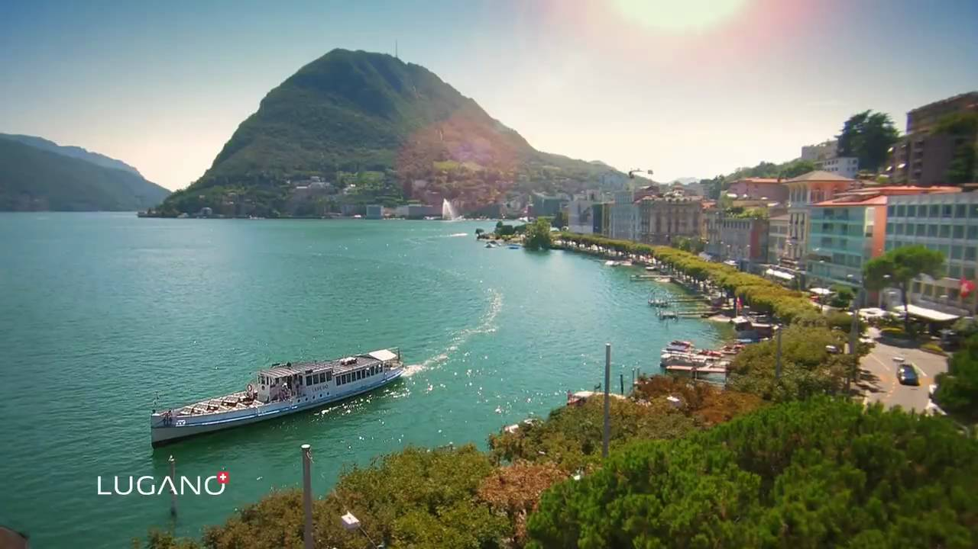

Around 11 million tourists visit Switzerland annually.

China

Currency: Chinese Yuan Renminbi

Geopolitical risk
There seems to be quite a high geopolitical risk emerging in China. China is still a poor country, with per capita gross domestic product at roughly a quarter of the U.S. level. But, because its population is four times larger, its total GDP (gross domestic product is the total value of the goods and services produced in a country in one year) is equal to America’s. And it is total GDP that determines a country’s ability to spend on military power, to provide a strategically significant market for other countries’ exports, and to offer aid to other parts of the world.
Looking ahead, even with the more moderate growth rates projected for the future, China’s GDP will grow more rapidly than that of the U.S. or Europe.
China is now expanding its strategic reach. It is asserting maritime claims in the East and South China Seas. In particular, China is relying on the so-called “nine-dash line” (originally created by Taiwan in 1947) to justify its claim to most of the South China Sea, where it has created artificial islands.
China also is expanding its geopolitical influence through initiatives like the Asian Infrastructure Investment Bank, aid programs in Africa, and its “One Belt, One Road” plan. The current Chinese political leadership wants a peaceful and cooperative relationship with the U.S. and other Western countries. China’s sources of risk can constitute an unusually serious set of geopolitical challenges. China will persist and threaten our economic future for years to come.

What are the main trade areas?
China is the world's greatest exporter of computers, broadcasting equipment, telephones, office machine parts, video displays, rubber tires. Other major exports include electrical transformers, furniture, knit sweaters, trunks and cases, vehicle parts, artificial flowers and arms and ammunition.
Major imports of China include soybeans, refined petroleum, refined copper, coal briquettes, vehicle parts, computers, petroleum gas and copper ore.
China exports more to the United States than to any other country by far, almost double the total amount of exports as their next biggest importer, Hong Kong. China also exports heavily to Japan, Germany, South Korea, and the United Kingdom. Most of China's imports come from Japan, South Korea, various other Asian countries, the United States and Germany.
China exports far more than it imports on the whole. It exports almost 398 billion dollars worth of goods to the United States alone, while its combined imports from its top three trading partners only reach about 392 billion dollars.

What areas does China invest in?
The UK is one of China's favourite places to invest. Almost half of all China's global investments have been in the energy sector, many of them designed specifically to provide power for the Chinese. But energy has not been China's primary interest in the UK. In fact, property investments far outweigh those in energy.
The motivation here is far more straightforward - profit. Myanmar, with vast oil and gas reserves as well as mineral deposits, has been a big draw for Chinese companies. China is the top investor in the country once known as Burma. China has been a big investor in Canada’s oil sands. The province of Alberta, whose oil sands give it the title of the largest oil reserves outside Saudi Arabia, has seen a lot of interest from Chinese energy firms. Chinese direct investment in the U.S. has been growing rapidly, nearly doubling in 2009 to $909 million from $462 million a year earlier and reaching $1.3 billion in 2010.

Tourism in China
China is the third most visited country in the world. Approximately 57 million tourists visited China in 2015.

- The Great Wall of China
The Great Wall, one of the greatest wonders of the world, was listed as a World Heritage by UNESCO in 1987. It is the most popular attraction in China.

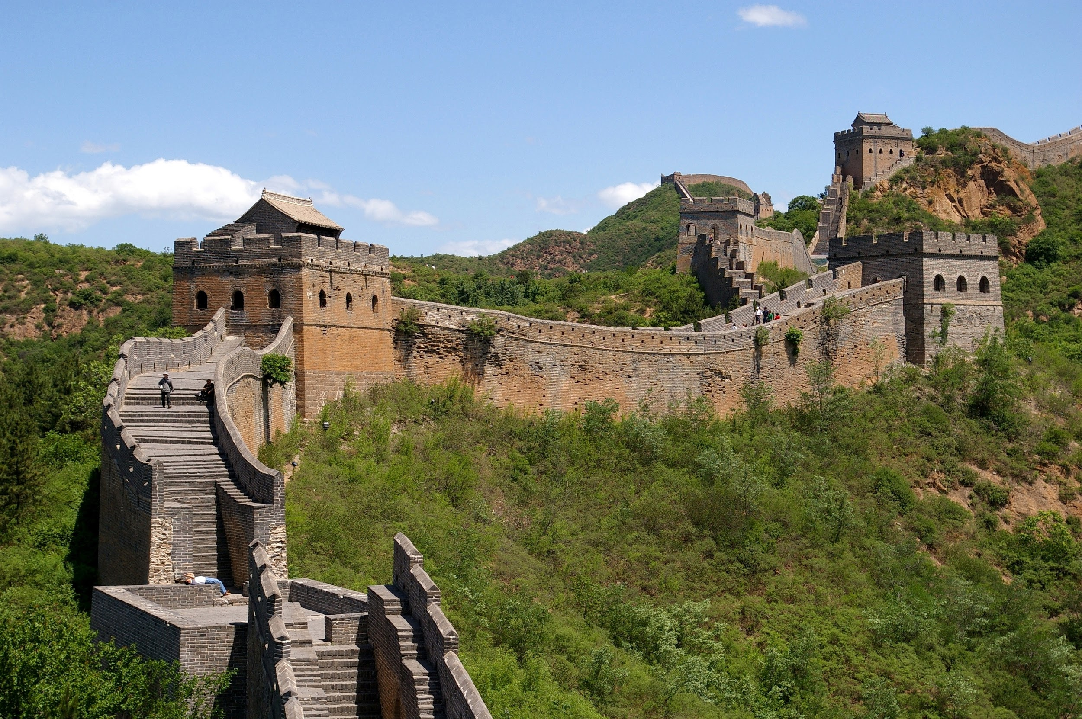

2. The Terracotta Army
The Terracotta Army, are the most significant archeological excavations of the 20th century. It is a site not to be missed by any visitor to China.

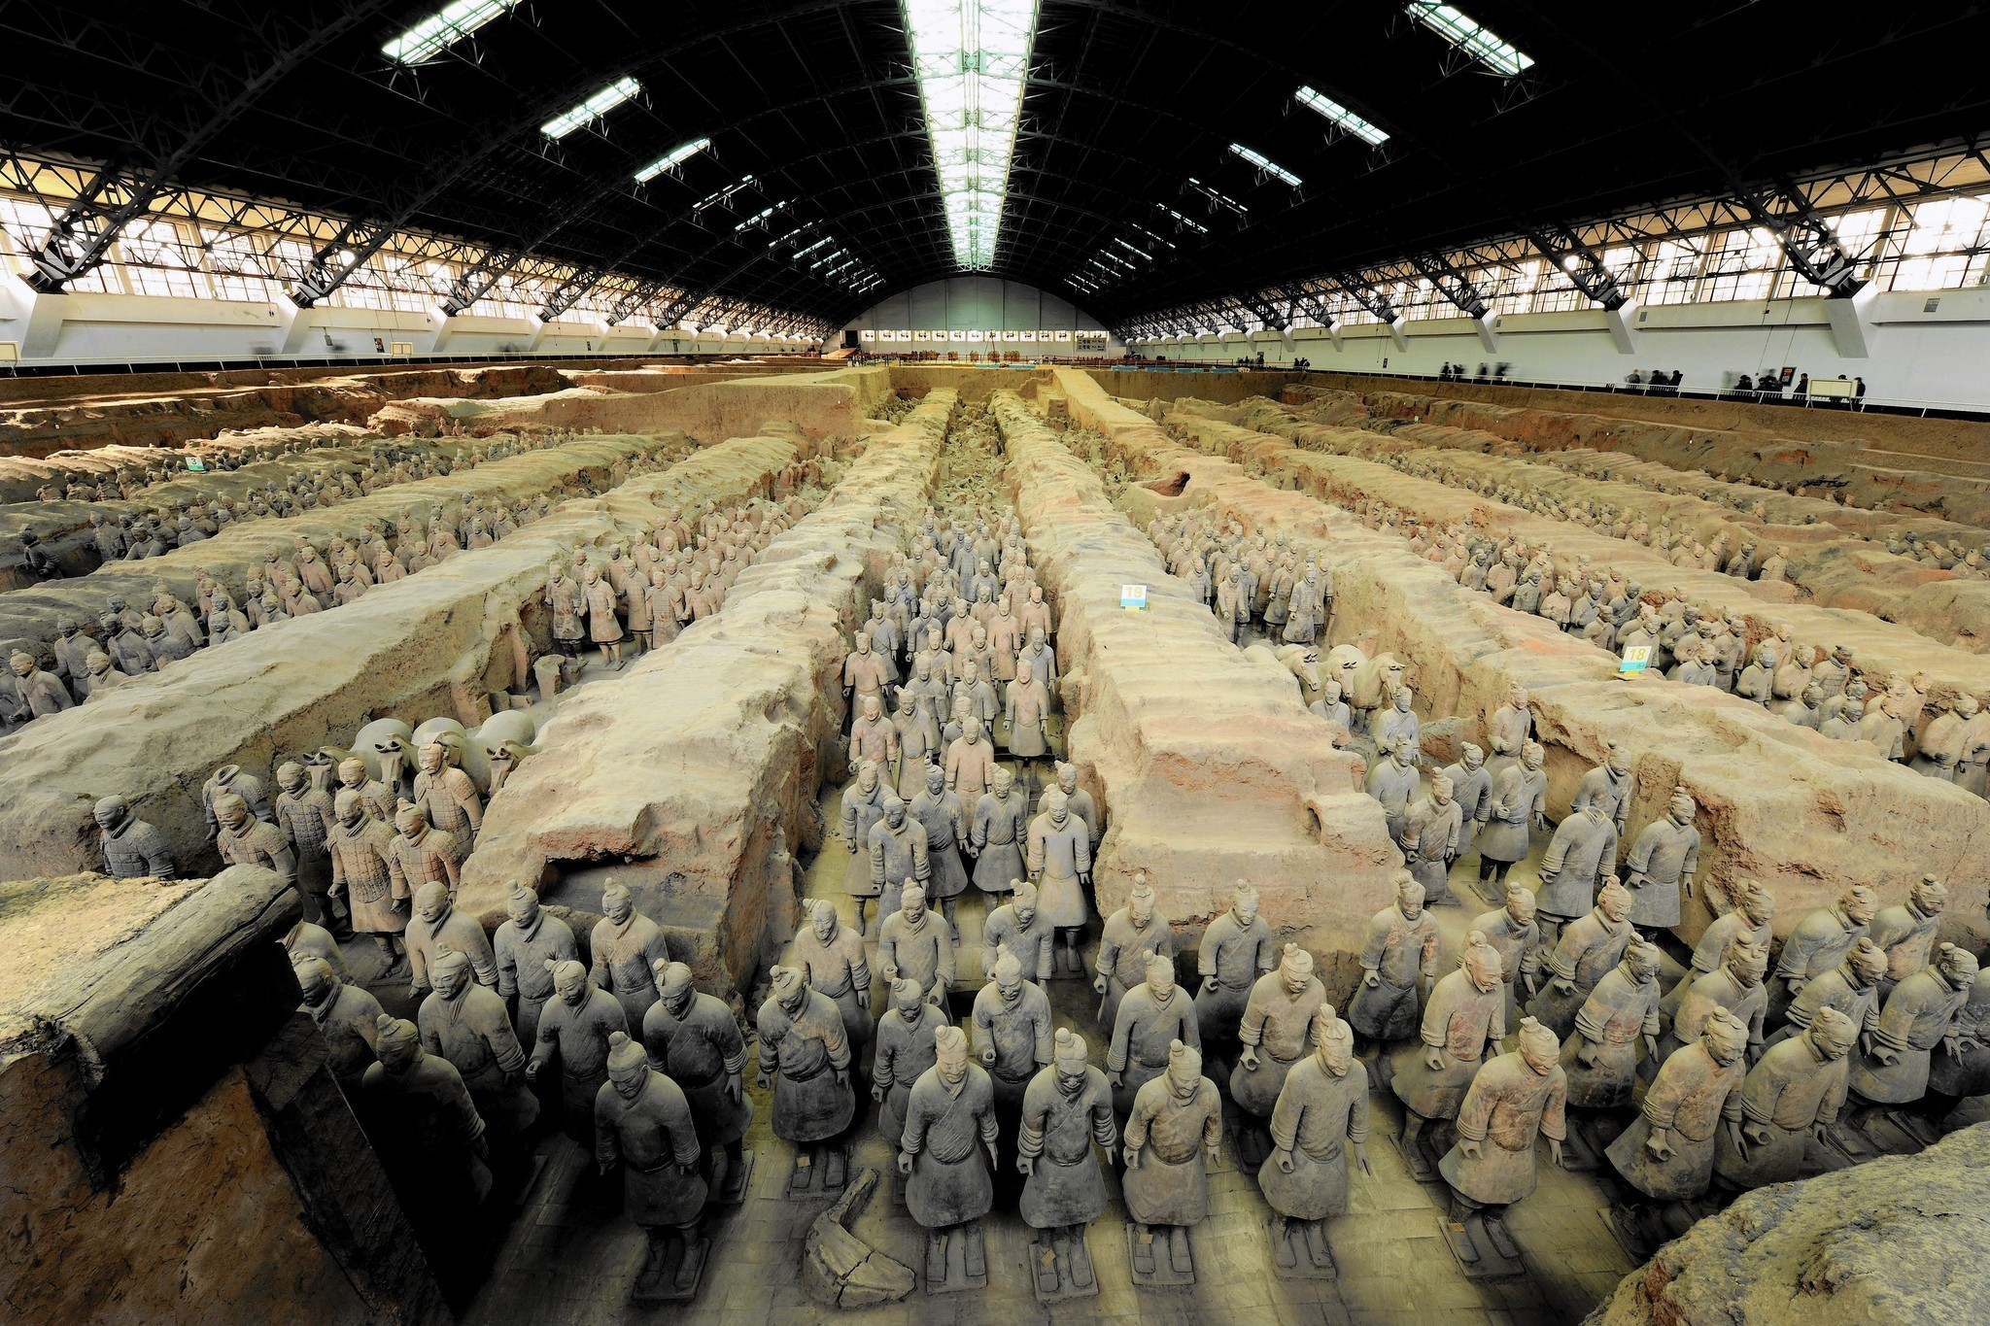

3. The Silk Road
The Silk Road is a historically important international trade route between China and the Mediterranean. The scenery and sights along the Silk Road are spectacular and intriguing. It is a major tourist destination in China.
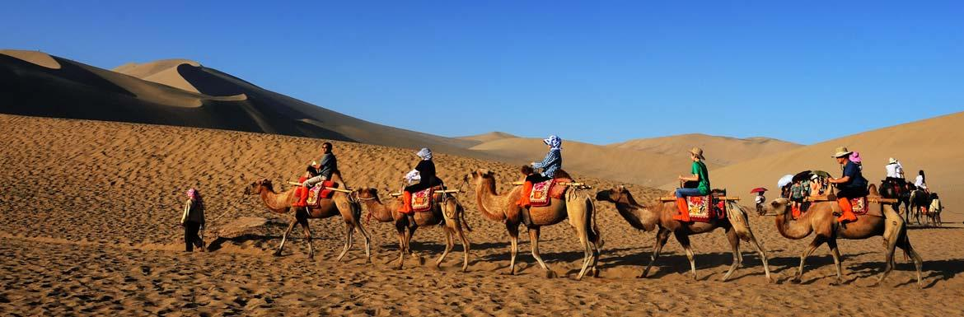

South Korea

Currency: South Korean Won

Geopolitical Risk
Strengths
-Firmly established democracy
-Advanced Economy with high per capita income
-Sound Financial sector
-Ample foreign exchange reserves
-Low external debt
-Strong business environment
Weaknesses
-Geopolitical risk stemming from North Korea
-Economic vulnerabilities due to external dependency
-Weak corporate governance
-Ageing population

South Korea is the world’s 12th largest market. The closure of a jointly run industrial park following North Korea’s rocket launch and nuclear test heightens geopolitical risks for the South.
South Korea said it would pull companies and workers from the ‘Gaeseong Industrial Complex’, removing the last remaining symbol of economic cooperation with the North. North Korea responded the next day, saying it would freeze the assets of more than 120 South Korean companies operating there. It ordered its army to occupy the complex.
In December 2015 was the first time the country received the third-highest ranking from a major ratings company. However the heightened geopolitical risk was one factor that could lead to a negative rating action. ‘Standard & Poor’s’ and ‘Fitch Ratings’ both rate the nation AA-, their fourth-highest ratings.
While previous provocations by the North had only a limited impact on South Korean financial markets, market volatility may rise if combined with external risks including China’s economic woes and lower oil prices.

What are the main trade areas?
South Korea is an export-orientated country, with a total trade volume of 884.2 billion in 2010. This figure also makes them the 7th largest exporter and 10th largest importer in the world. Since 2003, South Korea has established its network countries.

Total value of exports: US$466.3 billion (€434 billion)
Primary export - commodities: semiconductors, wireless telecommunications equipment, motor vehicles, computers, steel ships and petrochemicals
Primary export - partners: China (23.2% of total exports), US (10.1% ), Japan (5.8%), Hong Kong (5.3%)
Total value of imports: US$ 417.9 billion (€389 billion)
Primary imports - commodities: machinery, electronics and electronic equipment, oil, steel, transport equipment, organic chemicals, plastics
Primary import - partners: China(16.8% of total imports), Japan (15.3%), US (9%), Saudi Arabia (6.1%), Australia (4.6%)

What does South Korea invest in?
One of the things South Korea mainly invests in is research. They have a cylindrical apparatus of copper and gold in a lab. It's a prototype of a device that might one day answer a major mystery about the Universe by detecting a particle called the axion — a possible component of dark matter. In 1999, the country's investment in research and development (R&D) totalled 2.07% of its gross domestic product. The biggest chunk of the money goes towards applied research and development in industry, but the government has made major investments in basic science, too.
Main Investing Countries 2013, in %
Japan 27.8
USA 18.1
Netherlands 9.6
UK. 7.9
France 4.1
Germany 3.6
Singapore 3.6
Malta 2.7
Hong Kong 2.5
Main Invested Sectors 2013, in %
Manufacturing 40.8
Finance and insurance. 25.7
Trade and maintenance. 18.5
Transport and storage. 5.4

Tourism

- Jeju Island
The island’s mixture of volcanic rock, frequent rains, and temperate climate, make it very similar to the Hawaiian Islands in the U.S. The island offers visitors a wide range of activities: hiking on Halla-san (South Korea’s highest peak), catching sunrises and sunsets over the ocean, viewing majestic waterfalls and much more!

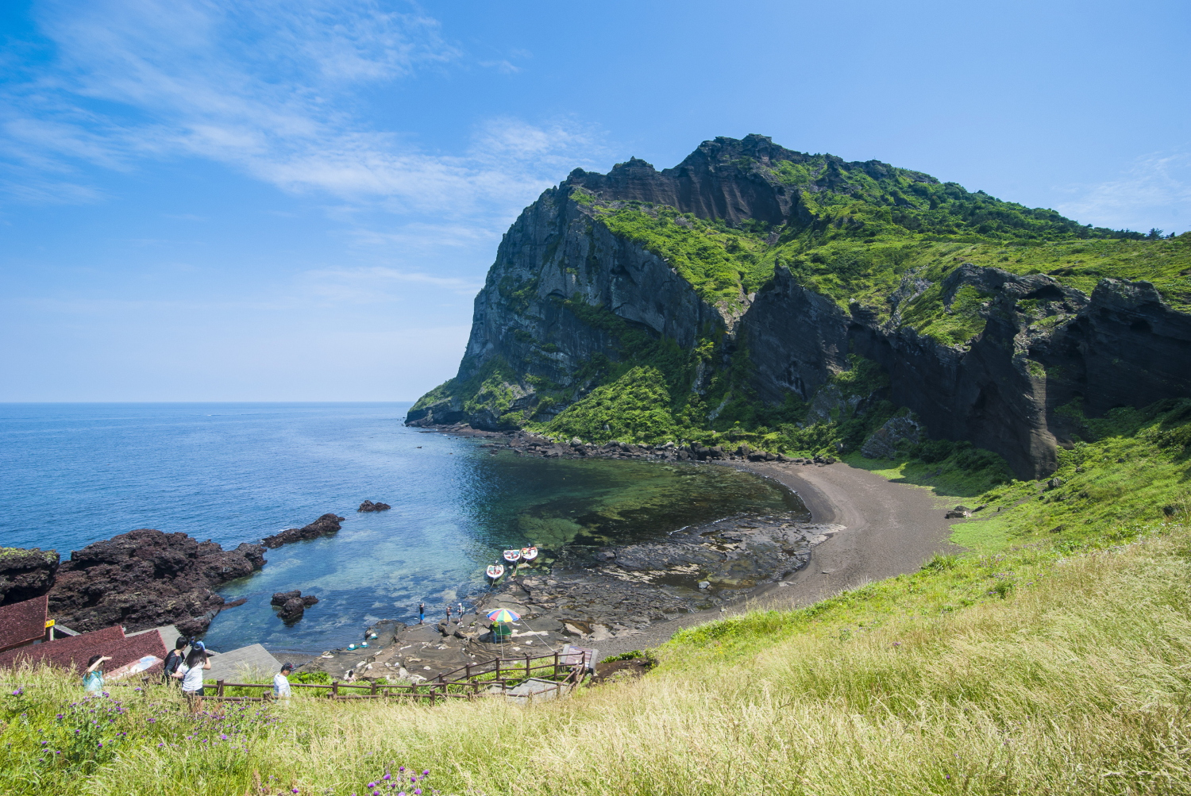

2. Seoul
Seoul is the capital city of South Korea and is also the country's political and economic center. This beautiful city consists of a wonderful modern and ancient architecture which make this city a worth a visit.

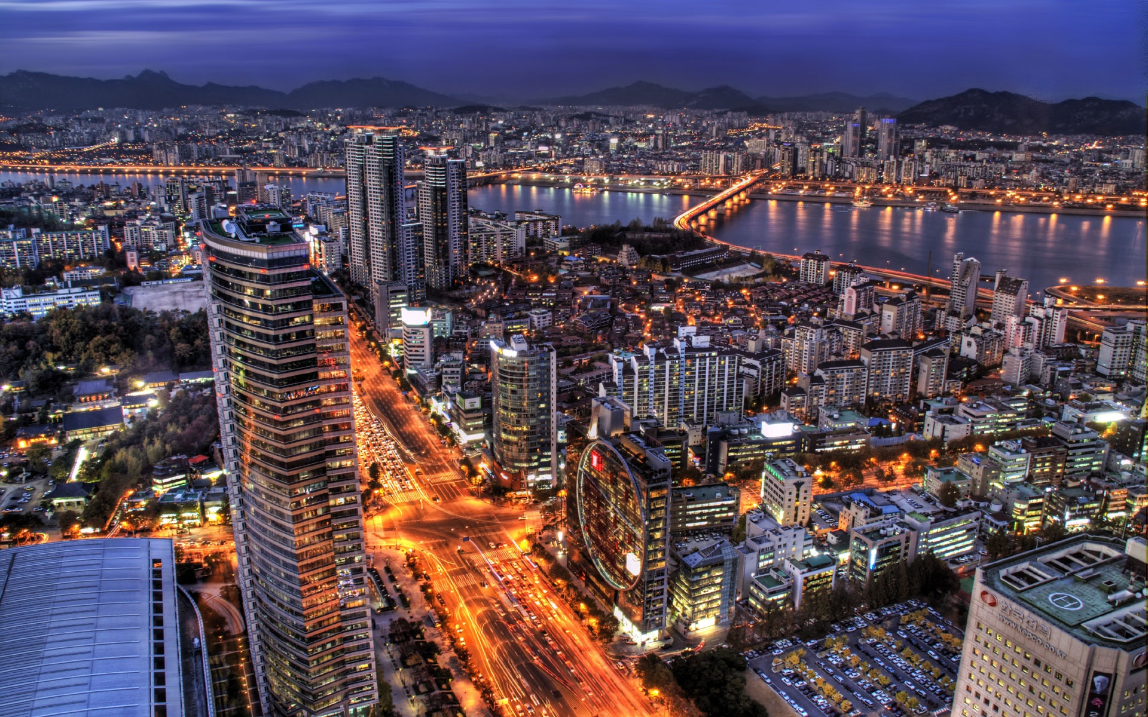

3. Gyeongju
Gyeongju is a small city north of Ulsan and Busan in the southeastern corner of South Korea. The city is actually referred to as the museum without walls. This is because the city has numerous historical sites.

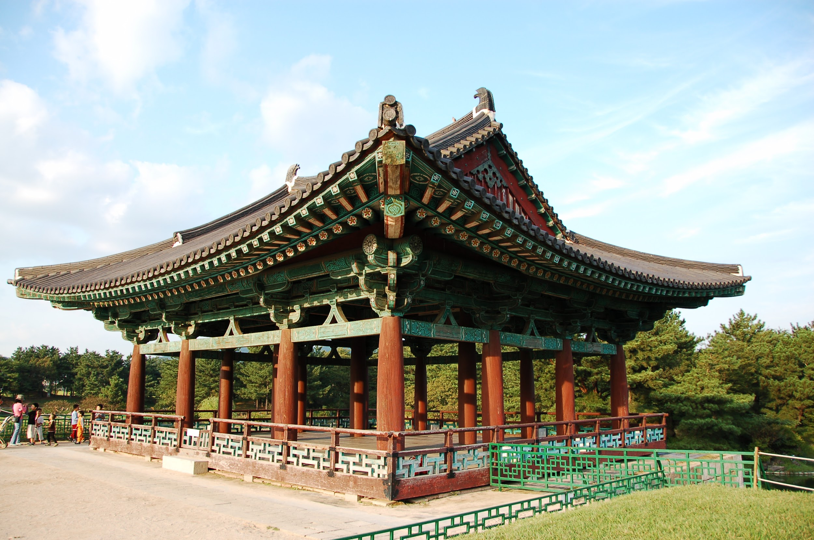

Malaysia

Currency: Malaysian Ringgit

Geopolitical Risk
Malaysia has long been regarded as one of Southeast Asia’s success stories. With a population of 30 million, it is the region’s third-largest economy. It is a rare example of a moderate and democratic Muslim state, one where the Islamic majority lives in reasonable harmony with the nation’s Chinese and Indian communities. But Malaysia’s delicate political and ethnic balance is starting to unravel as the country risks sliding into authoritarianism.
In February, the opposition was dealt a crippling blow when Mr Anwar was imprisoned for five years by a court on charges of sodomy. The case appeared at the very least politically motivated. This has now been followed by a sweeping series of arrests of opposition politicians and journalists.
This crackdown on civil society is dangerous for two reasons. First, it risks polarising Malaysian society, making the delicate balance between the country’s communities harder to sustain. The second concern is that if the political tension grows it could damage Malaysia’s economy. Malaysia is a significant net exporter of energy, making it vulnerable to the fall in oil prices. Foreign bond ownership in Malaysia is high at more than 40% - and bondholders could become back out if there is any further deterioration in the country’s economic and political outlook.

What are the main trade areas?
Malaysia was once the world’s largest producer of tin, rubber and palm oil.

Malaysia mainly exports the following commodities:
-Electronic equipment
-Petroleum and liquefied natural gas
-Wood and wood products
-Palm oil
-Rubber
-Textiles
-Chemicals

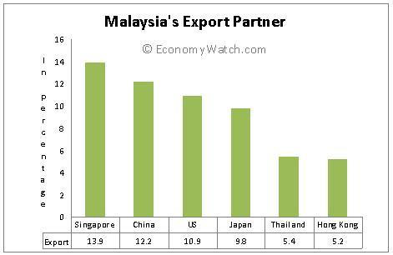

Malaysia mainly imports the following commodities:
-Electronics
-Machinery
-Petroleum products
-Plastics
-Vehicles
-Iron and steel products
-Chemicals

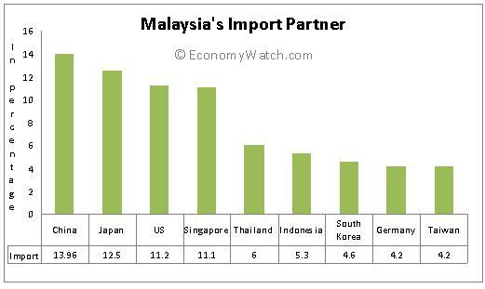
What does Malaysia invest in?
Malaysia mainly invests in Agriculture (61.2 million in 2016), Mining (387.5 million) and Plantation and Commodities (211.1 million) in the Primary Sector.
In the Manufacturing Sector Malaysia has invested 7,077.6 million as to date. The main things it has invested in, in the Services Sector are Real Estate (28,570.4 million in 2016) , Financial Services (7216.3 million) and Global Establishments (2067 million).
Below is a table of the domestic and foreign investment distributed in the Malaysian economy:

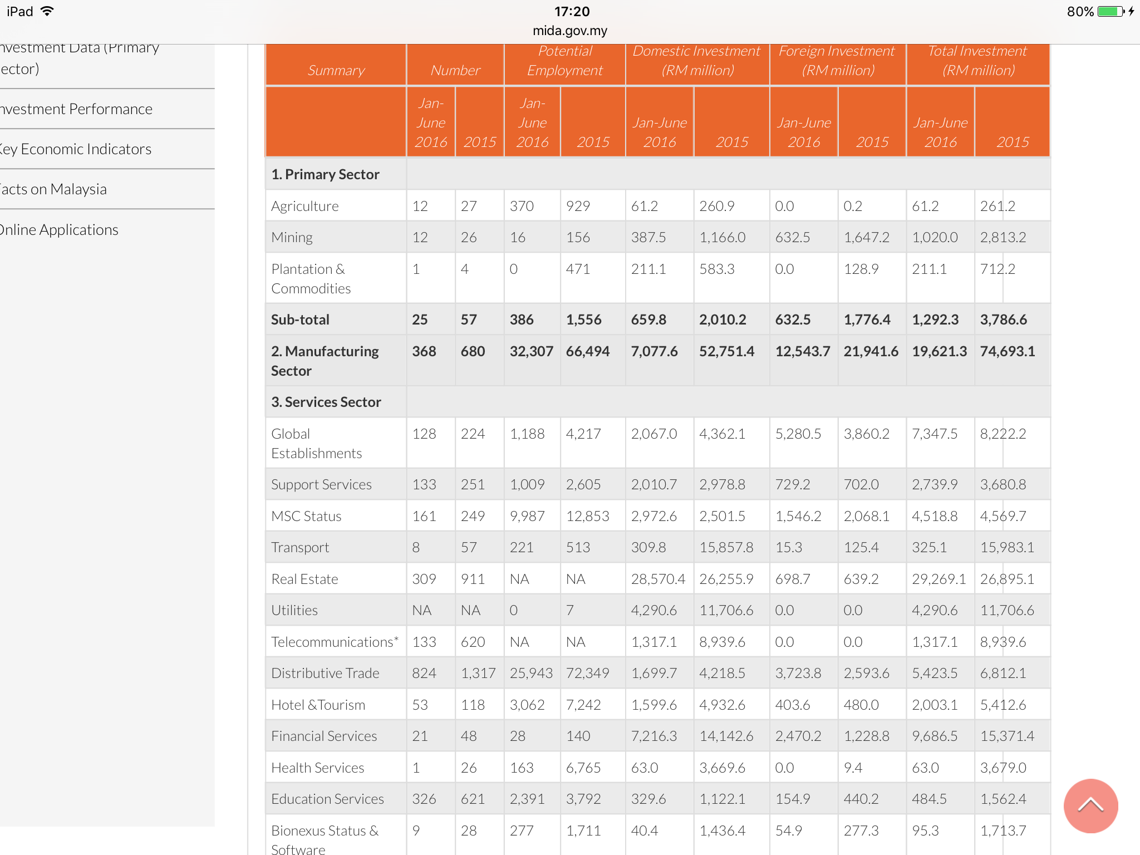

Tourism
If countries were awarded for diversity, Malaysia would top first place. From large island groups to mountains, fertile highlands and tropical rainforest, the country’s geography is every bit as diverse.

- Gunung Mulu National Park
Famous for its extraordinary limestone karst formations and phenomenal cave systems, the Gunung Mulu National Park is one of the most awe-inspiring natural attractions in all of Southeast Asia.

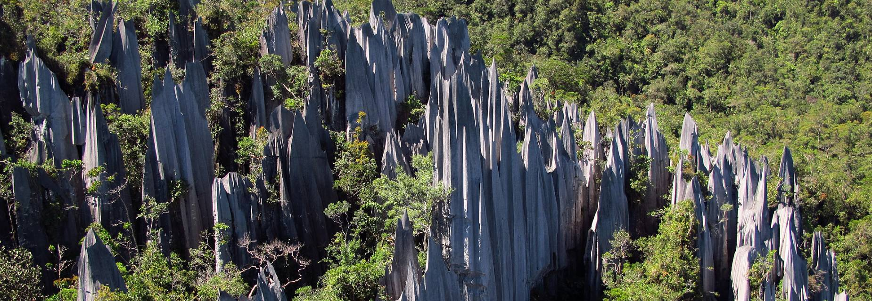

2. Langkawi
Located off Malaysia’s northwestern coast in the Andaman Sea, Langkawi is an archipelago of 99 islands boasting picturesque beaches, rainforest, mangroves and forest-clad mountains.

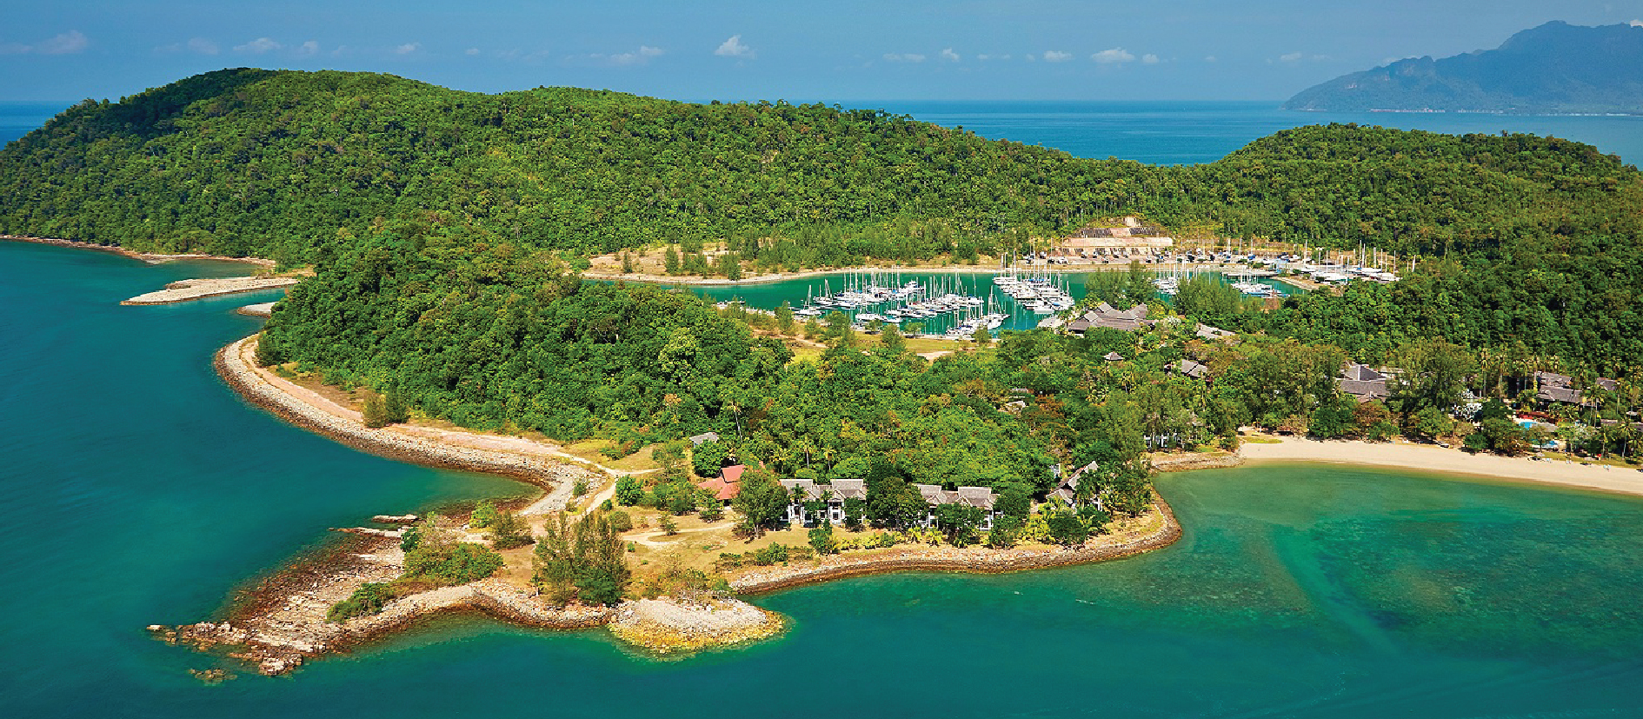

3. Kuala Lumpur
Commonly called KL by locals, this vibrant city is a cultural melting pot, noted for its impressive skyscrapers and buzzing scenes of shopping and dining.

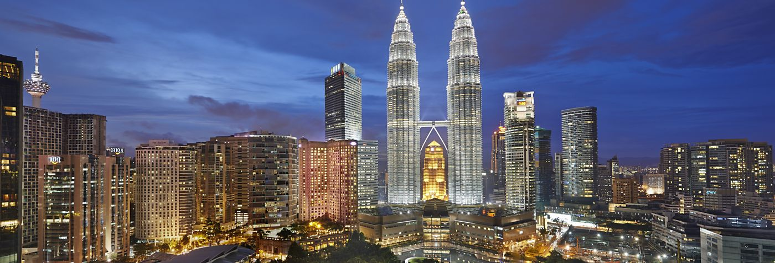

Norway

Currency: Norwegian Kroner

Geopolitical Risk
The oil price fall is making its mark on the Norwegian economy. Activity levels in the oil sector have fallen sharply. Large parts of the offshore fleet are laid up, and many companies are making workforce reductions. However, ripple effects to the wider Norwegian economy have thus far been limited. Expansionary fiscal policy, low interest rates and a weaker krone exchange rate are helping to maintain activity levels in other parts of the economy.
The flow of refugees to Europe and the UK's EU referendum are contributing to the economic uncertainty. Growth in household debt and house prices has continued to outstrip growth in incomes. However, there are wide regional differences in the housing market, with a fall in prices in Stavanger and very rapid price growth in Oslo. The growth in credit and house prices has helped to maintain activity levels in the Norwegian economy.
Norwegian banks are heavily exposed to residential and commercial property. In the event of a sharp fall in the property markets, banks will suffer substantial losses, both direct losses on loans secured on property and indirect losses as a result of economic ripple effects to large parts of the Norwegian economy. There is considerable uncertainty regarding the likely path of the international economy and the consequences for the Norwegian economy of low international growth and low oil prices. With a basis in that uncertainty, there are two possible scenarios for the Norwegian economy in the period 2016-2020. One scenario is relatively favourable while the other (the stress scenario) incorporates several years of low and negative GDP growth and a strong increase in unemployment.

What are the main trade areas?
Norway’s traditional economic activities include fisheries, fish farming and shipping. In shipping, Norway has the world’s fourth largest fleet in the world. After Russia, Norway is the world’s most important non-OPEC oil exporter. Norway’s exported services total to €31.1 billion whereas the country’s imports total to 29.6 billion.

Norway’s exports include the following:
-Oil and gas
-Shipping
-Wood products
-Industrial machinery
-Transport equipment
-Hydroelectricity
-Fish farming
-Seafood
-Timber
-Chemicals
-Metals, particularly semi-finished steels, ferro-alloys and aluminium
Main exports partners are:
-the United Kingdom (22 percent of total exports),
-Germany (18 percent),
-the Netherlands (10 percent),
-France and
-Sweden (6 percent each)
Norway’s Imports include the following:
-Machinery and transport equipment
-Miscellaneous manufactured articles
-Food and live animals
-Crude materials except fuels
-Mineral fuels, lubricants and related materials

Main import partners:
-Sweden (12 percent of total imports)
-Germany (11 percent)
-China (10 percent)
-UK and the US (6 percent each)

What does Norway invest in?
The fund consists of 60% equities, 35-40% fixed-income securities and up to 5% real estate, and is invested globally outside Norway.

Norway’s equity investments are spread across the world to capture broad gains in stock markets.
LARGEST EQUITY INVESTMENTS
-NESTLE .CH
-APPLE .US
-ROYAL DUTCH SHELL .UK
-ALPHABET .US
-ROCHE HOLDING .CH
-NOVARTIS .CH
-MICROSOFT CORP .US

Investments in real estate accounted for 3.1% of Norway’s fund at the end of 2016. The real estate share will be increased to as much as 5% of the fund value. New investments will generally be in well-developed markets and in office and retail properties.
The fund’s fixed-income investments are allocated 70% to bonds issued by governments and related institutions and 30 percent to securities issued by the corporate sector.

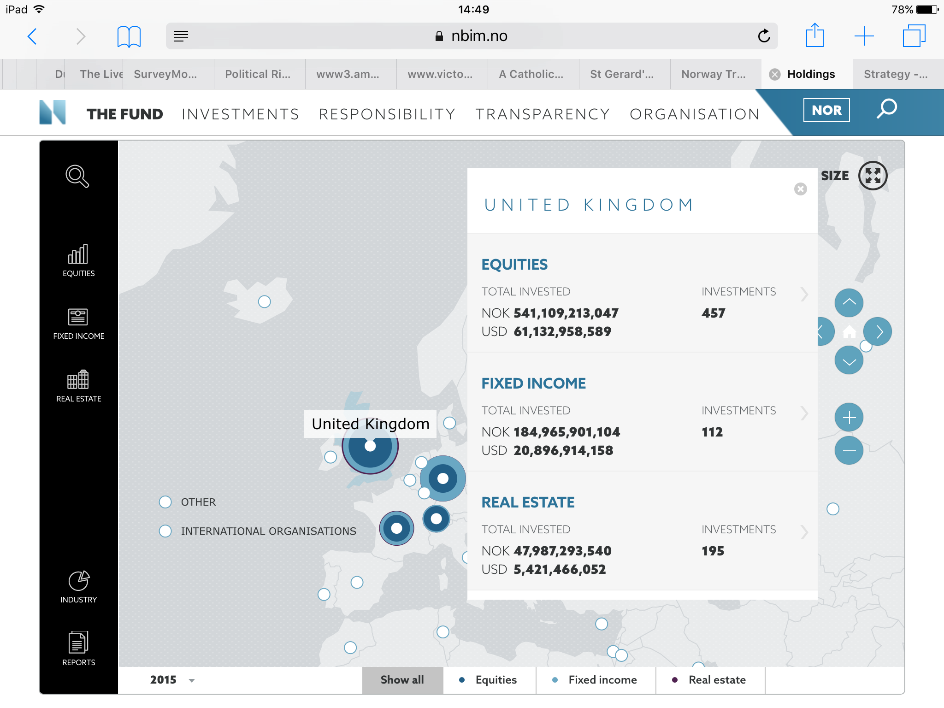
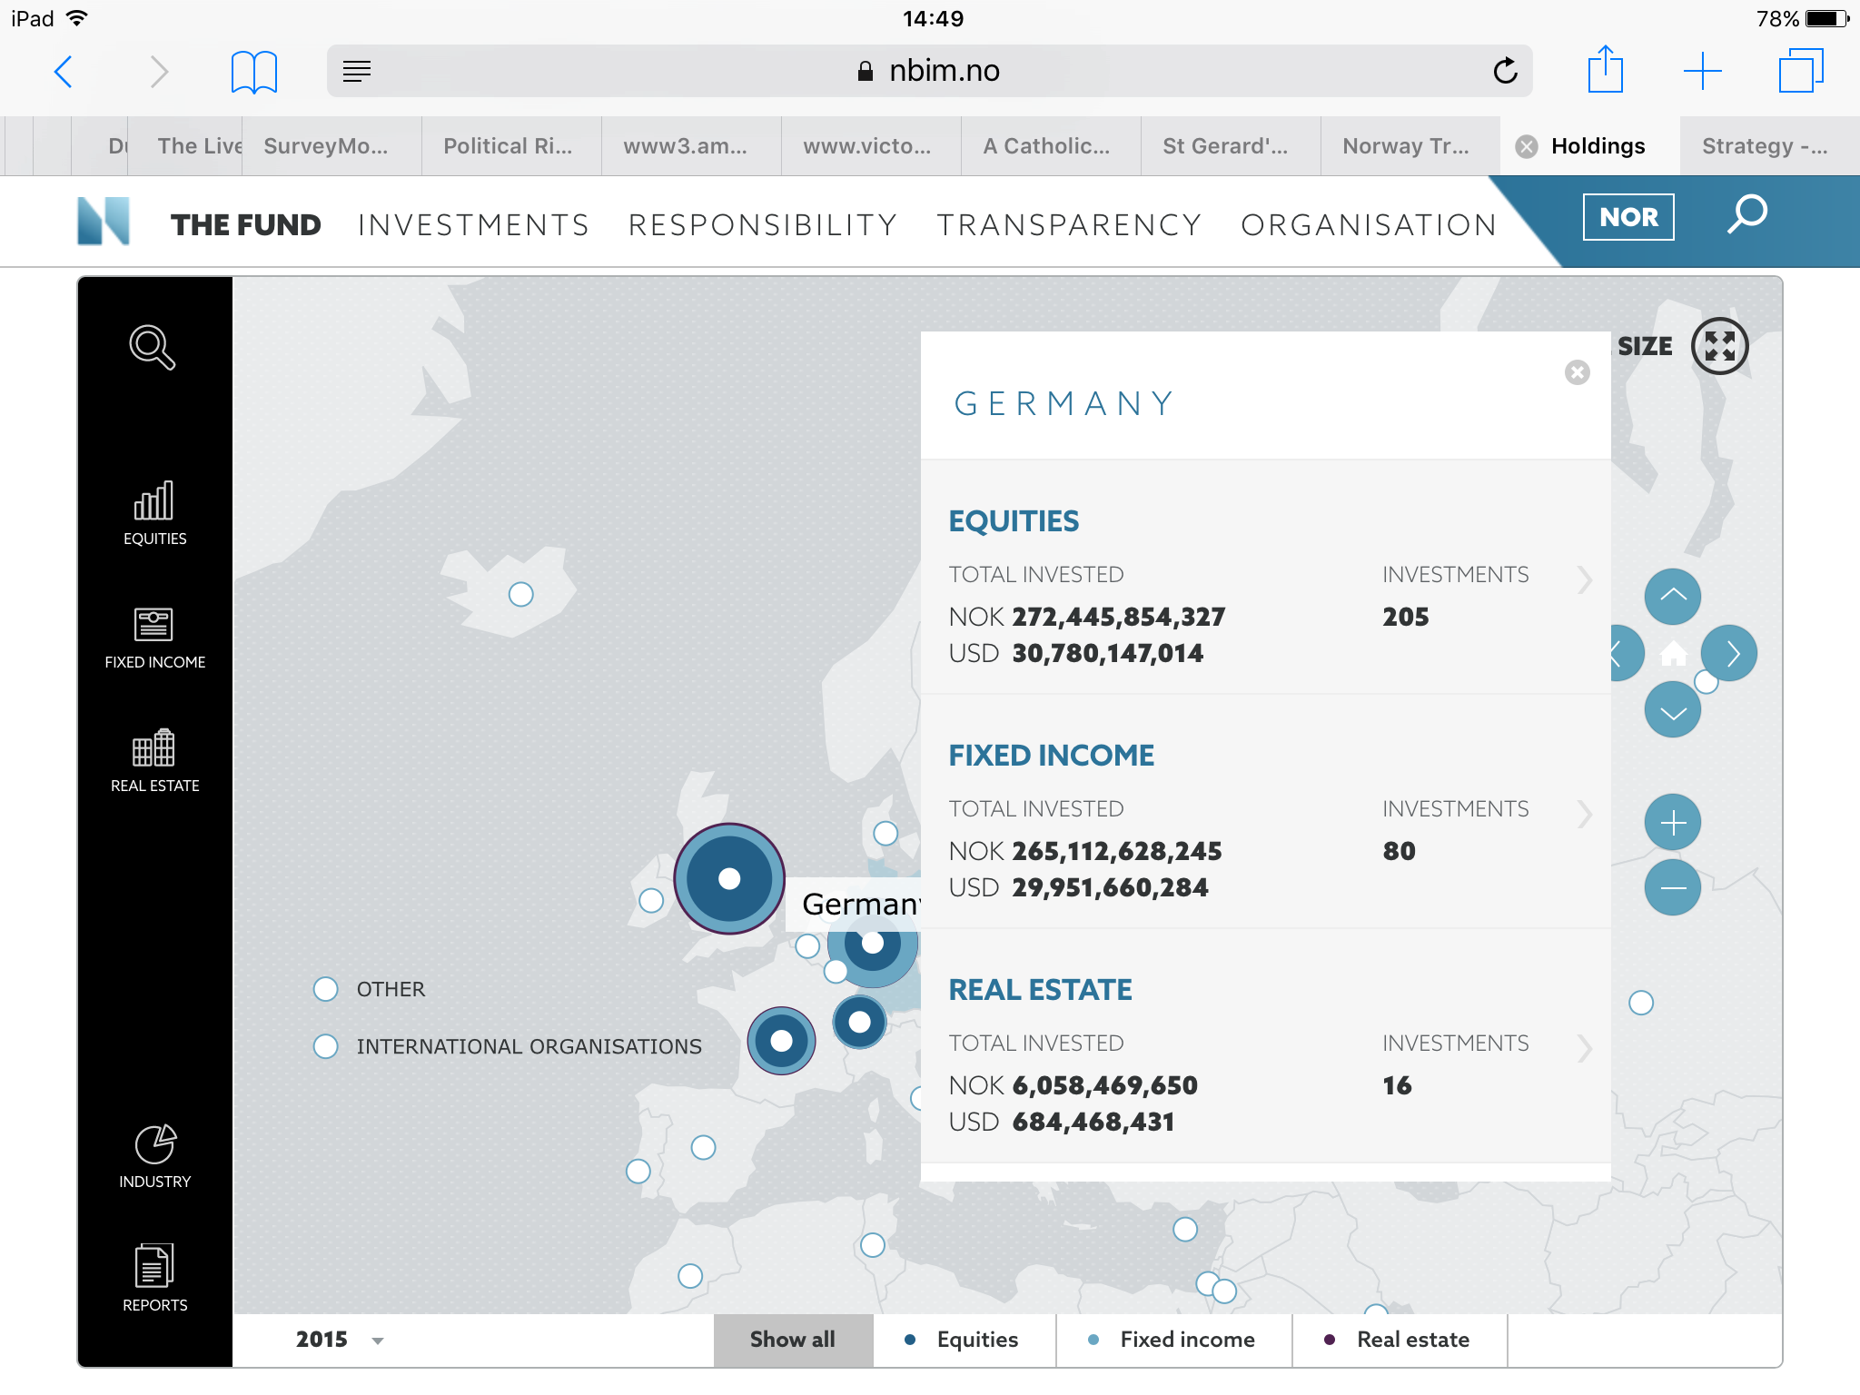

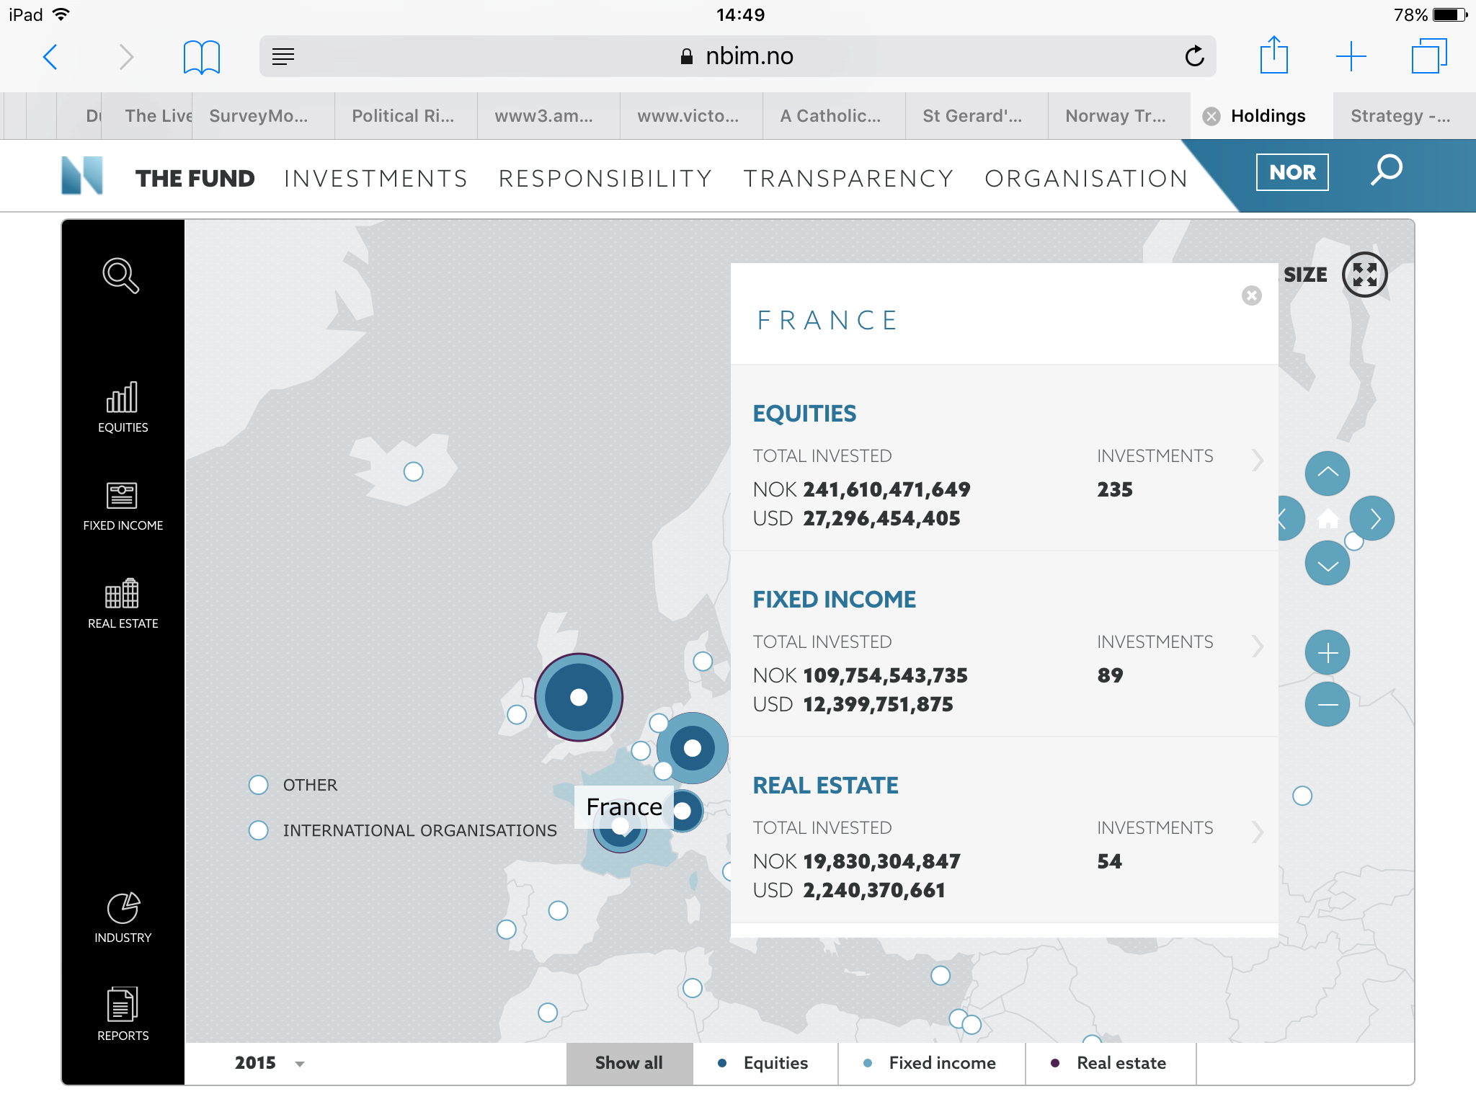

The Norwegian Government invest in the Government Pension Fund. The purpose of the Government Pension Fund is to facilitate government savings to finance rising public pension expenditures, and support long-term considerations in the spending of government petroleum revenues.

Tourism
From its majestic mountains and famous fjords to its modern yet picturesque cities, Norway is simply one of the most beautiful countries in the world. More than 30 million people visit Norway each year!

- Western Fjord
Norway’s famous fjords are found throughout the country and not limited to a particular region or location. Western fjords vary slightly in appearance they are generally relatively narrow, surrounded by steep rock faces, tall mountains and extremely deep.

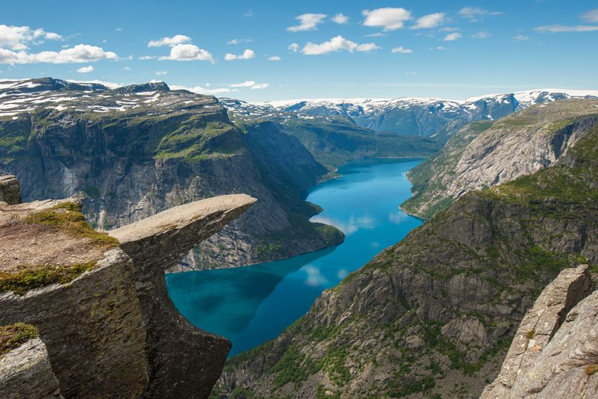

2. Bergen
Norway’s second largest city, Bergen has been the nation’s leading western port since the Middle Ages. Today, its 15th-century waterfront in the Bryggen district is both a working port and a tourist destination for visitors eager to sample fresh fare at seaside restaurants.

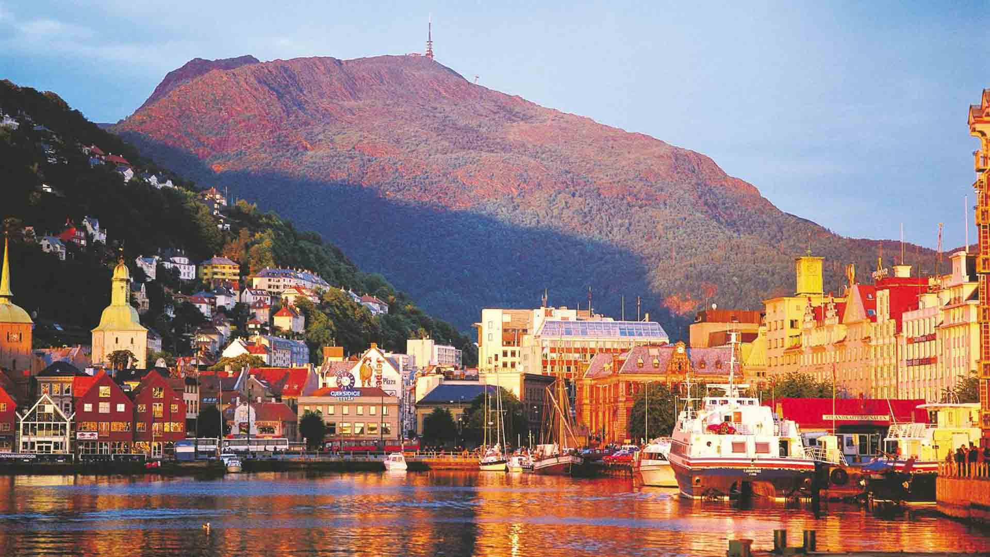
3. Lofoten Islands
One of the most popular places to visit in Norway, Lofoten is a group of islands in the northern part of the country. It is considered one of the most scenic parts of Norway!

