Careers Project
By Sophie O’Riordan

Diplomat

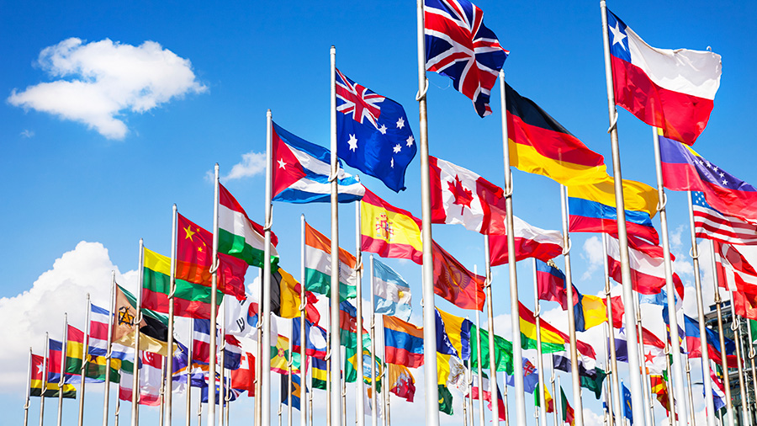

Career Outline

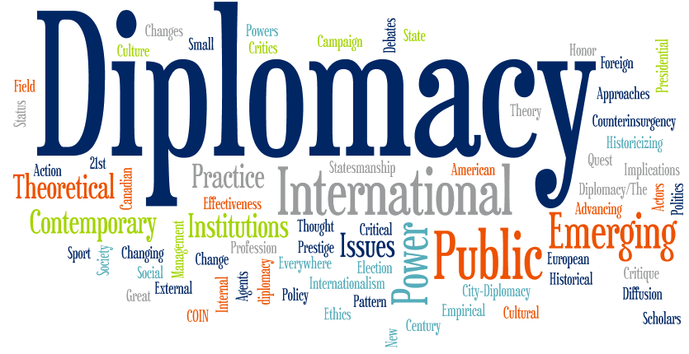

Diplomats do a very important job for their countries. Almost every country in existence has at least a few diplomats who are sent out to various other countries for the purposes of negotiating and mediating relations between the two governments. Diplomats represent their country’s government overseas, and counsel on international issues. They are employed by the civil service, within the Department of Foreign Affairs in Ireland, and are involved in the negotiation of international political agreements and the promotion of national policy and interest. A diplomat lives in the country that he is trying to communicate with. He will usually live in the embassy of his country. They are also granted something called diplomatic immunity to protect them while in a foreign country, and to allow them to do their job well. Usually a diplomat’s main goal is to simply maintain good relations with the country in question. By speaking with the leaders and establishing a friendly relationship, a diplomat not only establishes himself as a trustworthy person, but also builds trust in his own country. This could even be for the ultimate goal of establishing a treaty or becoming allies. Usually much of the communications will cover issues such as foreign aid, and what exactly watch country expects of the other. If done correctly, diplomacy is a great way for countries to get every single issue out on the table and establish a great relationship.

Work activities of a diplomat
- Representing the Irish government on international issues affecting the country.

- Promoting Irish policy and businesses to overseas governments, individuals, organizations and the media.

- Developing an understanding of local business practices and helping companies understand legislation surrounding the export of their goods and services.

- Negotiating international agreements, for example on drug control or endangered species.

- Gathering information about the political and economic state of their host country.

- Writing reports and advising ministers on relevant developments.

- Planning projects in detail and anticipating problems.

- Co-ordinating own workload and that of others to ensure accurate project delivery to frequent tight deadlines.

- Organizing high-level Irish Government visits and hosting small or large social functions.

- Assisting Irish citizens in difficulties abroad.

Interview with a Diplomat

Sir Vincent Fean
Sir Vincent Fean is a British diplomat and an alumnus (former pupil or student) and honorary graduate of the University of Sheffield. He has had a distinguished diplomatic career, spanning over 38 years in the British Diplomatic Service which has included appointments as High Commissioner to Malta, Ambassador to Libya and most recently Consul General to Jerusalem from which he retired in 2014.

- What advice would you give to current students interested in becoming a Diplomat?
I would recommend it. However, it is very competitive and popular – a bit harder to get into straight from university than it was in my time, so it is important to have other options too. It is important to develop an interest that ties in with foreign affairs, like living and working in a foreign country or doing a stint with an NGO (non-government organization) or charity which brings you into contact with another culture. It is also useful to know a language, but not essential. I have used languages a lot in my career, about half of which has been abroad, and languages are very important in being able to get under the skin of the country you are in. The Foreign Office is good at teaching you foreign languages – I learnt to speak Arabic there for instance.

- What have been the main challenges of working in the varied political environments you have?

I have worked in Europe – in Brussels and Paris – where the relationships are strong and grounded. The two trickier places that I have worked are Libya, under Colonel Gaddafi from 2006 to 2010, and Jerusalem, where I spent three years. Libya was very unpredictable. Working in Libya in those days, you didn’t need a diary – things either happened today, tomorrow or not at all.
Jerusalem was a different kind of challenge. I spent my time talking to both Palestinians and British people living and working in the occupied Palestinian territories – East Jerusalem, the West Bank and Gaza. I worked in parallel with my colleague in Israel and we were required to make joint recommendations to London. It was challenging because my main focus was the Palestinians, who are the occupied people and this made it hard to develop areas like the economy, which was heavily dependent on international aid from the European Union, the United States and so on.

- What have been the most rewarding aspects of your work?

Without being too sentimental, it has been a privilege to serve the country. I have served successive governments of all stripes since 1975, and the British values and interests that the Diplomatic Service aims to represent abroad are a continuum. It is also a privilege to work abroad for Her Majesty’s Government. The responsibility of trying to promote your country’s values and interests is an honour. It has been an incredible journey, which has allowed me to travel and learn about different cultures.

- Finally, what are your current areas of focus?

I retired two years ago, and continue to talk about Palestine and Israel pro bono. I advocate UK recognition of the state of Palestine, even if it is under occupation. I am a trustee of a charity called Medical Aid for Palestinians and I am the patron of the Britain Palestine Friendship and Twinning Network. I also offer fundraising advice for the St John’s Eye Hospital in Jerusalem.

Courses available at Colleges

To become a diplomat, you are not required to complete any specific university courses, however it is important to speak more than one foreign language and to have an interest in foreign affairs. Often students who have qualified as a solicitor/barrister and economics become diplomats. A first or second class honours degree is essential (70-100% - First Class Honours
60-69% - Second Class Honours).

CAO System: The Central Applications Office is the organization responsible for overseeing most undergraduate applications in the Republic of Ireland.
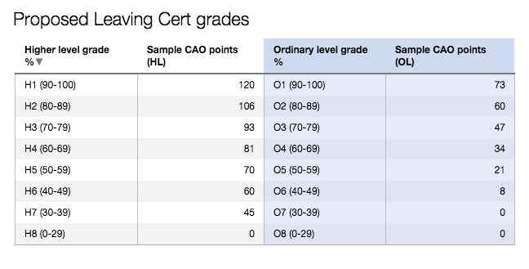

UCAS System: The Universities and Colleges Admissions Service (UCAS) is a UK-based organization whose main role is to operate the application process for British universities.

PLC Courses: Post-Leaving Cert Courses are aimed to develop vocational and technological skills in order to get a job or to go into further education and training.

Courses Available

DCU Bachelor of Arts in International Relations
Points: Minimum of 385
Requirements: Minimum of six Leaving Certificate subjects at Grade H7, to include the subjects English OR Irish AND the subject Mathematics. In addition, applicants must present at least two subjects at grade H5.

The BA in International Relations is normally a three-year course. However, you may elect to spend an extra year abroad in one of our partner universities in in China, the Czech Republic, France, Germany, Hungary, Poland, Scotland, Spain, Sweden, Turkey and the USA between your second and third year. This is an excellent opportunity to experience another society at first hand.

Year 1 Core Modules
Code | Title | Credit | Semester | Exam % | CA %
LG104 | Introduction to European Integration | 5 | Semester 2 | 0 | 100
LG116 | Introduction to Politics | 5 | Semester 1 | 100 | 0
LG117 | Intro. to International Relations & Security | 5 | Semester 1 | 0 | 100
LG122 | Core Skills & Methods for Intl Relations | 10 | Year long | 0 | 100
LG123 | Introduction to Development | 5 | Semester 2 | 0 | 100
LG125 | International Political Economy | 10 | Semester 2 | 0 | 100
LG132 | International Organisations | 5 | Semester 1 | 0 | 100
LG134 | Public International Law | 5 | Semester 2 | 0 | 100

Electives: French, German, Contemporary Cultural Debates, Intercultural Communicative Competence, American Political System, The Emergence of Modern America, Spanish.

Year 2 Core Modules

Code | Title | Credit | Semester | Exam % | CA %
LG218 | Independent Study Project | 15 | Year long | 0 | 100
LG219 | Foreign Policy | 5 | Semester 1 | 0 | 100
LG233 | International Security and Conflict | 10 | Semester 1 | 0 | 100
LG237 | International Human Rights Law | 5 | Semester 2 | 100 | 0
LG238 | Theoretical Approaches to World Politics | 5 | Semester 1 | 0 | 100
LG302 | Comparative European Politics | 5 | Semester 2 | 0 | 100
LG359 | Western Political Thought | 5 | Semester 2 | 0 | 100

Year 2 Optional Modules:
Electives: French/German/Spanish for international Business, French/German/Spanish Language and Society, Global Cultures, The Making of Contemporary Europe, America and the Wider World, Contemporary American Business and Society.

Year 3 Core Modules
3 Core Modules:
Code | Title | Credit | Semester | Exam % | CA %
LG329 | Key Issues in International Relations | 10 | Semester 2 | 0 | 100
LG362 | Key Issues in International Political Economy | 10 | Semester 1 | 0 | 100

Electives: French/German/Spanish Language, Conflict Resolution in Northern Ireland, Languages and Society, Russia and the Former Soviet Space, European Union Law, Contemporary Politics of Middle East, North Africa and Latin America, Issue in American Politics, Dissertation, Political Terrorism, Issues in European Integration, Contemporary India, International Peacekeeping, Political Leadership.

Trinity Business, Economic and Social Studies (BESS)
Points: Minimum of 510 points
Requirements: Minimum of 6 Leaving Certificate subjects which include a H6 Mathematics

The BESS programme offers students a broad-based education in business, economics, political science and sociology in the first year. After this students can adjust their module options to reflect their academic strengths, interests and emerging career aspirations. This unique aspect of the programme gives students the time to engage with all four areas and then the opportunity to specialise to a high level in either one (single honor) or two (joint honors) chosen subjects or disciplines.

 | Year 1 Modules | Year 2 Modules  (6 modules, choose 1 or 2 BESS disciplines) | Year 3 Modules  (6 Modules specialize in depth 1 or 2 BESS disciplines) | Year 4 Modules  (4 modules specialize in depth 1 or 2 BESS disciplines)
Business | ▪ Introduction to Organization and management | Organizational behaviour  ▪ Principles of marketing  ▪ Introduction to accounting  ▪ Introduction to finance  ▪ Introduction to operations  management  ▪ Creative thinking, innovation  and entrepreneurial action | ▪ Management accounting for  business decisions  ▪ Financial accounting  ▪ Human resource management  ▪ Organization theory  ▪ Services management  ▪ Business in society  ▪ Innovation, entrepreneurship  and business modelling  ▪ Corporate finance and equity  valuation  ▪ Digital technology in operations  ▪ Investments  ▪ Contemporary marketing  management  ▪ Personal and professional  development  ▪ Management experience and  reflection | Exploring organizational  experiences  ▪ Financial reporting and analysis  ▪ Advances in marketing theory  and practice  ▪ Managing new product  development  ▪ Social innovation and social  impact  ▪ Derivatives and international  finance  ▪ Business dissertation  ▪ Strategic management: theory &  practice
Economics | Introduction to Economics Mathematics and Statistics | ▪ Intermediate economics  ▪ Economy of Ireland  ▪ Mathematics and statistics | Economic analysis  ▪ Money and banking  ▪ European economy  ▪ Economics of less developed  countries  ▪ Investment analysis  ▪ Economics of policy issues  ▪ Industrial economics  ▪ Mathematical economics  ▪ Econometrics | ▪ Economic theory  ▪ World economy  ▪ Development economics  ▪ Economics of financial markets  ▪ Quantitative methods  ▪ International economics  ▪ Economic and legal aspects of  competition policy  ▪ Applied economics  ▪ Economics dissertation
Political Science | Introduction to Political Science | History of political thought  ▪ International relations  ▪ Comparative politics | Research methods for political  scientists  ▪ Irish politics  ▪ Government and politics of the  USA  ▪ Democracy and development  ▪ European Union politics | Contemporary political theories  ▪ Issues in contemporary politics  ▪ Contemporary international  relations  ▪ African politics  ▪ Topics in political science  ▪ Chinese politics  ▪ Politics of policy-making
Sociology | Introduction to Sociology | Gender, Work and Family  ▪ Introduction to social research  ▪ Power, state and social  movements | Globalisation and development  ▪ Researching society  ▪ Race, ethnicity and identity  ▪ Social stratification & inequalities  ▪ Comparative Sociology Europe | Sociology dissertation  ▪ Conflict studies  ▪ Digital lives and social networks  ▪ Labour markets, gender and  institutions  ▪ Migration
Complementary Modules | Choose one module  ▪ Law  ▪ Social policy  ▪ Intro to Central,  East European and  Russian area  studies  ▪ Language (French,  German, Spanish,  Russian or Polish) | Central problems in philosophy  ▪ History of philosophy  ▪ Logic, Language and Science  ▪ European Refugee Policy  ▪ Analysing Poverty and Social  Exclusion  ▪ Housing policy  ▪ Crime and Irish society  ▪ Language  ▪ Law  ▪ Broad Curriculum options | ▪ Life Courses and Evolving  Welfare States  ▪ Company law  ▪ Commercial law  ▪ International law | Poverty, inequality and  redistribution

London School of Economics and Political Science: Politics and International Relations
Requirements: A level: grades A*. International Baccalaureate: Diploma with 38 points. Proof of your English language proficiency may be required.
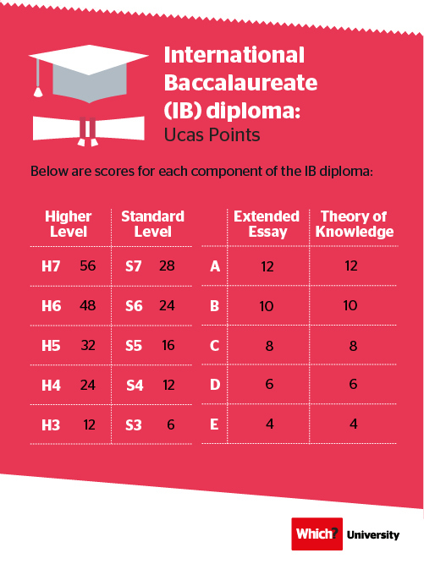

This programme combines the two complementary fields of politics and international relations in a joint honours programme, with around half of the programme in each field. You will learn political concepts and theories, will compare political phenomena in a variety of cultures and countries, and answer broad theoretical questions about the political world. You will also gain insight into how the international community works, studying alongside students from a wide range of countries.

Year 1

In the first year, you will take one compulsory course each in politics and international relations. You will choose either Introduction to Political Theory or International History since 1890. You will also choose one outside option, and will take LSE100, which is taught in the Lent term only.

Introduction to Political Science
Examines the comparative analysis of a range of political phenomena, including the forms of states and regimes, theories of elections and voting, political ideologies, the causes and consequences of democracy, and the management of the economy.

Concepts of International Society
Examines the theories and concepts designed to explain the nature of contemporary international relations.

One outside option:

LSE100
LSE100 is compulsory for all LSE undergraduate students, and introduces you to the fundamental elements of thinking like a social scientist.

Either
Introduction to Political Theory
Examines the foundations of Western political thought, followed by modern political theory.
Or
International History Since 1890
Explores the history of international relations from the 1890s through the 1990s.

Year 2

Power and Politics in the Modern World: Comparative Perspectives
A contemporary study of comparative politics.

Either
Introduction to Political Theory
This course examines the foundations of Western political thought, followed by modern political theory.
Or
International Political Theory
Combines classical theory with modern ways of explaining and understanding international relations.

Either
Foreign Policy Analysis I
Analyses various theoretical perspectives on foreign policy, and the means of conduct of the main actors in the international system towards each other
Or
International Organizations
Examines major theoretical and empirical aspects of the role of international organizations in international politics.

Year 3

Either
Foreign Policy Analysis I
This course analyses various theoretical perspectives on foreign policy, and the means of conduct of the main actors in the international system towards each other.
Or
International Organizations
This course examines major theoretical and empirical aspects of the role of international organizations in international politics.

Either
Dissertation
Or
One international relations option

Either
One government option
Or
One international relations option
Or
One approved outside option

PLC Course
Blackrock Institute of Further Education: Pre-University Law Level 5

This course is certified by QQI (quality and qualifications Ireland)
Assessment is based on a combination of work submitted during the year and exams. Learners who successfully complete all 8 subjects will be awarded a QQI Level 5 Certificate in Legal Studies.

CORE ELEMENTS
- Legal Practice and Procedures
- Business Law
- Family Law
- Libel and Defamation
- Criminal Law
- Word Processing
- Communications
- Work Experience
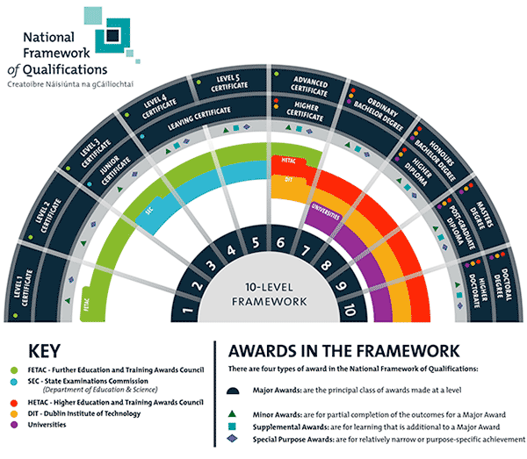

Suitable Leaving Cert Subjects

The Leaving Certificate Subjects which would be the most practical and useful to become a Diplomat would be the literary subjects, language subjects, History related subjects and Economic and Business related subjects.

Literary Skills gained ideally in reading, analysis and essay construction would be a great asset to become a diplomat. Strong verbal communication in different languages is vital for this careers choice. A keen interest in world news and following the key issues of the day are important in this career. It is beneficial to study history as it is helpful to integrate the history of a country into your background understanding of the language and its people. By studying Economics one would understand supply and demand, exchange rates, market prices etc. which would prove useful in the careers of a diplomat.

The best suited Leaving Cert Subjects to become a Diplomat would be:
- English
- French/Spanish
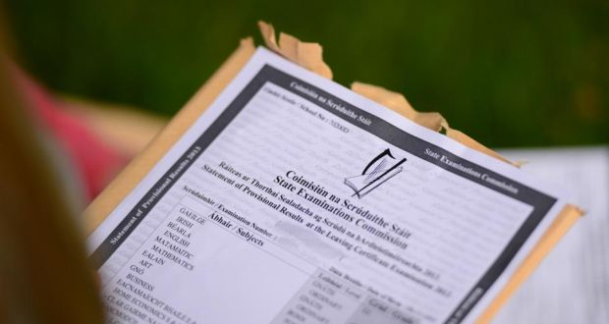
- History
- Economics
- Business
- Religious studies
- Mathematics

Family Influences

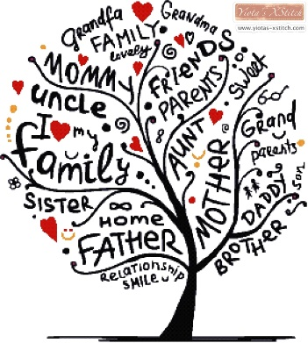
I have noticed a trend in the occupational choices in my family. Many of my relatives have pursued careers which are enterprising and innovative, which involve creativity and working with people, careers which would most likely involve spending time indoors as opposed to jobs that work in nature. My Irish relatives would not be very practical, so to say, they would prefer typing and thinking than creating products with their hands! To give you an idea of the type of careers my Irish relatives have I will list a few of the below:
- Primary school teachers
- Lecturer in a French University
- Purchasing manager
- Insurance official
My Dutch family would also tend to be have more intellectual jobs as opposed to jobs that demand physical work. My grandmother worked in a fashion shop, she was also very talented at making clothes from her daughters (my mum and her sister) and my grandfather was the director of a prominent company in The Netherlands. Obviously, every person has their own personality, but you do inherit certain qualities and certain aspects of your character from your family. In the personality test, I was told I am an idealist, and I believe this is not a coincidence. The dictionary says an idealist is ‘a person who is guided more by ideals than by practical considerations’. My family have guided me and influenced me a lot, and due to this I have formed my own thoughts and created my own personality. However, although my personality is unique and different to the rest of my family, at the very center I have become who I am because of who my family are. My family have helped shape my thoughts and interests.

My most influential role models are my parents. My father works for the European commission in the Political section. Prior to this he has worked in many other sections in the Commission including the trade section, which involved him traveling the world to negotiate trade deals and also the environmental area along with many others. My mother has created her own company; therefore, she is self-employed. She advises multi-national companies on European Law, she is a lawyer or advisor. Her job also involves a certain amount of travelling throughout Europe. Both my parent’s jobs seem very interesting and exciting. No two days are the same, each day is filled with new experiences and challenging work. The careers of my parents’ appeal to me, they fascinate and interest me. I did a week of work experience with my father in the European commission Representation in Dublin, and I really enjoyed myself! As my parents are both involved in the European union, I have developed a strong interest in the EU and the work they do. In addition, because of my multi-cultural childhood in Belgium, I have seen the world in a different light and learned about many cultures and meet many interesting people. Growing up in a multi-cultural environment, and being bilingual creates a different mind-set. I believe this experience has led to me having a more open mind, and shown me the countless possibilities for my future. Lastly, this school year, Transition year, has been a brilliant experience that has introduced me to many different careers, and has helped me develop an independent mind-set. Throughout my life, I have been positively influenced in many ways, as mentioned above and this has helped me become who I am, and has helped me decide on a career path for the future!

Career and Employment Trends

Starting salary for a diplomat: 28,188 euros (average salary in Ireland 45,000 euros)

Average annual salary: 50,000 euros (the highest rank of a diplomat can get 179,000 annually)

Levels of progression: You have access to a wide range of Civil Service training, designed to prepare you for your first overseas posting. This includes foreign language training. Third Secretary is the entry grade to a diplomatic career and is essentially a training grade from which subject to suitability. Then you are encouraged to identify your own training needs as part of an appraisal and staff development programme. After 2 years, you can apply to join the Fast Stream programme if your manager thinks you have the potential for senior management. A Third Secretary can be promoted to First Secretary. Further competitive processes open the door to promotion to Counsellor and higher, including Ambassador.

Working environment and conditions: Travel - during working day is occasional and posting abroad are common as Third Secretaries can expect to divide their career between service in the Department in Dublin and in over 70 Irish missions abroad.

Working hours - mainly office hours Monday–Friday with from 9-5pm. Diplomats attend evening/weekend functions including those falling on public holidays. You'll normally work 9am to 5pm, Monday to Friday, if you're based in the UK. Overseas, your hours and conditions may vary according to the culture and climate of your host country. You may also be on call 24 hours a day.

Location - in Dublin and in over 70 Irish missions abroad. Most overseas postings last from 3 to 4 years. You must be willing to work anywhere in the world.

Opportunities for self-employment - not possible.

Typical employers - Department of Foreign Affairs.

Summary and Conclusions

So why does this career suit me?

I have a good knowledge of foreign languages, including Dutch, French, English and a Junior Cert level of Irish. It is vital to be able to understand and speak foreign languages comfortably in this career, as one could be posted to any country and would be expected to be able to communicate with the people in this country. I am capable of planning projects and enjoy doing so too.
As mentioned in my personality summary the Kiersey Type that most describes is a ‘teacher’ as I value organization and planning. I am good at communicating messages and expressing my thoughts on important issues. Although I am not the most confident person when I need to debate, or say I speech I can improve my confidence. I like a career that challenges me on a daily basis and gets me out of my comfort zone.
I am currently taking the subjects for the Leaving Cert which are the most appropriate to prepare me to become a diplomat, so I am learning the necessary skills over the next two years. Finally, I have the skill of writing reports and essays, in addition I thoroughly enjoy researching information and transferring the information into a condensed report in a short amount of time. I practiced this skill while working with the European Commission in Dublin and also for various projects at school. This skill is very important in the career of a diplomat.

Most importantly this careers path interest me, as I am fascinated by international affairs and international relations and I have a high degree of awareness of Irish political, economic, social and cultural life. At this early stage in life I am not yet certain about what career I would like pursue in the future, actually I don’t have the power to know what the future has got in store for me! However, I have an idea about what type of careers I am more interested in, and by doing tests such as the EirQuest I have a good idea about what careers best suit me. Over the next few years I will make sure to keep my eyes wide open and grasp any opportunities presented to me, as I am determined to make the most out of my future!

I have really enjoyed doing this project! It has allowed me to research different careers in depth, and I have discovered many university courses that have captivated me along the adventure of creating this project. It has given me a moment to reflect on the influences my family has on le and this project has opened my eyes to the countless possibilities there are for my future.

Passion is what gives meaning to our lives. It's what allows us to achieve success beyond our wildest imagination. Try to find a career path that you have a passion for – Henry Samueli

Sophie O’Riordan 4D

